



**SM6P07NI Digital Media Project**

**50% Project**

**2019-20 Autumn**

**Student Name: Rahul Balami**

**London Met ID: 22067315**

**College ID:** NP01MM4A220025

**External Supervisor:** Enter your External Supervisor Name Here

**Internal Supervisor** Enter your Internal Supervisor Name Here

**Assignment Due Date: Wednesday, May 7, 2025**

**Assignment Submission Date:** Click or tap to enter a date.

**Word Count: 4699**

*I confirm that I understand my coursework needs to be submitted online via Google Classroom under the relevant module page before the deadline in order for my assignment to be accepted and marked. I am fully aware that late submissions will be treated as non-submission and a marks of zero will be awarded.*

Table of Contents

1. Introduction 1

1.1. Project Title 2

1.2. Objective 3

1.3. Aim of project 4

2. Finding Client to Client Finalization 5

3. Area of research 6

3.1. Game Development Tools and Methods: GDevelop and Aseprite 6

3.2. Genre and Visual Style: Narrative Platformers and Pixel-Art Environments 7

**Stray** 9

4. Topic, Research Question & Target Audience 11

4.1. Topic 11

4.2. Research Question 11

4.3.1. Title 12

4.3.2. Tagline 12

4.3.3. Genres 12

4.3.4. Story Timeline 12

4.3.5. Target Audience 12

4.3.6. Common Interests: 13

4.3.7. Opinion 13

4.3.8. Beliefs 13

4.3.9. Expectations 13

5. Resources 14

5.1. Software to be used 14

5.1.1. G-develop: 14

5.1.2. Aseprite 15

5.2. Hardware Tools 16

5.2.1. XP-Pen Deco Pro 16

5.2.2. Lenovo Legion 5 17

5.3. Websites used 18

5.3.1. Pinterest 18

5.3.2. YouTube 18

5.3.3. Google Form 18

5. Product Research 19

5.1. Game Development 19

5.2. Health Bar 20

5.3. Patrolling Enemy 21

5.4. Creating a platformer game 22

6. Project Plan 24

6.1. Previous Plan 24

6.1.1. Pre-Production Gantt Chart 24

6.1.2. Production *Gantt Chart* 24

6.1.3. Post-Production Gantt Chart 25

6.2. Current Plan 26

6.2.1. Pre-Production Gantt Chart 26

*6.2.2.* Production *Gantt Chart* 26

*6.2.3.* Post-Production *Gantt Chart* 26

7. Pre-production Phase 27

7.1. Character Design 27

7.1.1. Development process 28

Dog Character 28

Main cat character (Front and side view) 30

Cat hurt 32

Enemy character 33

Footpath 34

Settings Button 36

7.2. Colour theory 37

7.3. Mood Board 38

7.4. Environment Design 39

8. Production Phase 40

8.1. Character Development 40

8.2. Animation 41

8.3. Enemy AI 42

8.4. User Interface 43

8.5. Sound Effect 44

9. Post-Production Phase 45

9.1. Compile 45

9.2. Post finalization 46

10. Problems faced and it’s solutions 47

10.1. Collision Detection and Integration of movement 47

**Problem:** 47

**Solution:** 47

10.2. Sound not playing during gameplay 48

**Problem:** 48

**Solution:** 48

10.3. Long screen load time 49

**Problem:** 49

**Solution:** 49

11. User Testing & Findings 50

11.2. Survey Form and Results 50

11.3. Reflection on the survey result 58

11.4. Technical Testing 59

11.5. Third Party Evaluation 60

12. Conclusion 61

13. Bibliography 62

14. Appendix 63

14.2. Mail exchange with client 63

14.3. DMP Letter provided by college 64

14.4. Weekly Logs 65

**Table of Figures**

Figure 1: G-develop application 8

Figure 2: Aseprite 9

Figure 3: XP-Pen deco pro 10

Figure 4: Lenovo Legion 5 11

Figure 5:Research on game development 13

Figure 6: Research on implementation of health bar 14

Figure 7: Research on implementation of patrolling enemy 15

Figure 8: Research on implementation of platformer game 16

Figure 9: Implementation of platformer game without coding 17

Figure 10: Pre-production gantt chart 18

Figure 11:Production gantt chart 18

Figure 12:Post-Production gantt chart 19

Figure 13: Pre-production gantt chart 20

Figure 14: : Production gantt chart 20

Figure 15: Post-production gantt chart 20

Figure 16: Process of enemy design 23

Figure 17: Process of cat design 25

Figure 18: Process of hurt cat design 26

Figure 19: Process of enemy character design 27

Figure 20: Process of footpath design 29

Figure 21: Process of setting button design 30

Figure 22: Survey result for age group 44

Figure 23: Survey result for occupation 45

Figure 24:: Survey result for how often user play 2D games 45

Figure 25: Survey result if the game was easy to play 45

Figure 26: Survey result on experience 46

Figure 27: Survey result on game environment 46

Figure 28:: Survey result on emotion connection 46

Figure 29: Survey result on if dialog box helped 47

Figure 30: Survey result if the story telling is well-paced 47

Figure 31: Survey result of gane's visual opinion 47

Figure 32: Survey result if style matched the tone of story 48

Figure 33: Survey result on background music opinion 48

Figure 34: Survey result if any glitches or bugs 48

Figure 35: Survey result of suggestion to improve 49

Figure 36: Survey result on which part of game user enjoyed 49

Figure 37: Survey result for satisfaction 49

Figure 38: Survey result on mood and feeling after gameplay 50

Figure 39: Survey result for if user would recommend this game 50

Figure 40: Survey result for rating 51

Figure 41: Mail exchange with client 55

Figure 42: DMP Letter provided by college 56

# Introduction

PurrKour is a project for a 2D pixel-art platformer video game that has the simple goal of creating a fun and engaging experience through parkour gameplay in a serene, urban pixel environment. The project is created as a final year project and set out to explore how narrative, engagement, and creativity could contribute to a fun experience in a serene pixel city with engaging gameplay. The scene is set on a busy, but serene, city street with detail to buildings, animated elements, and whimsical elements such as dodging and destroying dogs that the player meets along the way.   
  
The objective that led to this project is based on the question – “How can pixel art visuals and simple parkour mechanics merge to deliver an interactive and visually enjoyable 2D platformer experience?” This project included planning and concept consideration during pre-production, pixel character and scene creation in Aseprite, and gameplay development in GDevelop. This report considers all stages of development from storyboarding, to asset creation, to level design for gameplay interaction. It also reflects on the creative and technical journey of developing PurrKour, as well as the outcomes created.

## Project Title

“PurrKour” is a 2D story driven platforming game built with GDevelop for gameplay and Aseprite for pixel art. PurrKour follows an emotional journey of a cat protagonist as it travels through an urban neighborhood while facing challenges from an opposing gang of dogs led by the cat's estranged sibling. This project is about using storytelling as part of engaging gameplay, and examining ideas of betrayal, vengeance and emotional maturity in the process.

The Set throughout a warm, inviting pixel-art city, where there are small businesses, apartment buildings and delightful details to keep the world alive, PurrKour will contrast some cosy and peaceful setting, with some action sequences to give players a jolt. The platforming will be smooth and flowy, with parkour-inspired movements and have things to jump over/engage with. The game is ultimately aimed toward players who are interested in emotional narratives, love indie pixel art things and enjoy grounded character-driven stories. Overall aesthetic and mechanics are inspired by games like Stray and Celeste, and we want to strip things down to their simplest form, emotionally.

# Objective

PurrKour is a narrative platformer designed specifically for players who enjoy emotionally engaging stories as well as fluid and whether engaging platforming techniques and controls, particularly in indie and pixel-art games. PurrKour is developed for players that enjoy heartfelt stories with the themes of abandonment, finding oneself, and building resilience by connecting with gameplay. With these objectives in mind, the PurrKour development team has crafted the following objectives:

* To create a story-based platformer where visually telling the story and character growth can connect players to themes in an emotional way.
* To create smooth and intuitive platforming mechanics that evoke a flow and increase movement and challenge.
* To design a visually immersive urban environment, reflective of the protagonist's emotional journey, using pixel-art aesthetics.
* To create levels that accompany the narrative arc of the game, increasing complexity and emotional weight as the story develops.
* To use development tools such as GDevelop and Aseprite to build gameplay and visual assets more efficiently.
* To provide a consistent and comprehensive user experience across devices and resolutions with responsive design.
* To have game mechanics and visual design support themes of betrayal, survival and personal growth.

## Aim of project

The aim of this project is to develop an emotional and artistically inspired 2D platformer game about storytelling, unique to independent video games. Using GDevelop and Aseprite, we want to create a game that is not only fun to play, but is also an amazing narrative experience. It will explore themes of family, abandonment and perseverance.

PurrKour is meant to inspire those individuals interested in being game developers and/or storytellers by showcasing the fact that interesting and meaningful games can be created with basic tools and little resources. It will act as a creative outlet that combines game play and narrative in a pixel-art world, while hopefully inspiring exploration and skillful movement through gameplay based parkour mechanics.

This project will provide meaningful examples of how smaller, indie productions can still provide meaningful user experiences. It will be directed towards players who appreciate a heartfelt story and a saturated immersive world, but also to be an excellent resource for students interested in video game courses, students studying character design, visual storytelling and independent game design development.

In the end, PurrKour was meant to highlight the possibility of creativity and self determination in developing video games and to encourage others to tell their own stories, through interactive media.

# Finding Client to Client Finalization

At the onset of my last year project work, I collaborated with Mr. Sovit Poudel, with the company Truenary Solutions, which is run by a software research and development company that strived to deliver quality products and innovative designs. I received Mr. Poudel's email address from another student in college, and our first form of communication was via email. I had explained my idea about making a 2D game development project. I wanted to work with Truenary because I had been interested in the creative work they engaged with, and I thought Truenary's vision aligned with my vision in developing story-led digital media and games. Apart from the gaps in communication, I thought it was a wonderful opportunity to see its workflow and technical skills within a software process. I pitched my idea via email, and received verbal agreement from Mr. Poudel about the collaboration. There weren't any video meetings that took place afterwards and this was mainly relied on email exchanges. We agreed that I would create a 2D game within my creative direction and was encouraged to consider narrative elements. The project was talked through and finalised, and was under development in the last semester, signifying the beginning of the production phase my Digital Media Project.

# Area of research

There were two areas of research that were vital to the development of PurrKour, a 2D pixel-art story-driven platformer. This research development informed by the following guiding question:

“How can the use of particular tools, tropes, and aesthetics facilitate the development of an emotionally engaging, technically sound 2D platformer?”

The two primary areas that were engaged with in this project were:

## Game Development Tools and Methods: GDevelop and Aseprite

The first area of research was to identify the features, routine uses, and interoperability between GDevelop and Aseprite. GDevelop was selected for its no-code visual programming platform, alongside built-in support for sprite animation, character logic/behaviour, platforming physics, level design constructs, and UI components. The research explored how with event-driven logic, GDevelop could achieve complex relationships and narrative progression. Conversely, Aseprite was investigated for its role as a clean and expressive pixel-art animation tool and sprite-sheet creator.

Compatibility and workflow of these two tools were examined to ensure ease of asset integration and development. The findings proved that the tools met the project's artistic and mechanical outcomes and the acceleration of development and iteration for developing a game solo or in a small team was beneficial for an indie project.

## Genre and Visual Style: Narrative Platformers and Pixel-Art Environments

The second area of inquiry concerned visual storytelling, emotional tone, and specific genre mechanics. It was important to find the pixel-art style related to urban environments, atmospheric storytelling, and player feedback. Inspirations were sourced from classic to modern indie games to reach answers around the parkour-style movement, pacing level, and overall feel of the game.

Two big titles impacted the direction of the development of PurrKour in an important way:

#### **Celeste**

For the area of my research, I engaged with the game Celeste and studied a narrative-focused, single-player platformer that marries emotional storytelling with mechanically precise control schemes. The game is about the protagonist, Madeline's, journey up Celeste Mountain, a story in which her climb is a metaphor for overcoming obstacles and conflicts both individually (i.e., self-acceptance) and mentally. I focused primarily on how Celeste contains intuitively simple controls (jump, climb and air-dash), yet offers deep expressive complexity to its controls in more than 700 levels or platforming screens that remain challenging and engaging. Each death involves learning, and the low-time penalty associated with the game's respawn system uplifts the importance of practicing or extending enduring effort. I was also intrigued by the manner in which Celeste frames its feeling or emotional tone using its ambient soundtrack, pixel art, and tacit dialogue. These elements shaped how I thought about character movement, game-play difficulty, and emotional themes within my project.

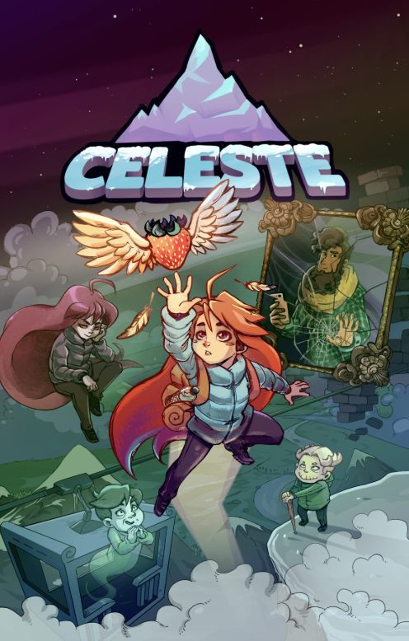

Figure 1: Celeste game

### Stray

I was also inspired by Stray. Stray is a third-person adventure game where players take on the role of a stray cat roaming the neon-drenched cybercity of the future. What I love about Stray is its environmental storytelling, using both location and interaction to describe story beats instead of dialogue-heavy cutscenes. The sense of exploration was incredibly immersed through how I played and interacted with either my environment or the inhabitants within the space. The relationship between the cat and a small, flying drone named B-12 added emotion to the game through companionship rather than heavy exposition. Fulling leaning into the fact that players can be a cat and playing the cat differently climbing, scratching, and annoying the robotic citizens of the city and my understanding of the personality and life of the space expanded. The design decisions here influenced environmental design and mood in my project, convincing me to think about integration of gameplay mechanics and world-building in our stories.

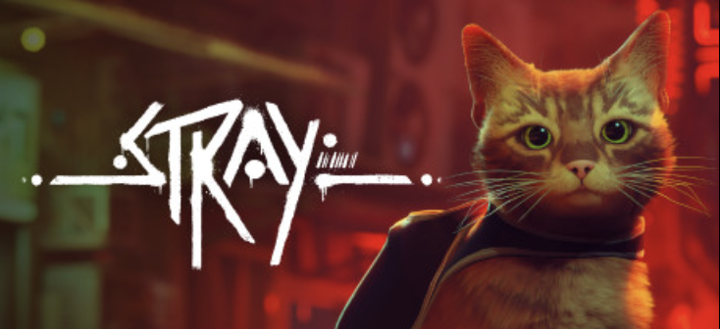

Figure 2: Stray

Therefore, These references aided us in determining the mood and mechanical behavior of PurrKour. We could ensure the narrative and game were seamlessly working together to create a meaningful and emotional experience. Themes about abandonment, perseverance, and facing things head on were referenced through game logic and game visuals, intentionally designed by genre convention.

# Topic, Research Question & Target Audience

* 1. Topic: PurrKour

A 2D platformer game created with pixel-art visuals that follows the emotional, physical and aesthetic journey of an abandoned cat in an unfamiliar urban environment by utilizing agility, instinct, and resilience. It is a movement-based game built on a strong narrative that explores themes of abandonment, trust, survival, and personal growth, while taking inspiration from independent success stories like Celeste and Stray, and combining parkour mechanics with emotional storytelling through minimalist visuals and pixel perfect aesthetics.

## Research Question

**In what ways do 2D pixel based games that contain an emotionally driven narrative and movement mechanics that allow emotions to be expressed, create immersion and player engagement we define as 'player engagement' in the context of indie platformers?**

This project examines how pixel based arts and movement design can be used to tell emotionally compelling stories. It is researching development tools that include GDevelop and Aseprite to be sure of technical feasibility and to stay within aesthetic parameters. It will also discuss frameworks to approach development, including genre conventions, visual storytelling options, and player psychology that would inform creating an immersive gameplay experience.

* 1. **Target Audience**

### Title

PurrKour

### Tagline

Each jump is a decision to stay alive.

### Genres

Platformer, Indie, Emotional Adventure

### Story Timeline

You play a stray cat who has been left behind in a decaying city. You are a willing participant who will platform, explore, and resist what this world threw at you to learn more about your past, meet characters/interfaces, and find value in the world that cast you away.

### Target Audience

Primary Group

* Age: 21-25
* Gender: All
* Location: Worldwide, more focused on an urban gamer, with access to indie games.
* Occupation: Students, young professionals, fans of indie games, creatives

Secondary Group

* Age: 16-20
* Gender: All
* Location: Worldwide
* Occupation: Gaming students.

### Common Interests:

Indie games, emotional narratives, pixel-art, cats, parkour, narrative games.

### Opinion

Compassion, resistance, self-discovery, connections.

* + 1. Beliefs

An appreciation of games developed with heart, support for small developers, belief in the power of a narrative in games as an artform.

* + 1. Expectations

Gamers will leave emotionally connected to the main character and reflective upon their journey. They will experience tight, responsive controls combined with emotional storytelling that will generate empathy. They will explore themes of survival, growth, and healing all conveyed indirectly, but rather through movement, level design, and visual cues. PurrKour seeks to leave a lasting legacy by taking a simple story about a stray cat and turning it into an allegory for human struggle and victory.

# Resources

## Software to be used

### G-develop:



Figure 4: G-develop application

GDevelop can provide more possibilities to create games without having to write single code or limit the types of games that can be created (for example 2D, 3D, or multiplayer).

For this project, creating this game primarily used GDevelop. The game logic is implemented, levels looted, user interaction included, and even the game mechanics such as very basic movement, collision detection, and enemies AI have been controlled using GDevelop.

(gdevelop, 2025)

### Aseprite

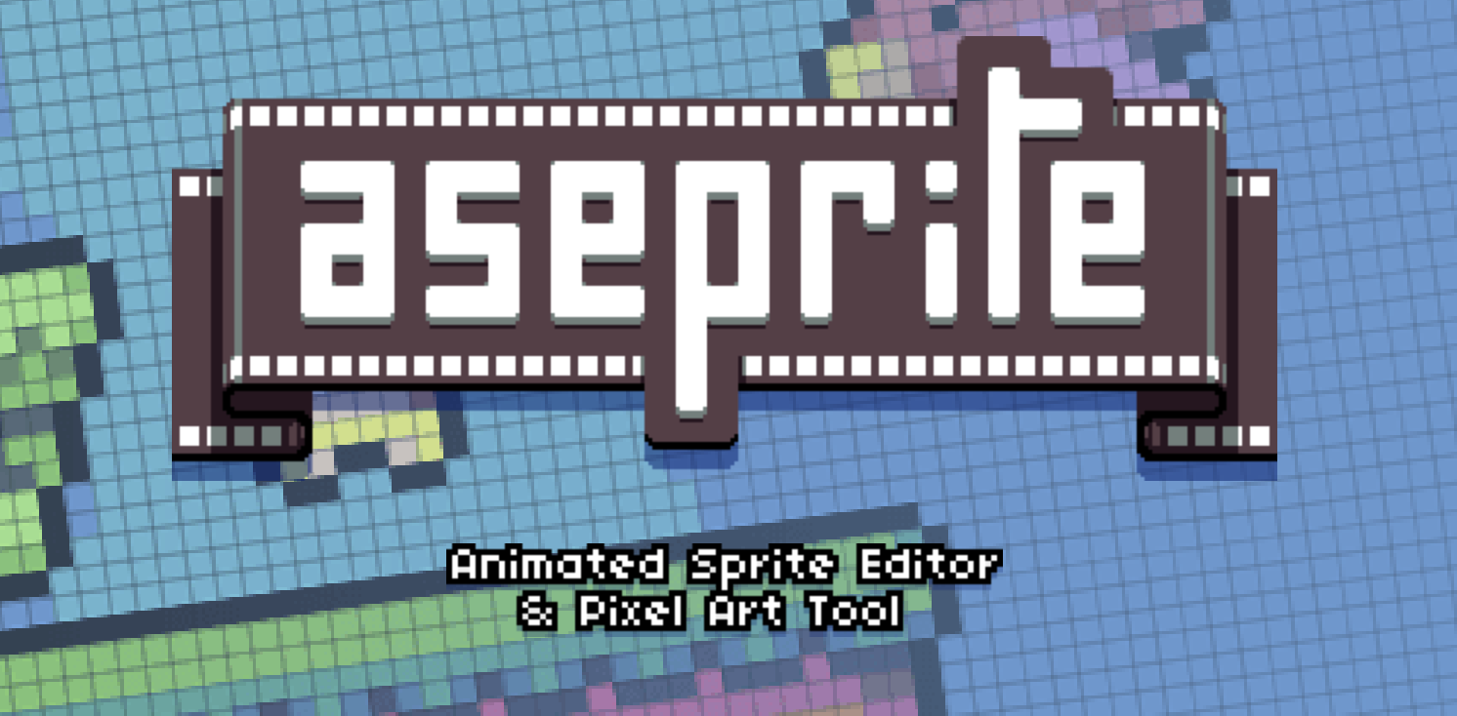

Figure 5: Aseprite

Aseprite is a program that allows you to create 2D animations for video games. Produce sprites, pixel-art, retro-style graphics, and everything one can imagine about the 8-bit and 16-bit era.

For this project, characters have been designed visually, together with the environments and other assets, in the pixel-art style Aseprite. The tool not only contributed much to visual consistency throughout the game but also gave life to the characters and the world through animations and visual storytelling.

(aseprite, 2025)

## Hardware Tools

### XP-Pen Deco Pro

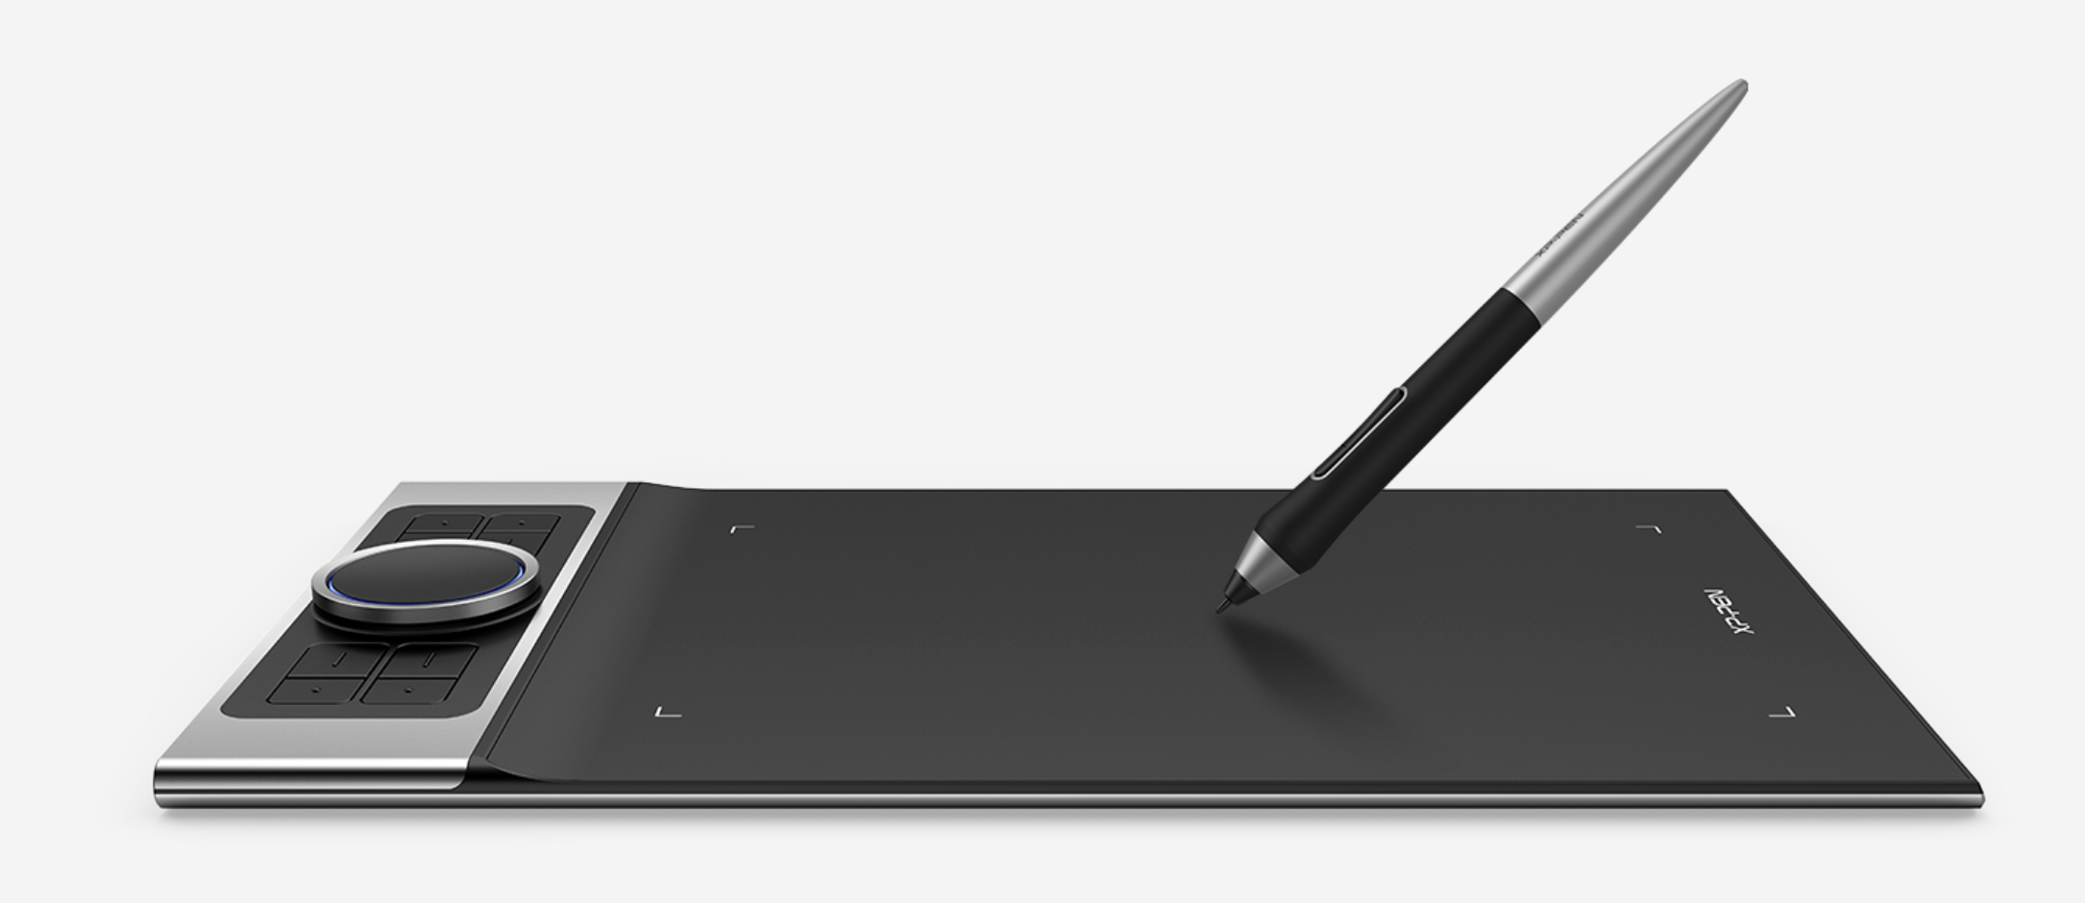

Figure 6: XP-Pen deco pro

* Pressure Sensitivity: 8192 levels
* Resolution: 5080 LPI
* Connectivity: USB-C, Bluetooth (on select models)
* Compatibility: Windows, macOS, Android
* Active Area: 11 x 6 inches

(XP-pen, 2025)

### Lenovo Legion 5

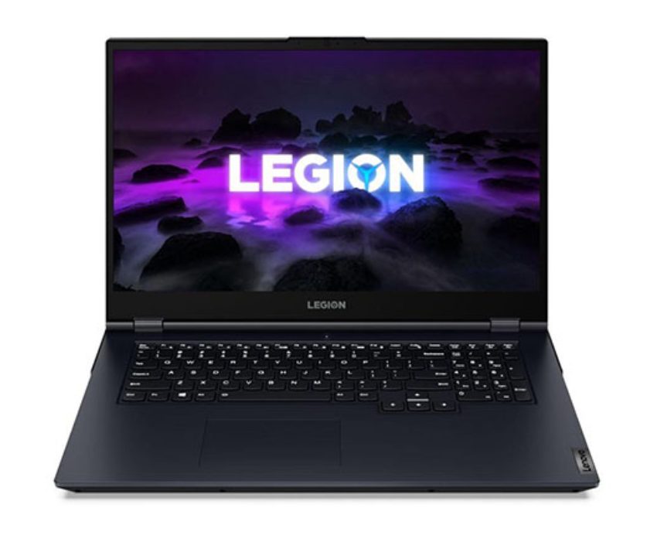

Figure 7: Lenovo Legion 5

* Operating System: Microsoft windows 11
* CPU: 64-bit Intel
* RAM: 512 GB
* Processor: AMD Ryzen 7 7735HS

(gadgetbytenepal, 2025)

## Websites used

### Pinterest

* Reference collection

### YouTube

* Game development tutorials

### Google Form

* To create survey form

# Product Research

## Game Development

To create a game in Gdevelop which is a no-code, open-source and an easy game engine, the following tutorial was followed.

YouTube Link: <https://youtu.be/mckuSpr8vio?si=L0Ye98EbCzqhHbqp>

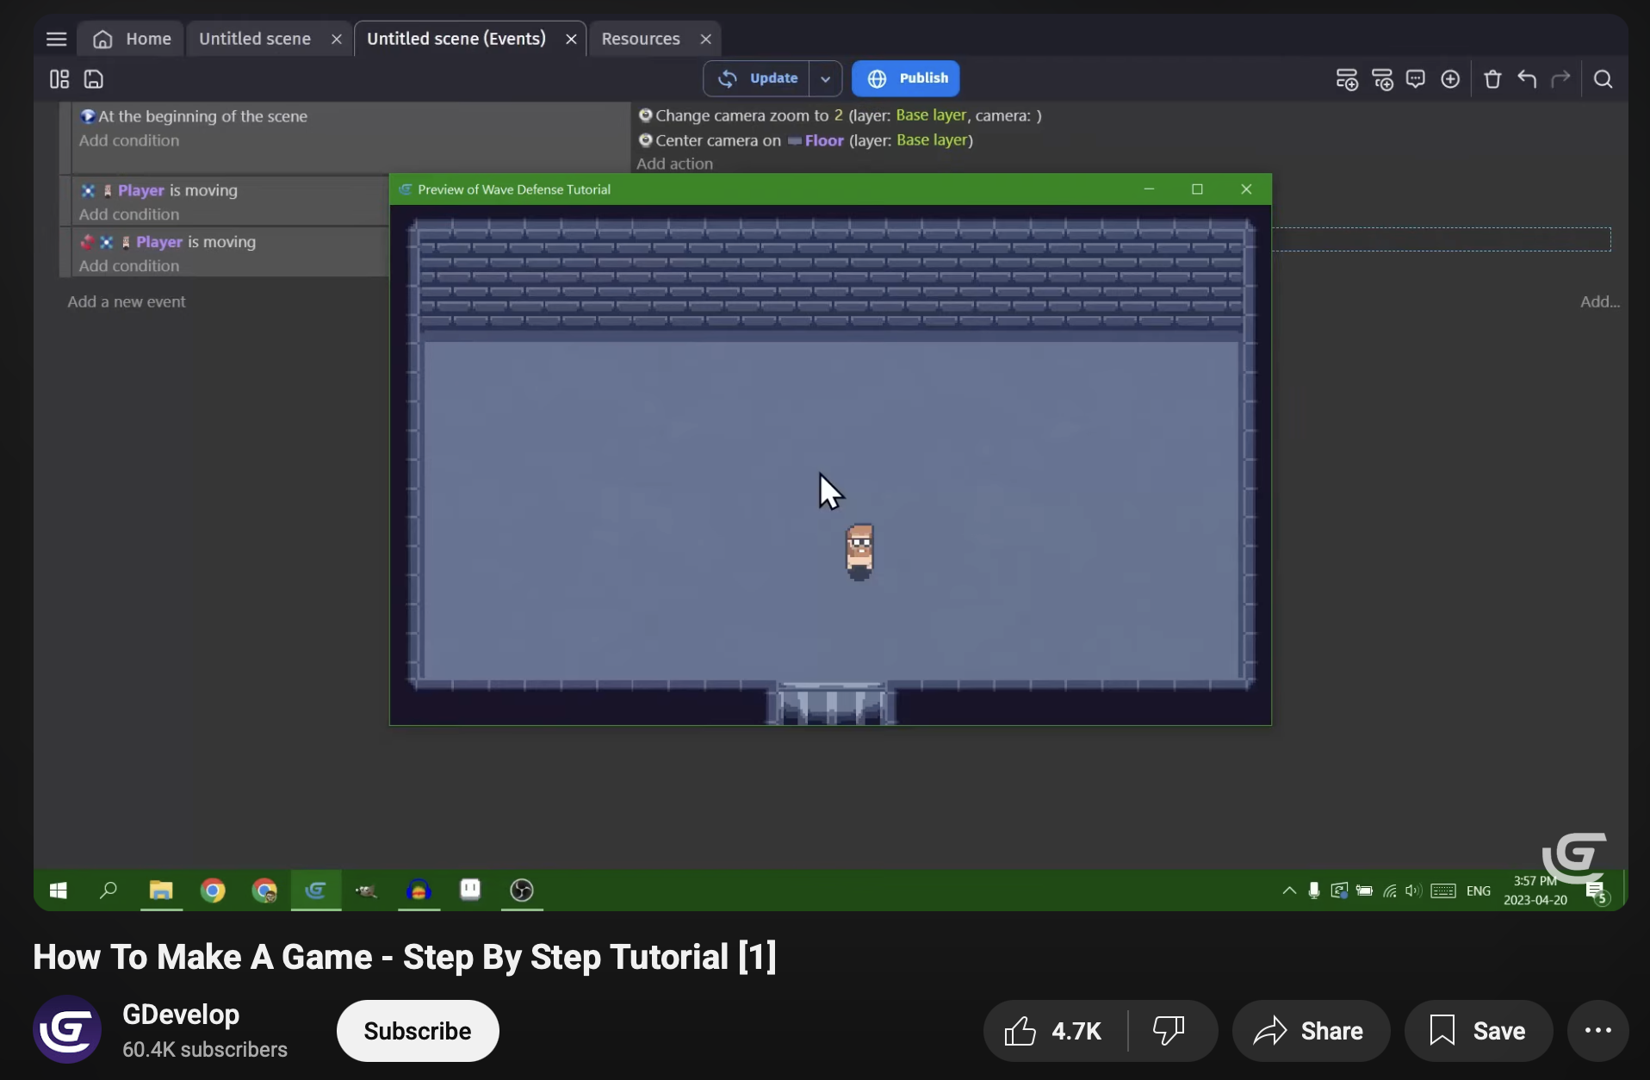

Figure 8:Research on game development

(GDevelop, 2025)

## Health Bar

To create a health bar on enemies to execute them by the protagonist, the following tutorial was followed.

YouTube Link: <https://youtu.be/HagU5uA0vxM?si=NlvpQ0QOUT0Dht_E>

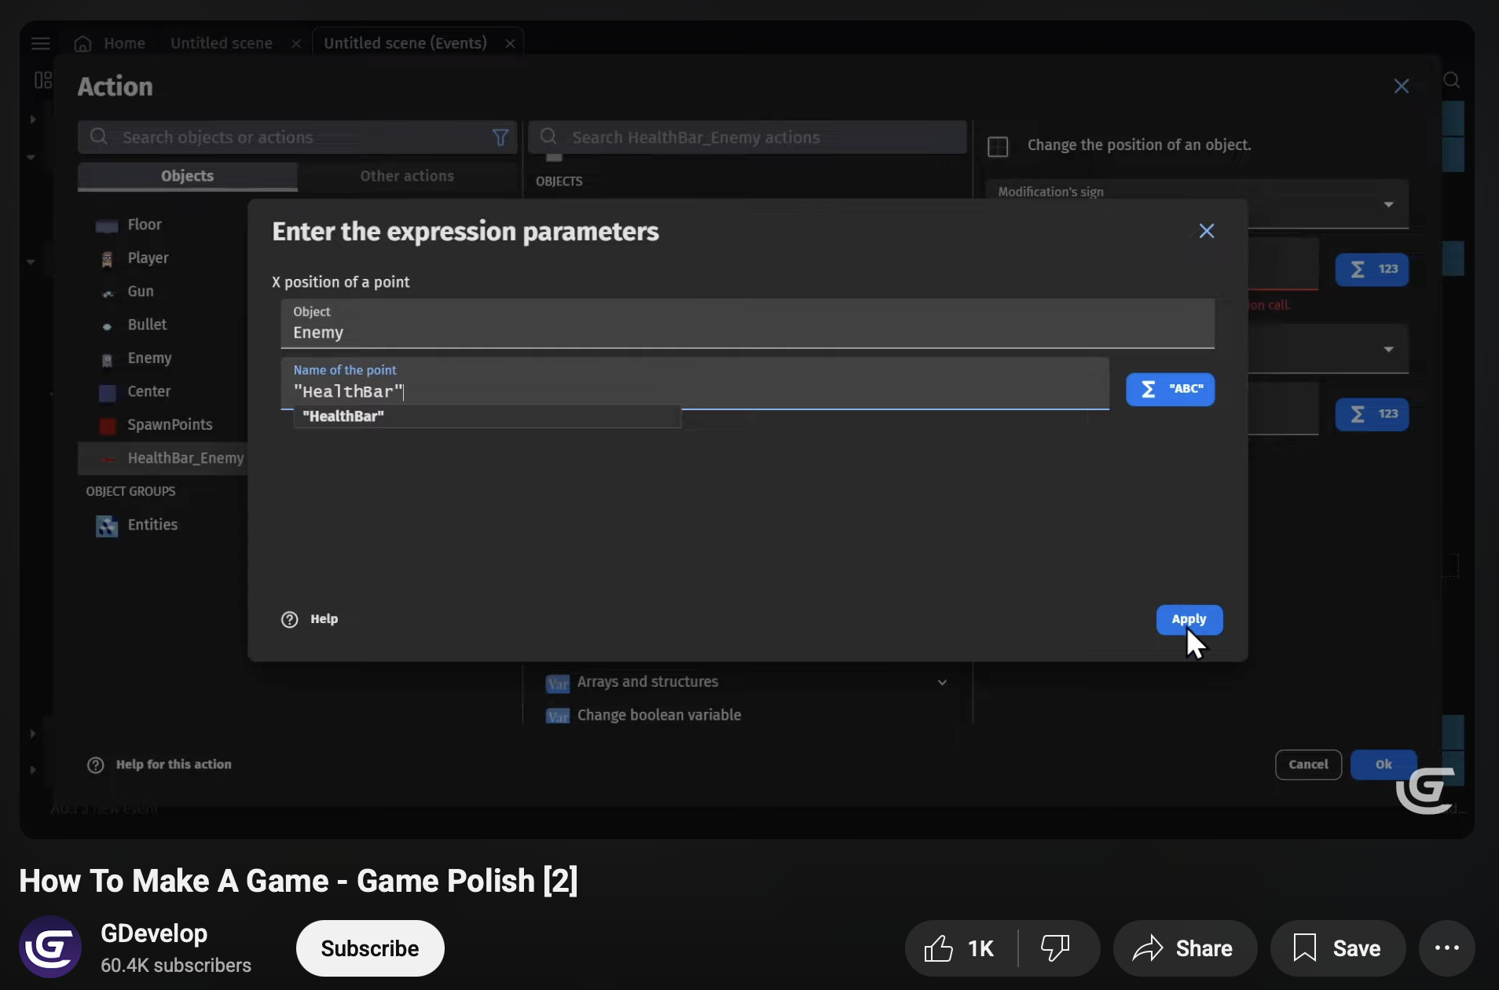

Figure 9: Research on implementation of health bar

(GDevelop, 2025)

## Patrolling Enemy

To create a multiple platformer behaviour enemy to attack on the protagonist, the following tutorial was followed.

YouTube Link: <https://youtu.be/0aGBYsrGwm0?si=euO3_D6MH4gUOLqR>

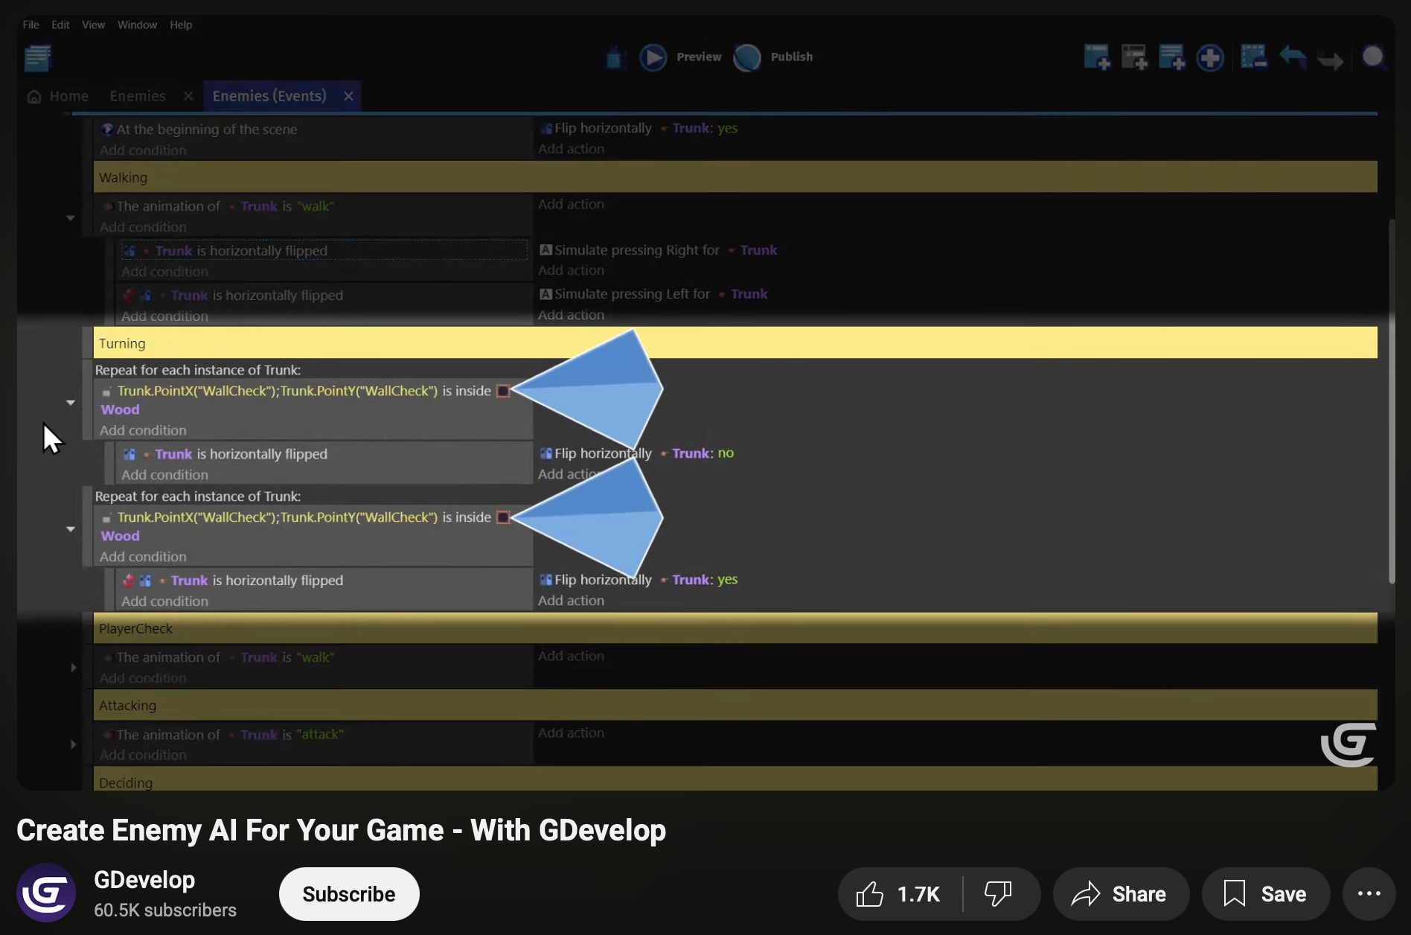

Figure 10: Research on implementation of patrolling enemy

(GDevelop, 2025)

## Creating a platformer game

The various movements such as jumping and move left and right for both the enemy and protagonist without coding were created following the tutorial below.

YouTube Link: <https://youtu.be/Li4vhL1bXLc?si=G7XtHTD9TUbop4vF>

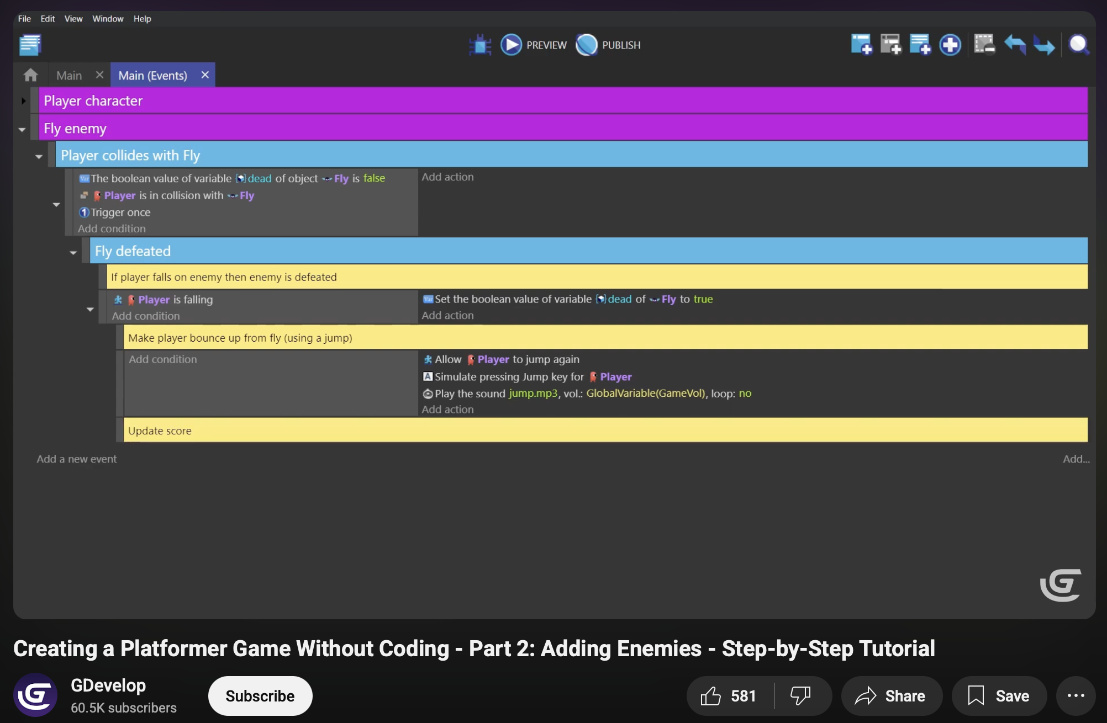

Figure 11: Research on implementation of platformer game

(GDevelop, 2025)

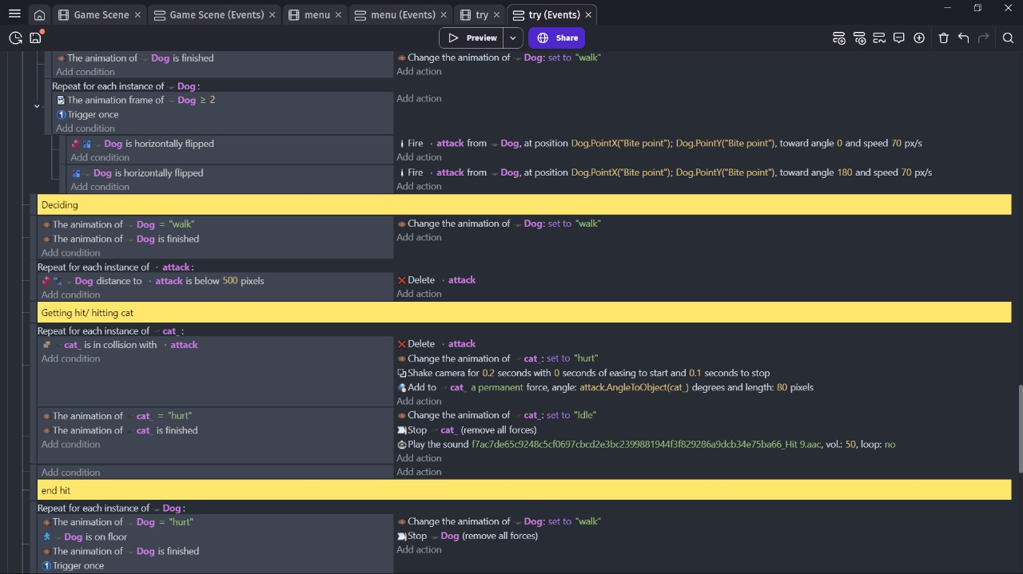

Figure 12: Implementation of platformer game without coding

# Project Plan

The revised Gantt charts make it clear that there have been significant changes to the production phase that have now cascaded to the post-production period. The main factor was the amount of time it took to design and animate the pixel-art assets, particularly the time it took to animate the parkour movement and environmental interactions of the cat. In addition, completing the sound effects and background music took an unexpected amount of time, largely due to the sourcing and editing of audio. The delays in level development and testing, due to the revisions made in production, have reorganized the project timeline and in turn altered the post-production plan.

## Previous Plan

### Pre-Production Gantt Chart

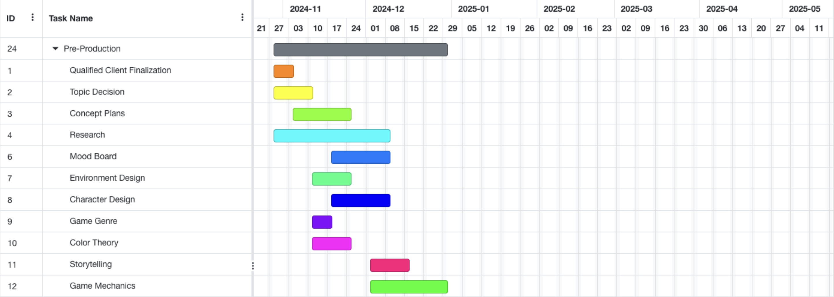

Figure 13: Pre-production gantt chart

### Production *Gantt Chart*

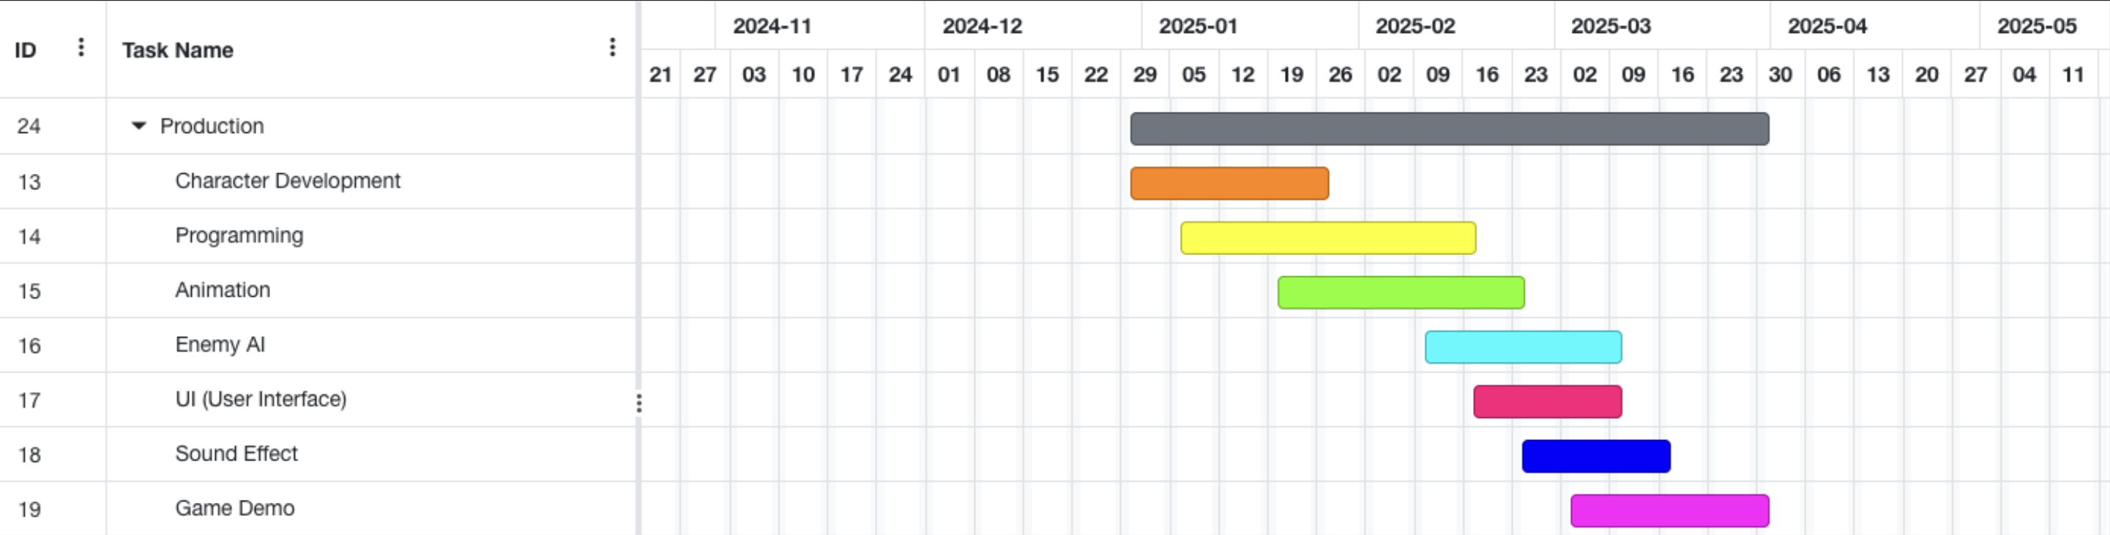

Figure 14:Production gantt chart

### Post-Production Gantt Chart

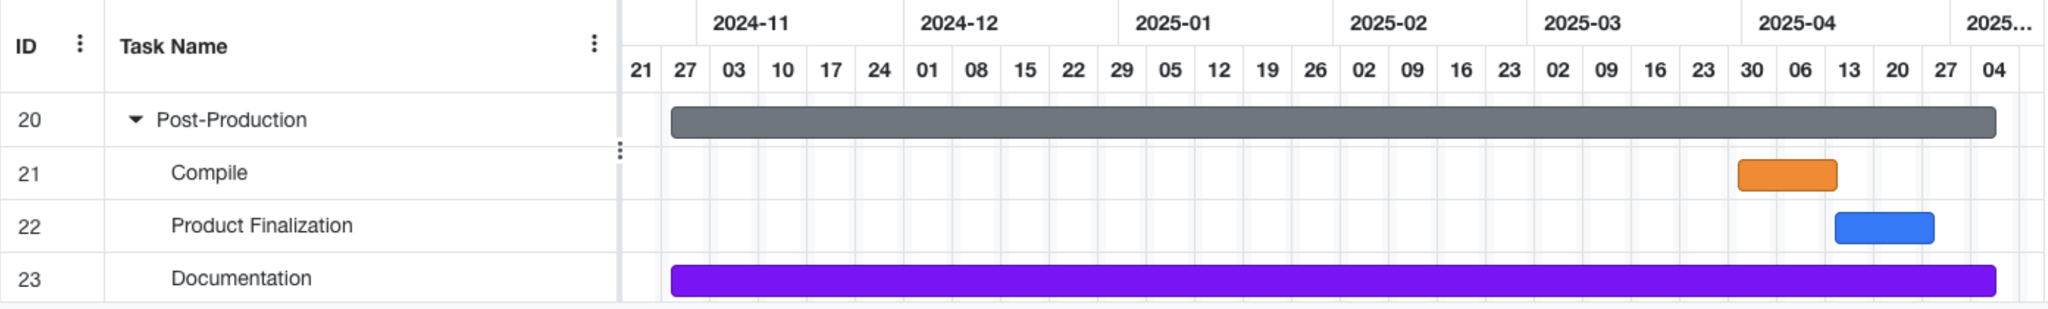

Figure 15:Post-Production gantt chart

(onlinegantt, 2025)

## Current Plan

### Pre-Production Gantt Chart

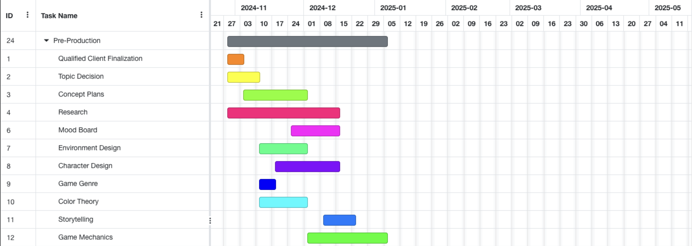

Figure 16: Pre-production gantt chart

### Production *Gantt Chart*

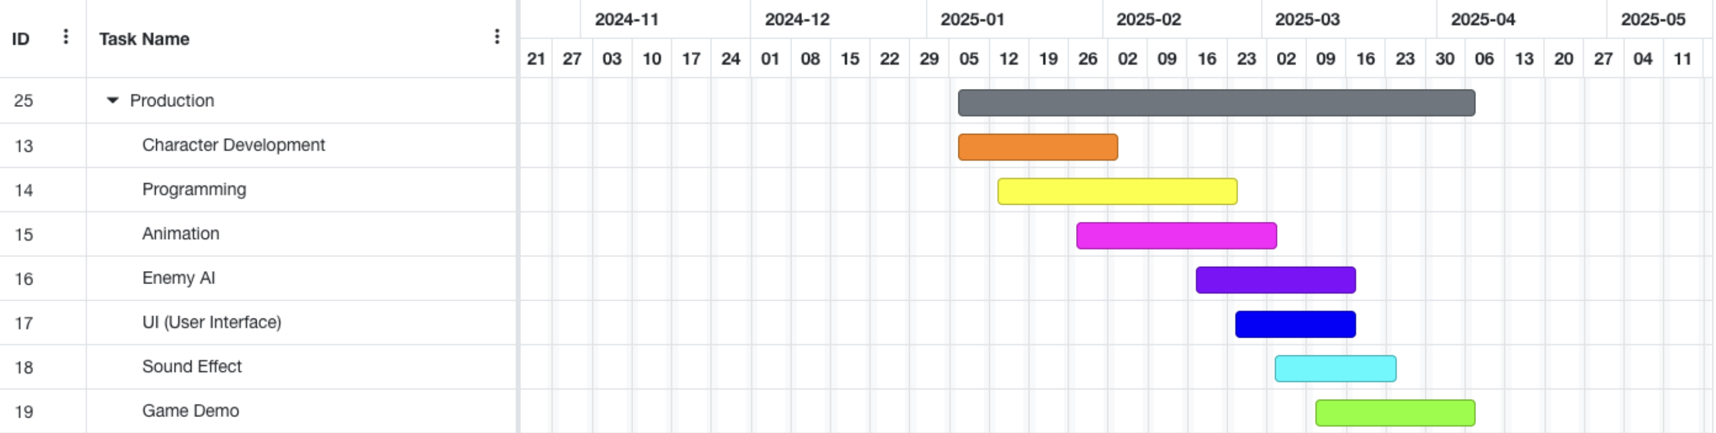

Figure 17: : Production gantt chart

### Post-Production *Gantt Chart*

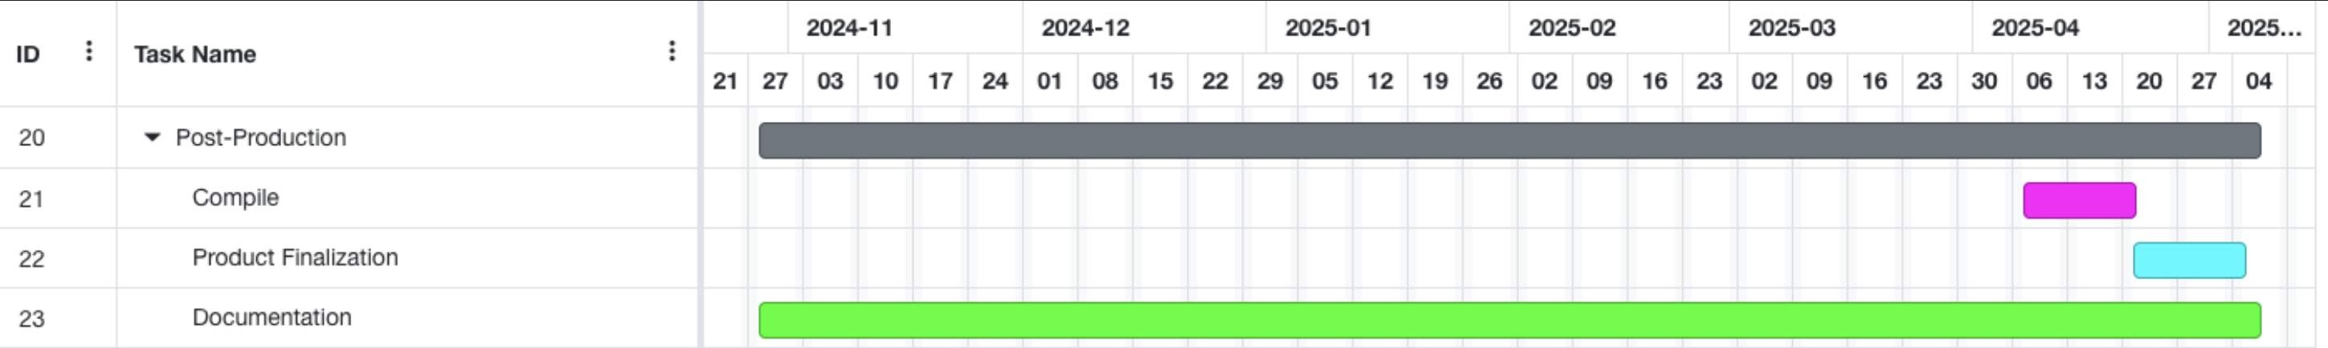

Figure 18: Post-production gantt chart

(onlinegantt, 2025)

# Pre-production Phase

## Character Design

The character design approach was consistent with the client's brief. The client asked that the design be "simple, relatable, and utilitarian" with the narrative. The cat, dog and enemy reflected the description of "very typical but also quietly driven."

In Aseprite, I designed these characters in earth tones that fit with the palette of the environment. The palette of colors used here made the characters feel appropriate and true to the game world. In terms of the limitations of the pixels we needed to keep in mind.

Details, such as the red collar for the cat and the angular posture and red eyes of the dog, help define traits that give the characters distinction and personality while staying within the limitations of pixel art. I created a turnaround sheet and a number of key poses for characters to experiment with expressiveness and momentum while defining the same pixel grid. These designs represented the client’s vision for characters founded in nostalgia yet existing in a semi-realistic, emotional space.

Given below are the screenshots of character designing process;

## Development process

### Dog Character

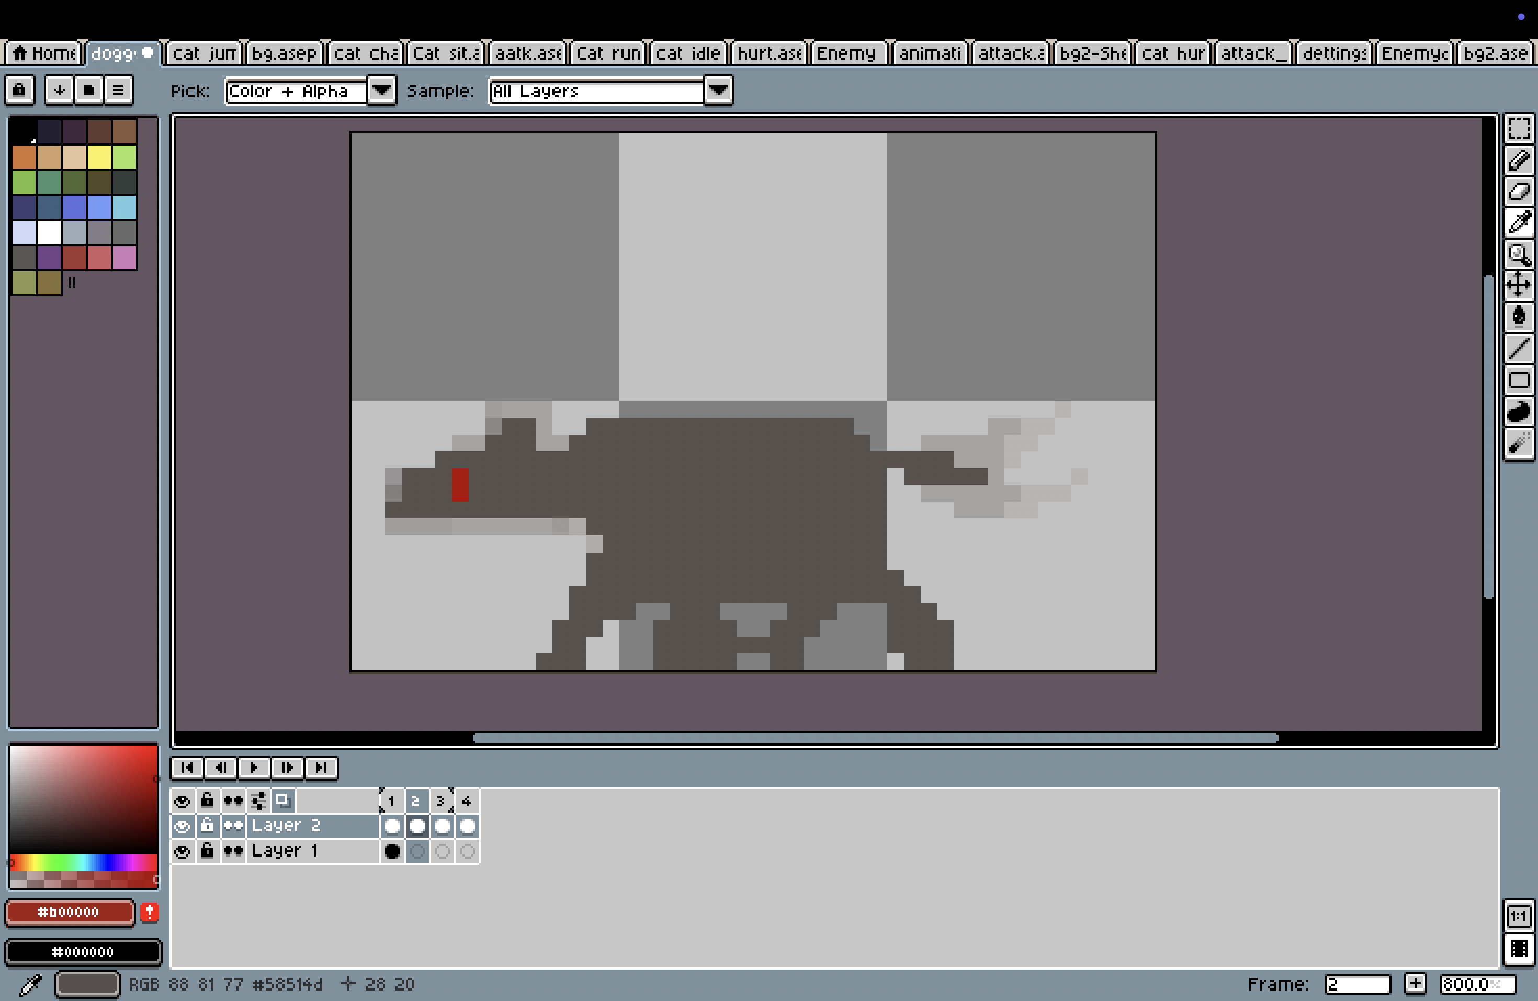

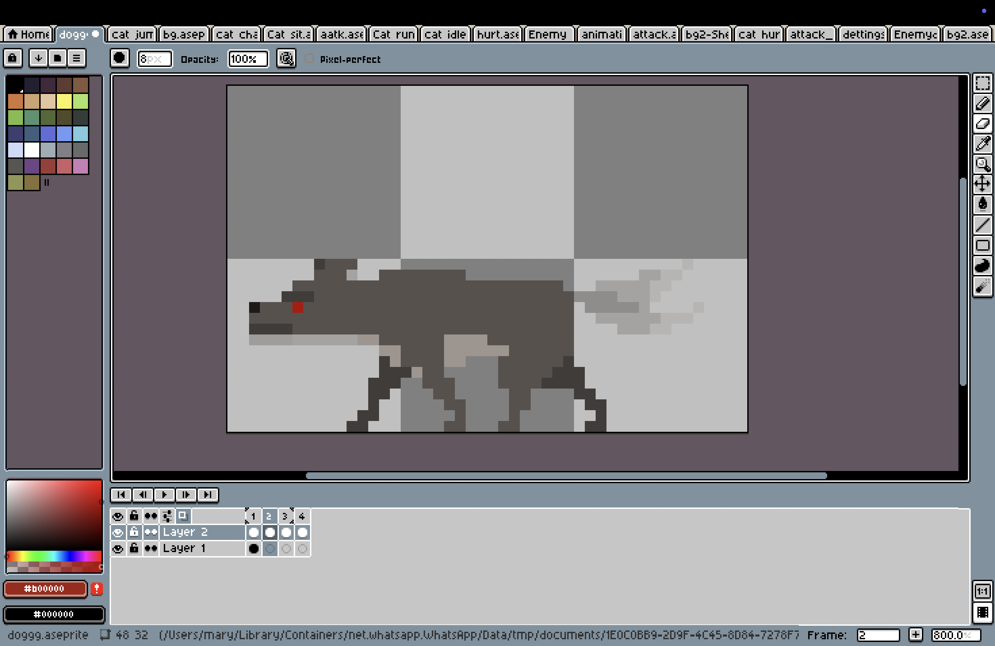

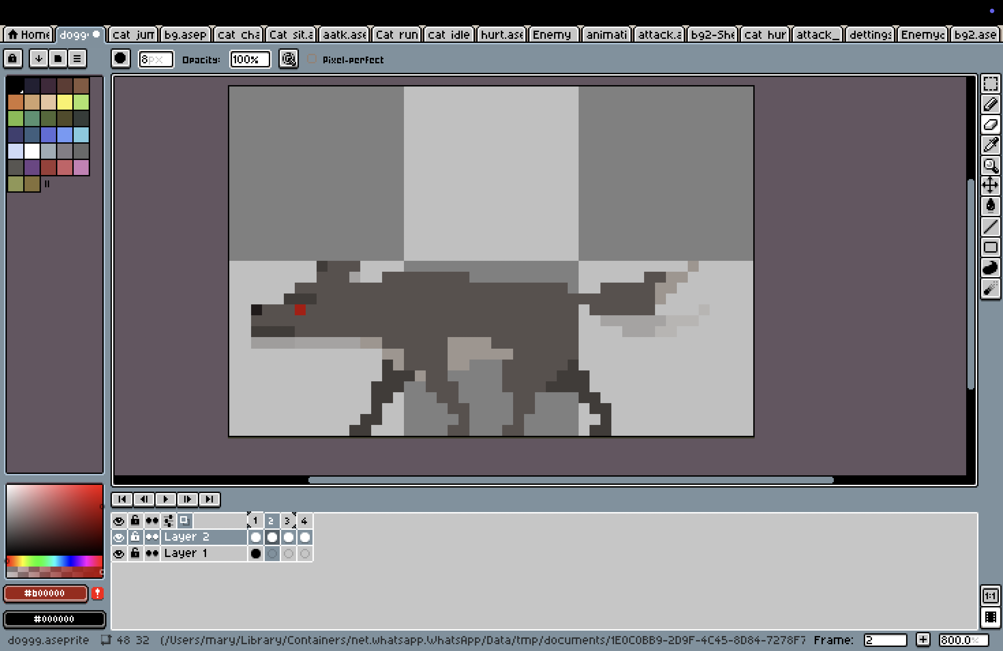

Figure 19: Process of enemy design

### Main cat character (Front and side view)

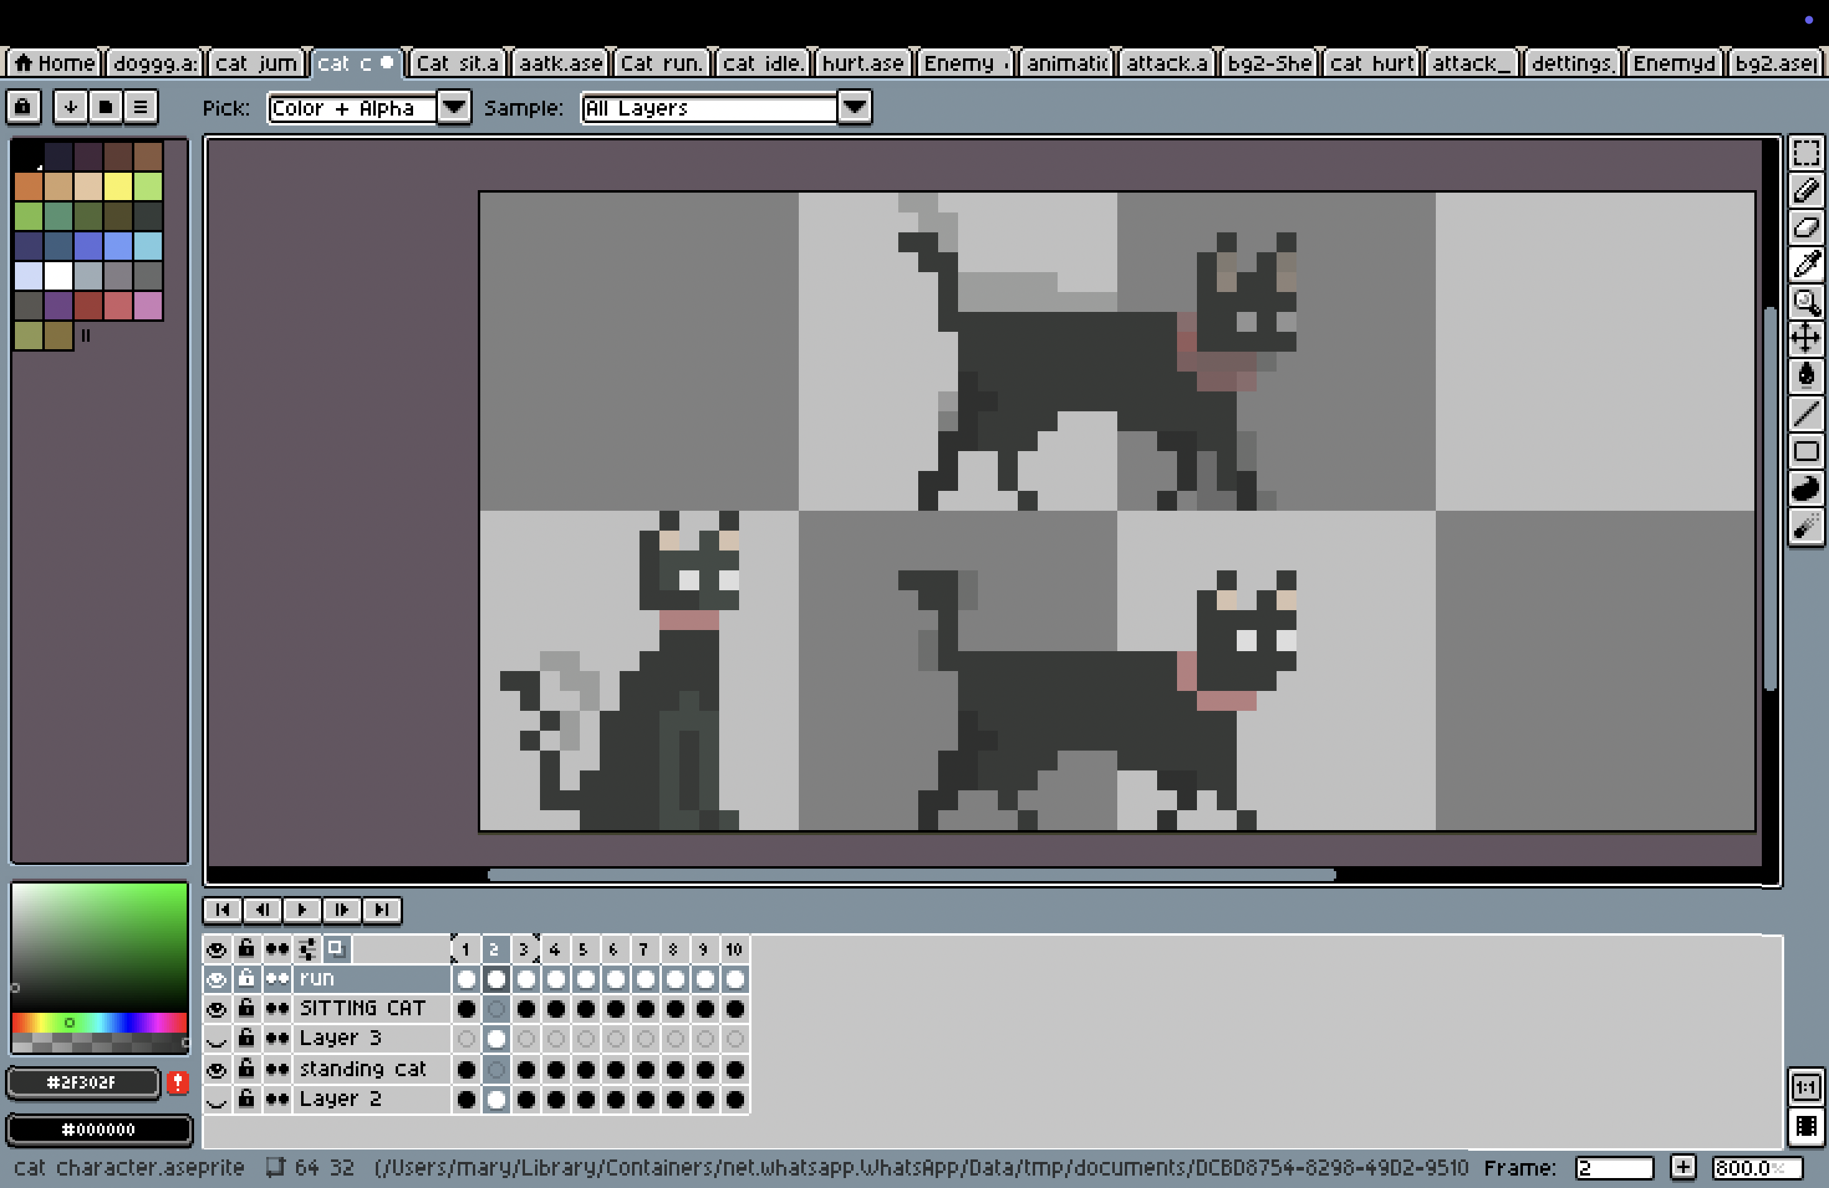

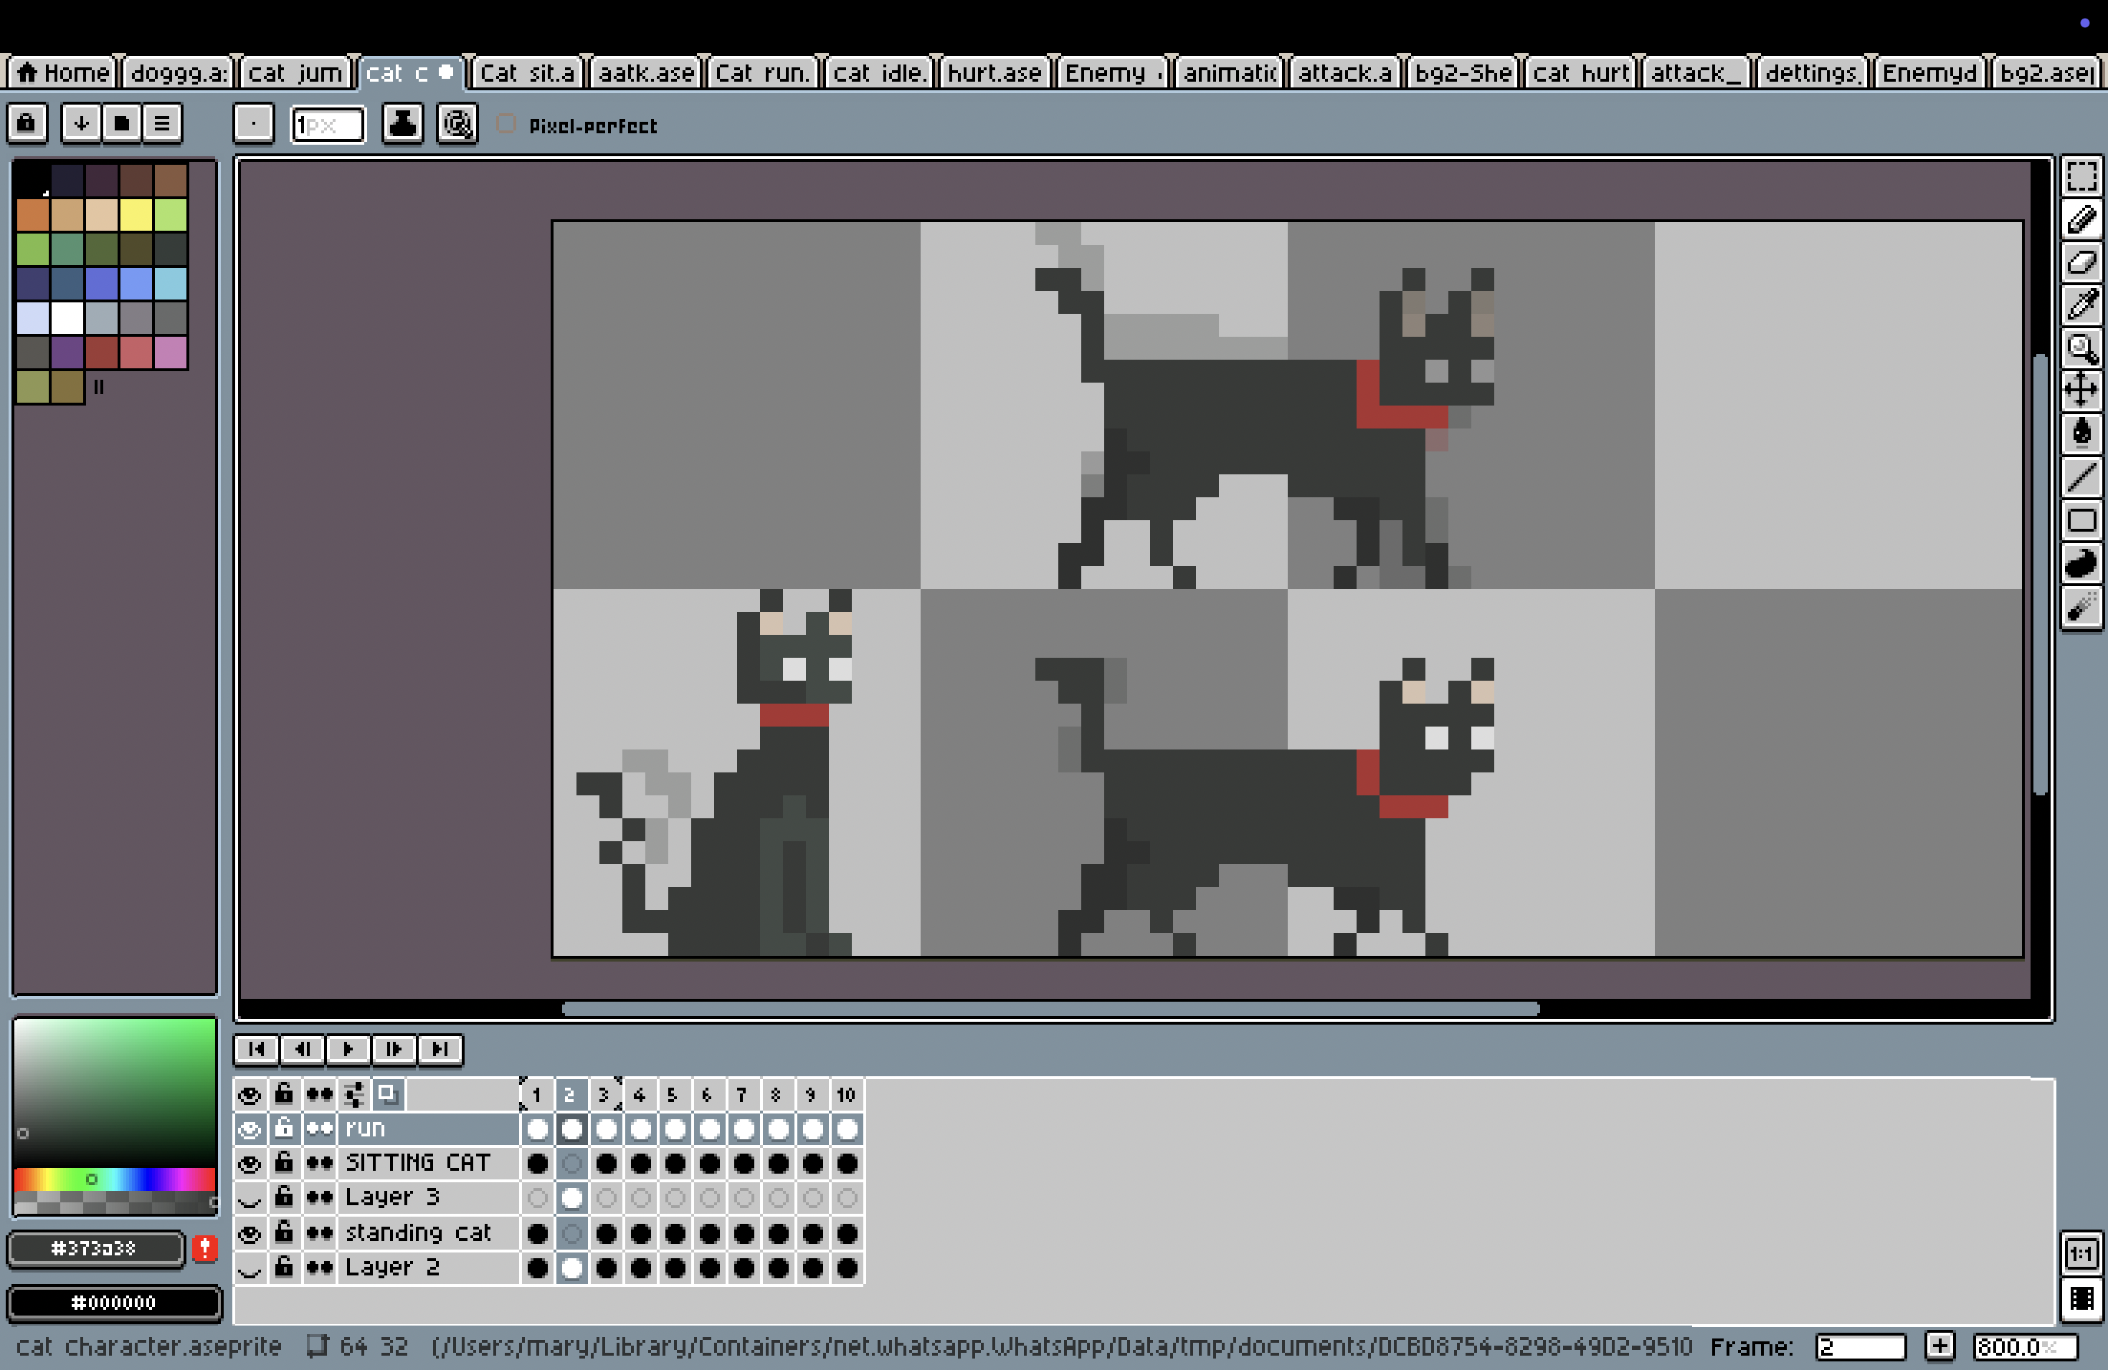



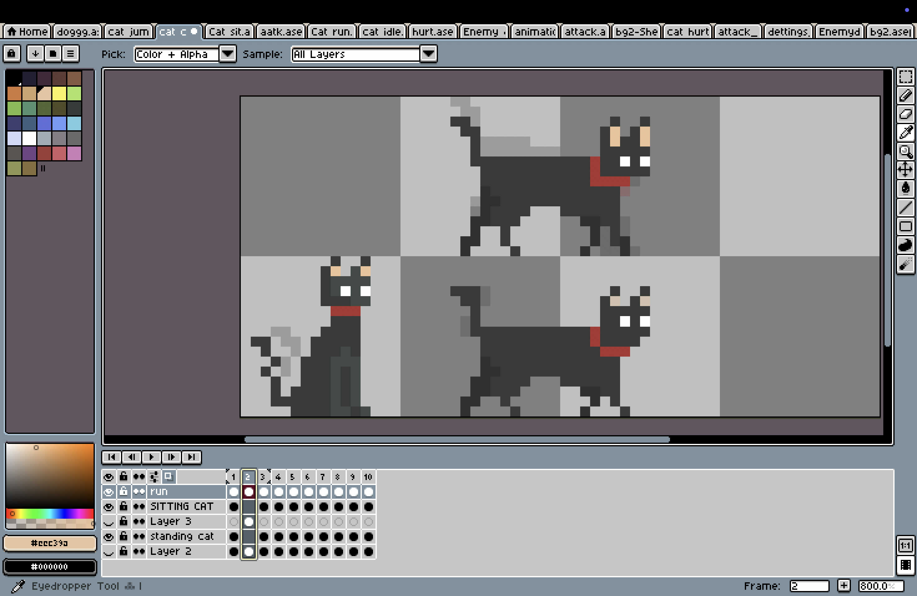

Figure 20: Process of cat design

### Cat hurt

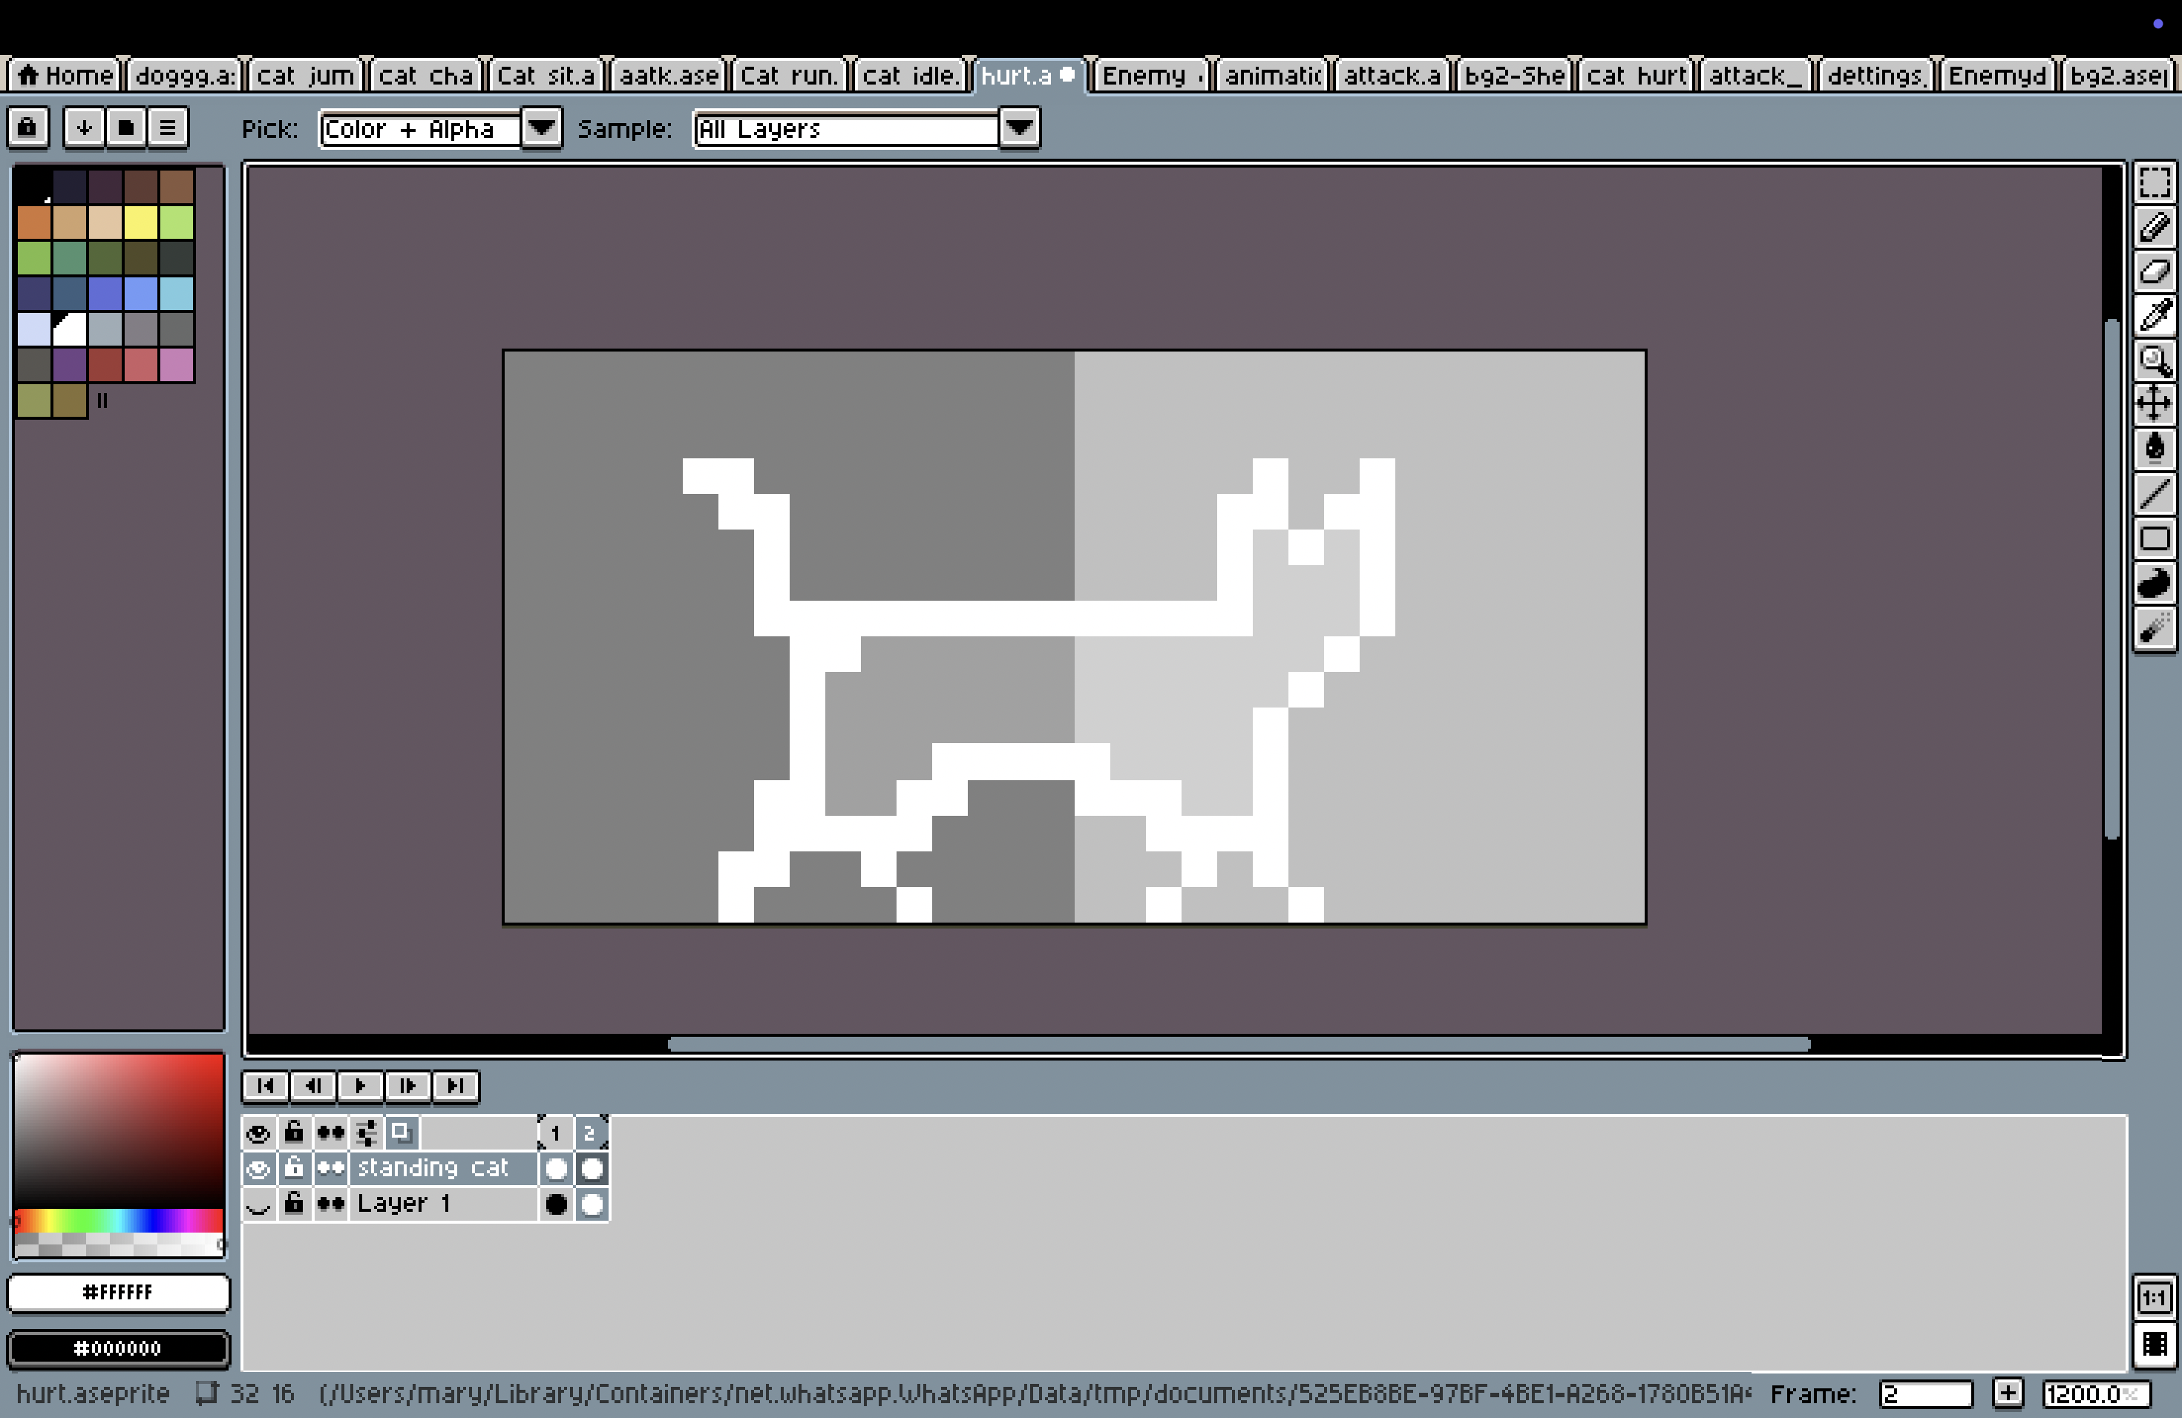

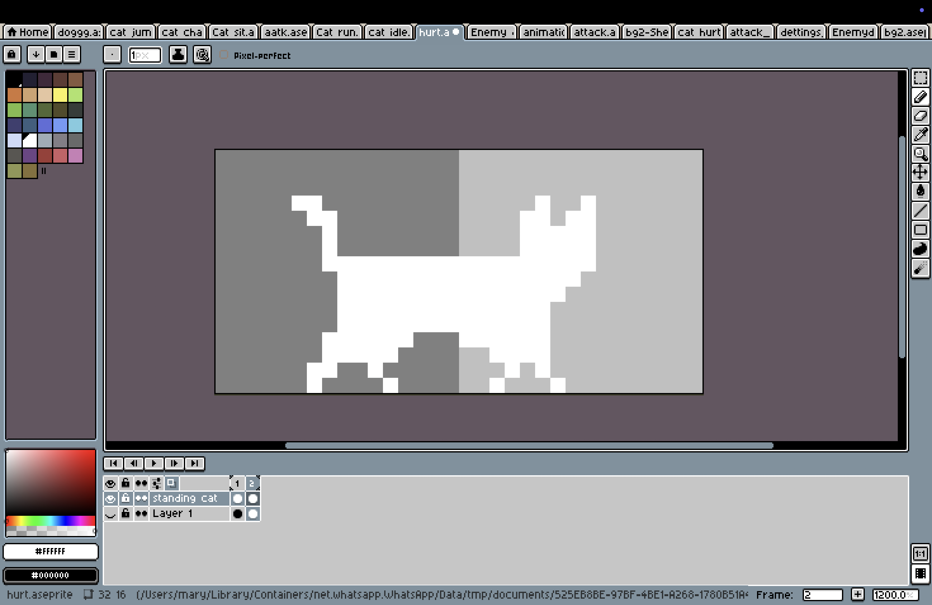

Figure 21: Process of hurt cat design

### Enemy character

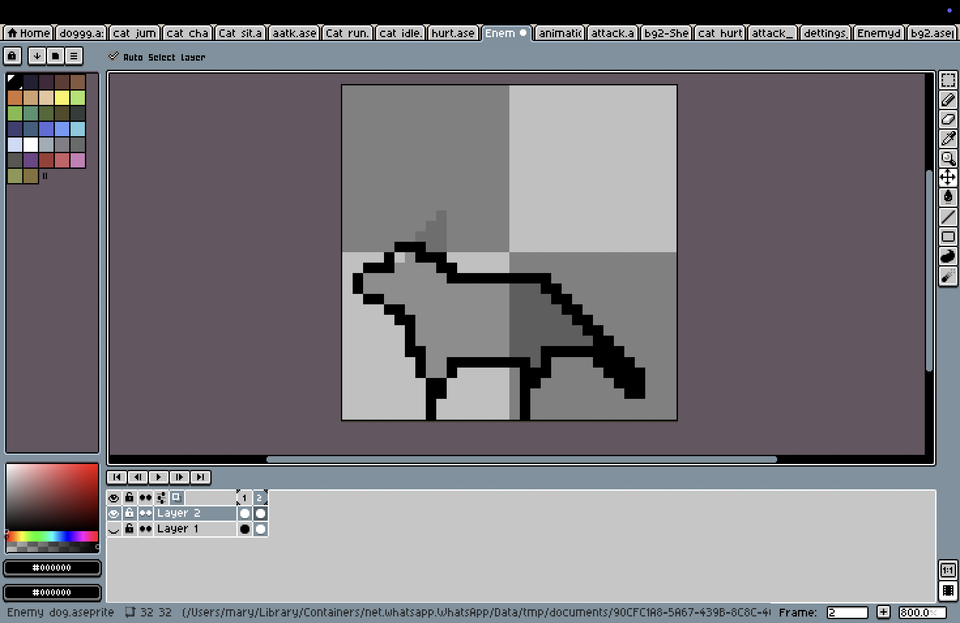

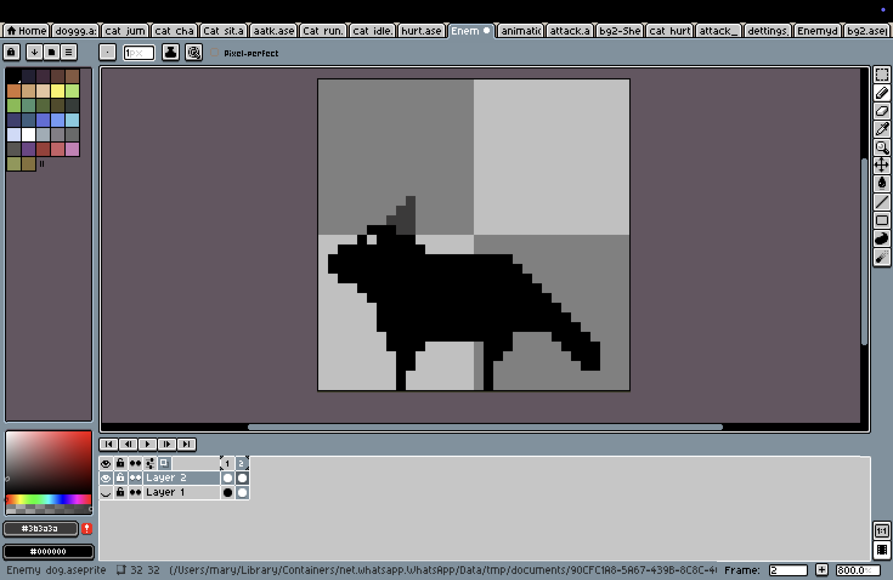

Figure 22: Process of enemy character design

### Footpath

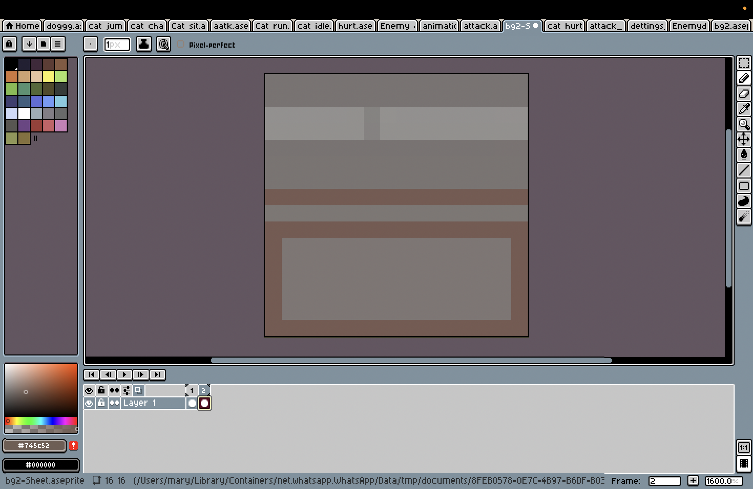

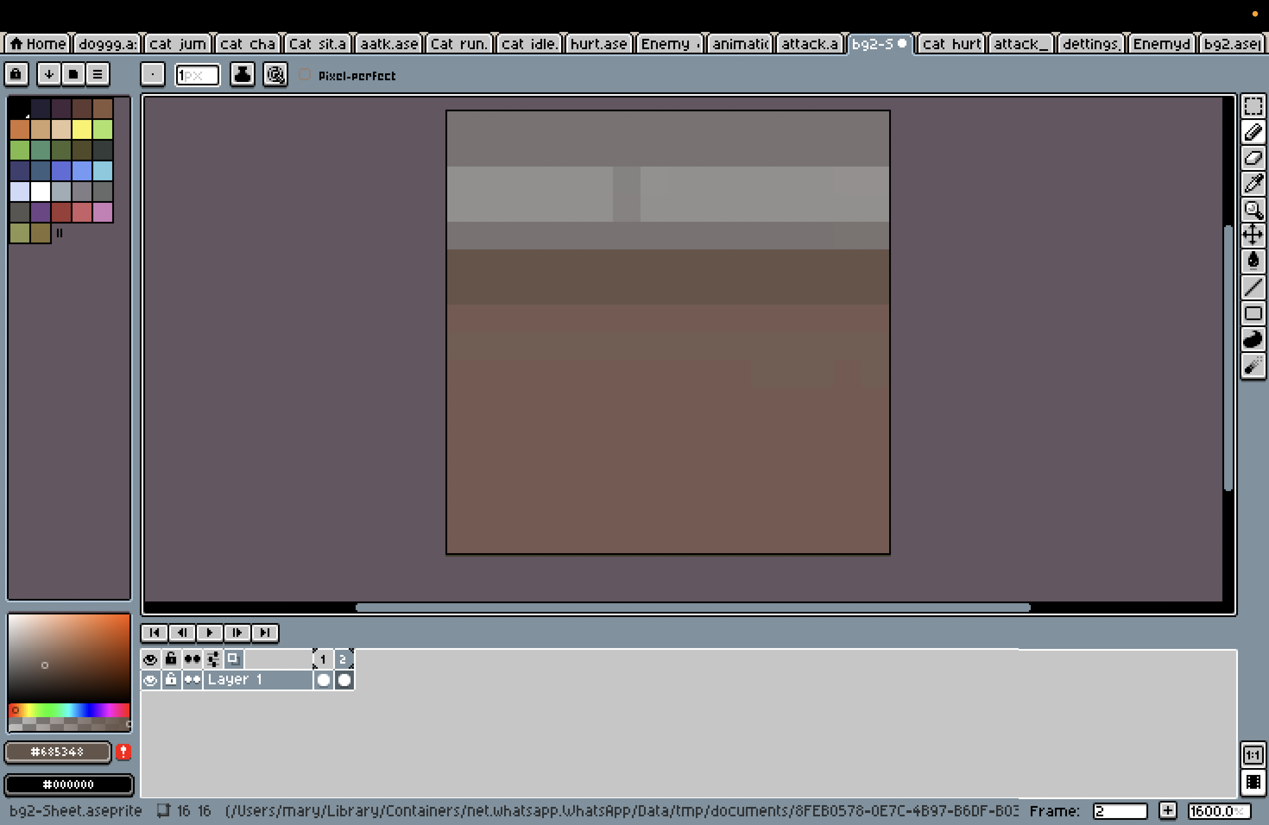

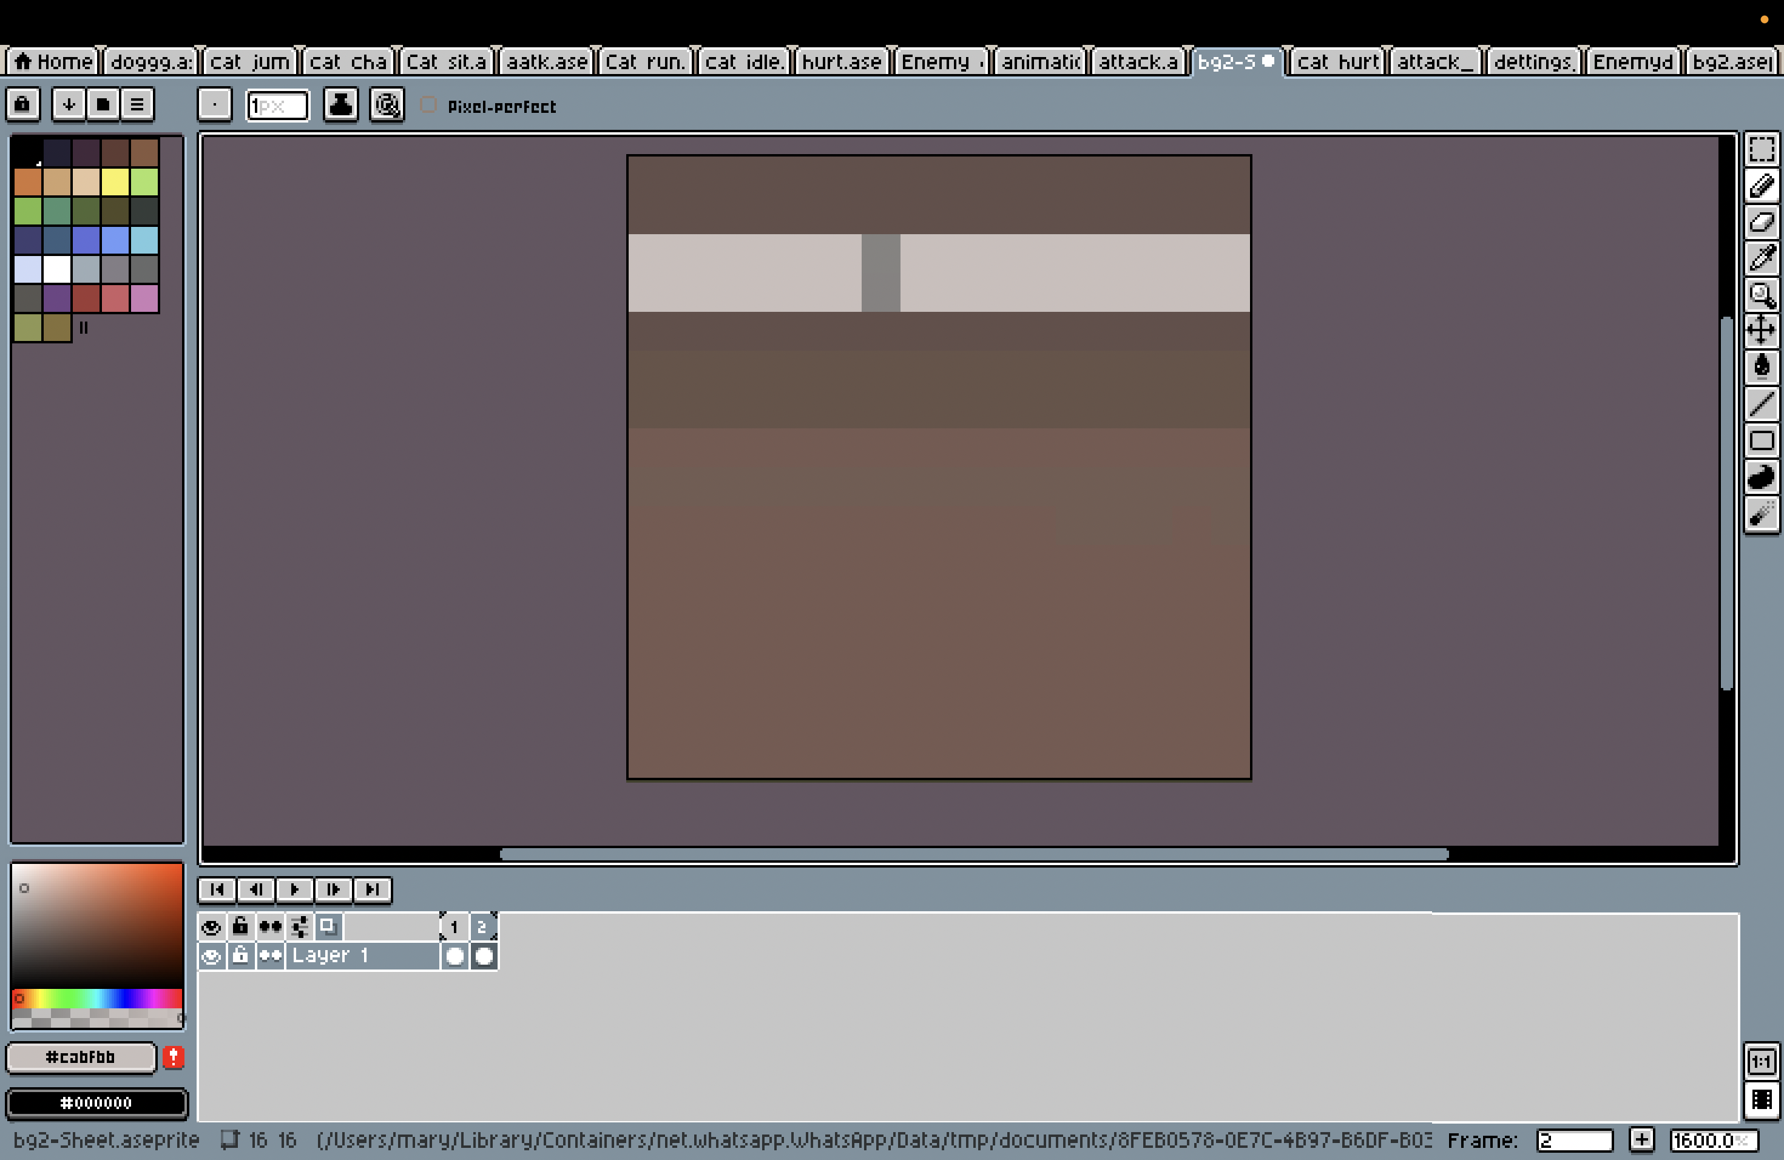

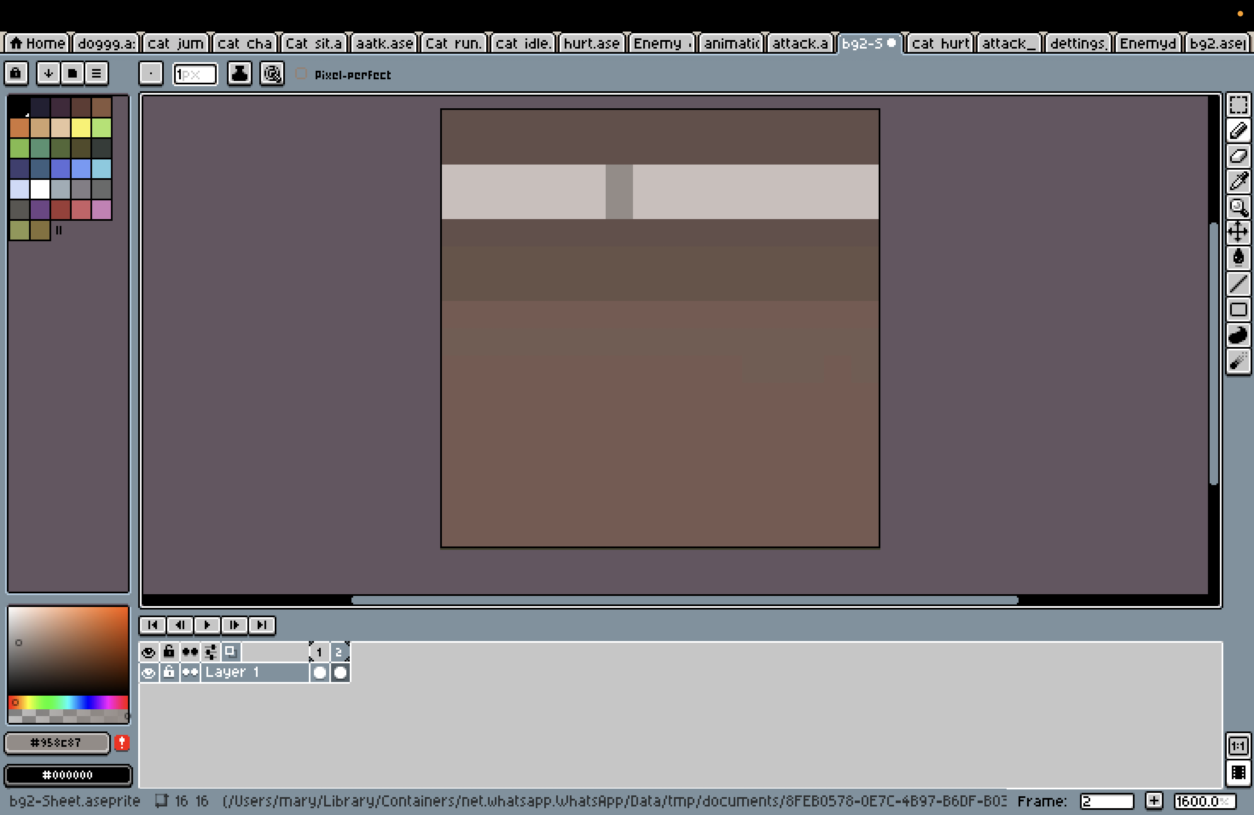

Figure 23: Process of footpath design

### Settings Button

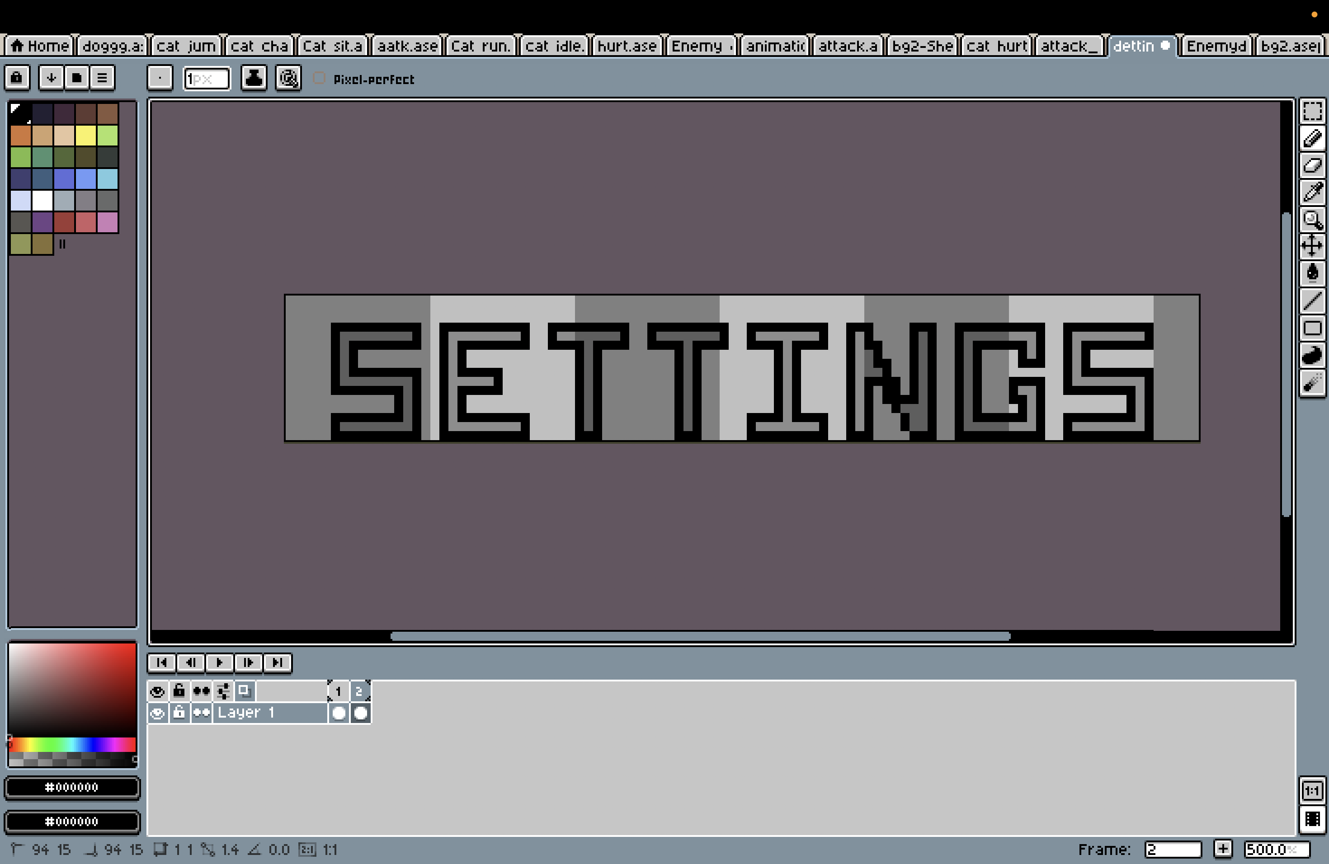

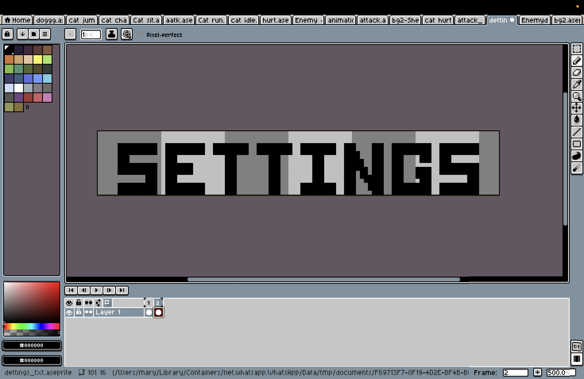

Figure 24: Process of setting button design

## Colour theory

Upon the client's request for a grounded yet nostalgic feel, color theory was vital to producing the game’s visual feel. With a brief conversation explaining that they were looking for a semi-realistic urban setting that was slightly worn down, muted earth tones were chosen. Colors such as brown, olive green, dusty beige, and slate grey were consistently used to suggest age, decay and history in the environment. These elements help support the secondary emotional tone in the story without being overpowering. Color palettes were first tested using swatch trials in Aseprite before being finalized. The amount of neutral and warm tones also aide in presenting the interactable elements without overloading the player visually.

(coolors, 2025)

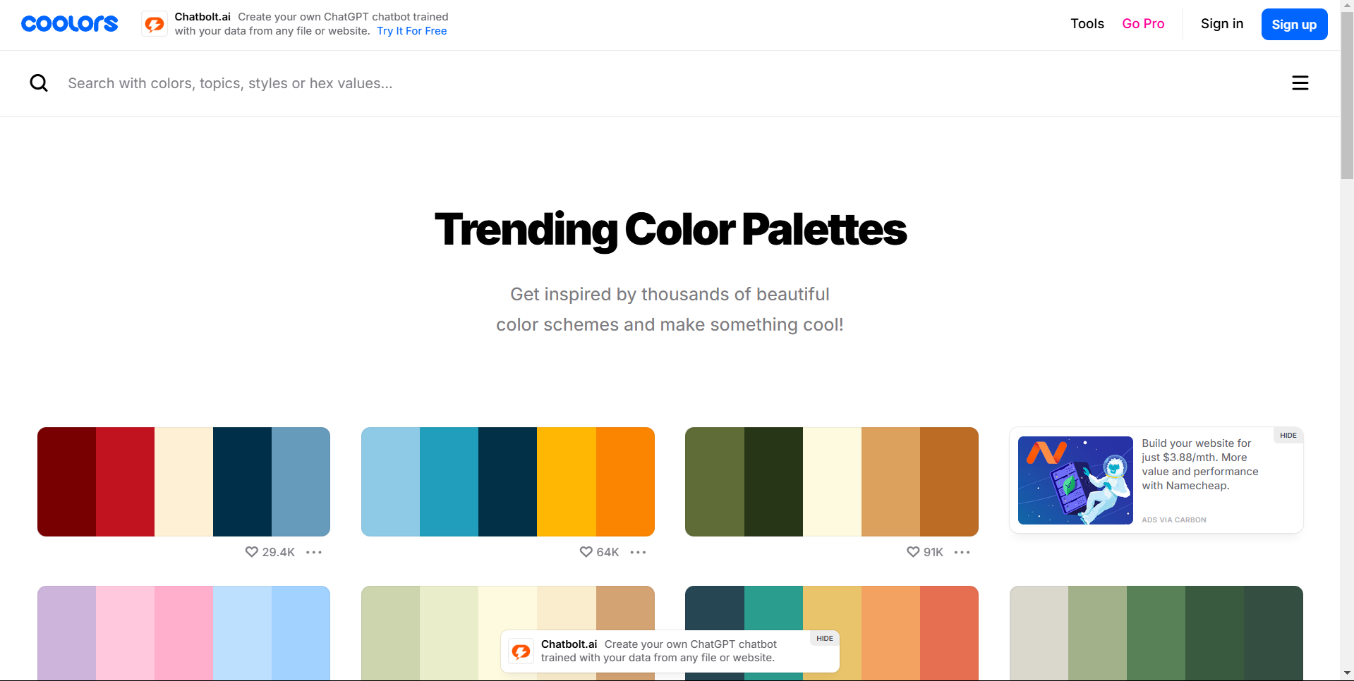

## Mood Board

In following the client's desired tone, a mood board was collected with a selection of pixel art references, modern urban environments, and everyday street views. Pinterest boards and pixel art forums were referenced to explore how artists convey life and realism in relatively small resolutions evoking atmosphere through lighting, composition, and texture. The client expressed an interest in environments that felt "regular, but emotionally textured" guiding the selection of imagery of vibrant shop signage, humble houses, roadside furniture, and architectural detailing. Impromptu visual voyages with extra detail (characteristics) like laundry hanging on lines, bicycles everywhere, and hand painted sign writing. All these reference materials guided the environments that felt believable yet had a visual expression of itself without excess complexity. Ultimately, the reference materials helped build an environment that made an emotional connection as intended.

Pure ref was used to make the mood board for the sake of this DMP. It was an essential part of the work as this is used as the reference to set the tone of game.

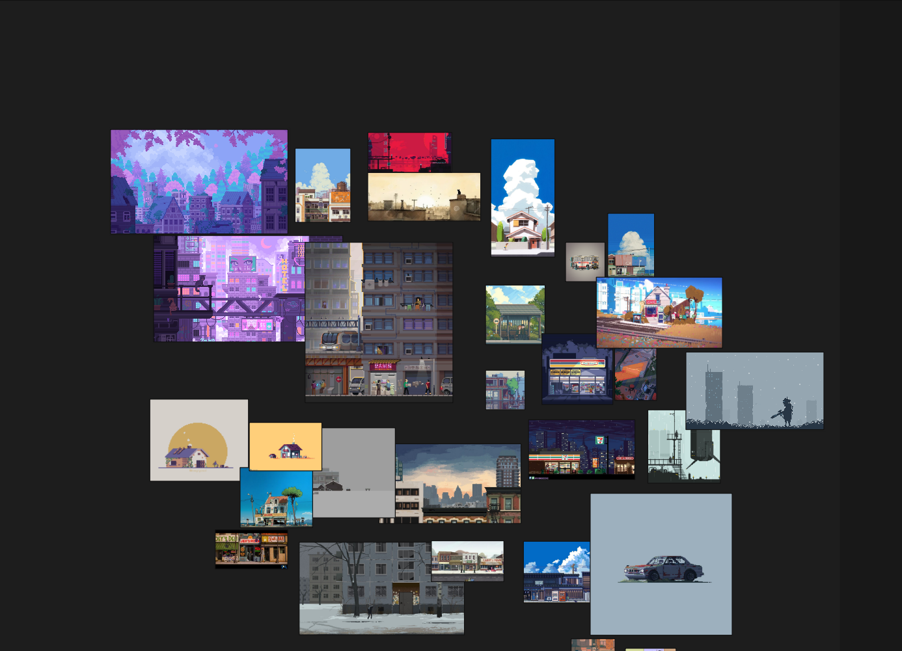

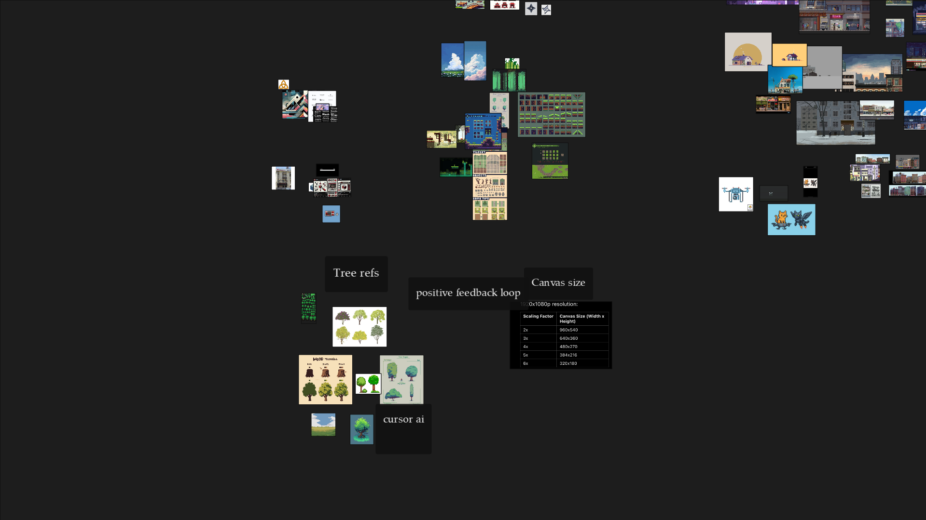

## Environment Design

Taking into consideration client feedback about wanting it to feel like a semi-realistic street through familiarity and grounded ness, the environmental design process was structured for layout, character interaction, and storytelling, developing the scene block by block in Aseprite. Where consistent perspective and scale have to work together for gameplay and navigation, each building had to either feel or be a realistic endeavour. Important to note is that each structure had to feel lived in normal, which meant designing real world physical elements like mailboxes, signage, air conditioning units, and actual pixel wise shopfronts with faux detail. Overall, the scene needed to feel consistent, believable and reflect human aspects of everyday urban life. Although the client was not available for any live input, this direction was guided by the keywords of their original brief and their references, where the strong focus was on relatability and mood. The final street scene looks to embody an emotional subtlety that conveys a sense of quiet normalcy that is appropriate for the games semi-realistic expression.

There are various environments in this game. They are divided into different levels. Designing the environment was a tedious task due to a lot of assets that needed to be hand drawn and the little intricacies, that are needed to design a Level. There are Specifically three levels in this came

### Level 1

This is the first level in the game. This is a very important part as it is the first level of the game and it leaves the first impression. For the setting, this is in the hometown of our main character. He is just chilling when the enemies attack him.

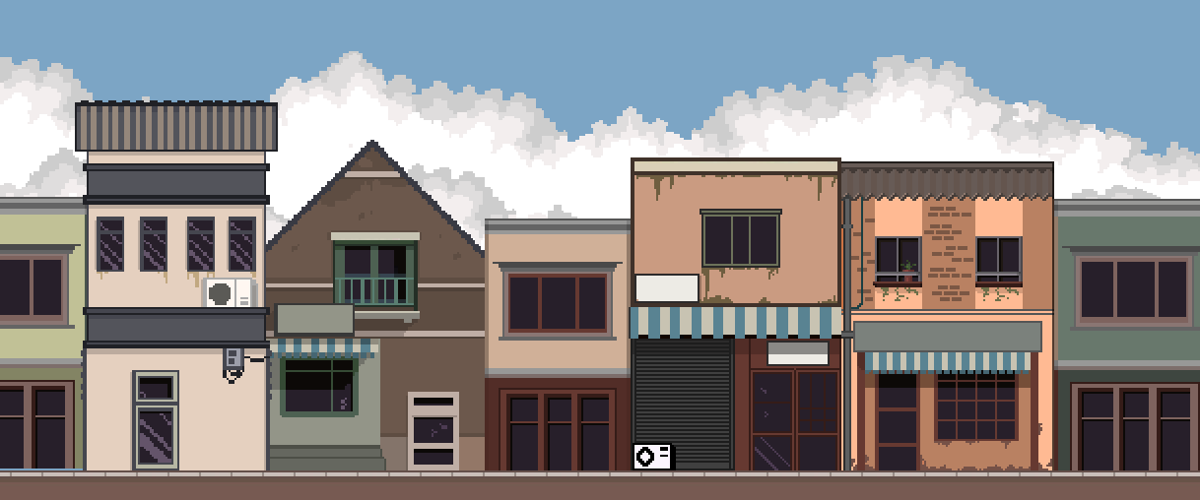

This is the final product of the level design. It took a long time to make. It was done through a tedious process of drawing every thing by hand, pixel by pixel.

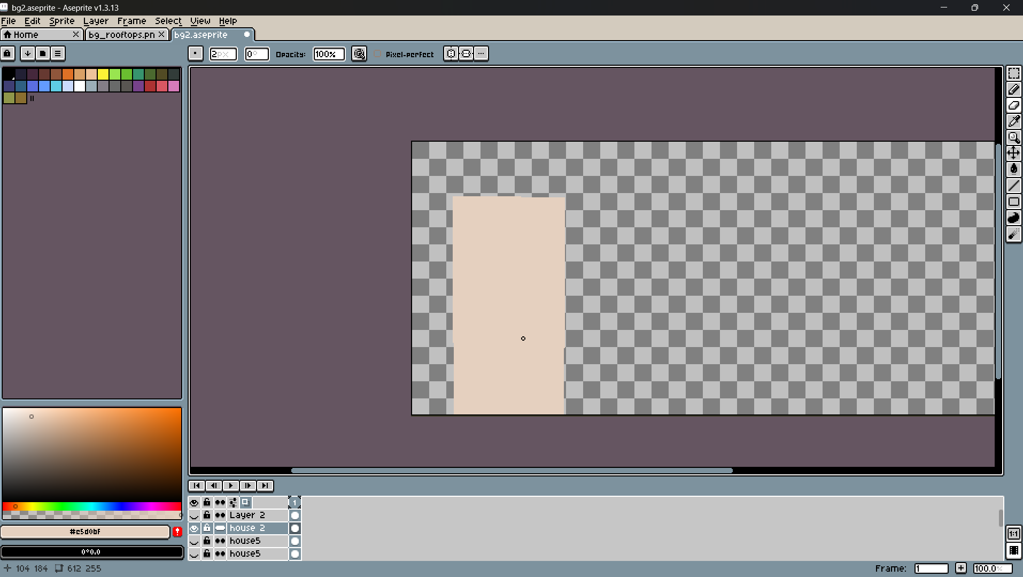

First, Outlines were made of the buildings.

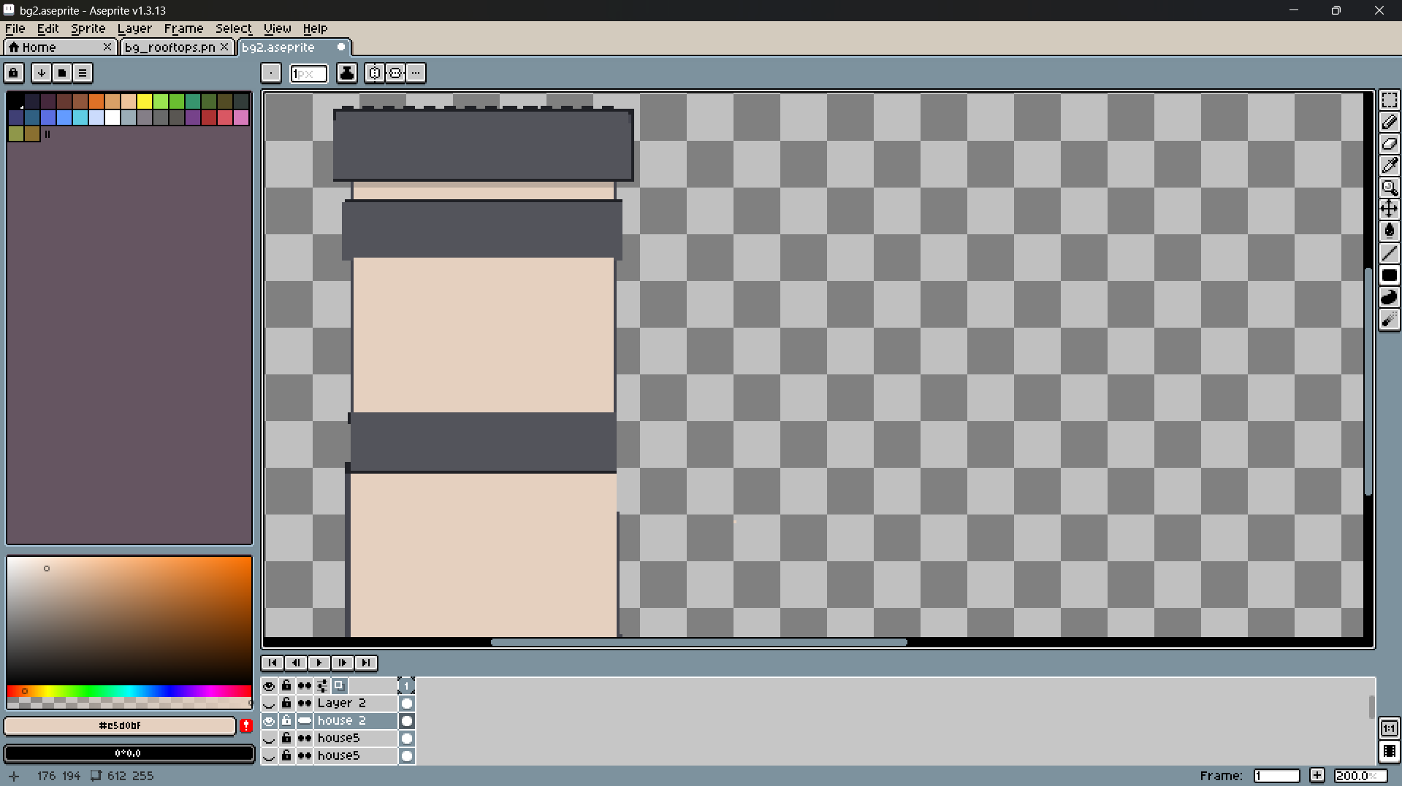

Slowly, more details were added like windows and other things.

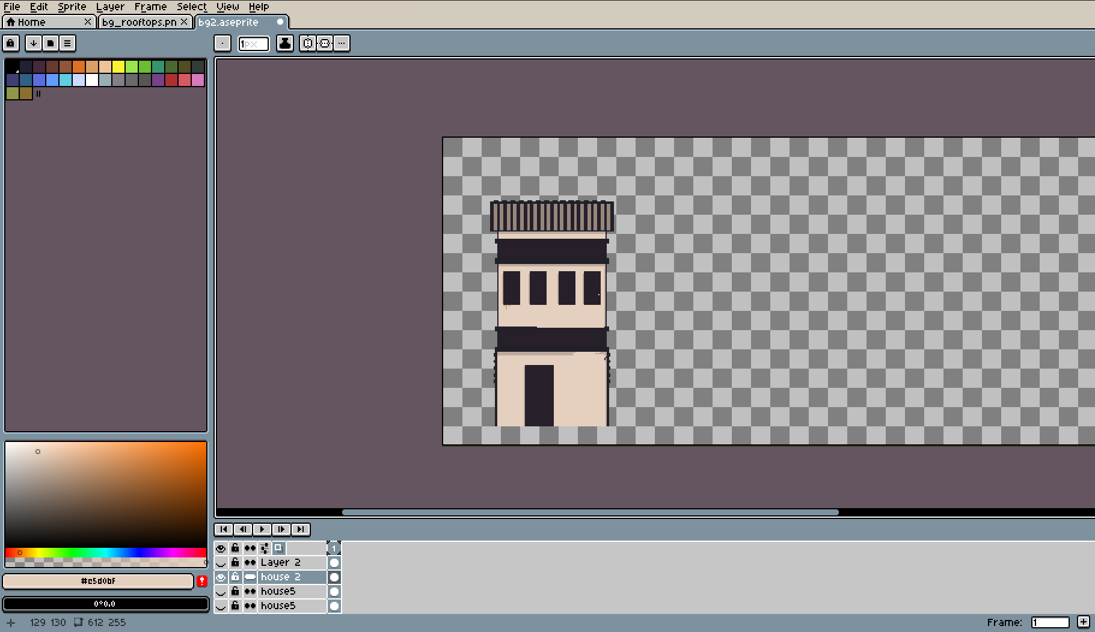

More details were slowly added.

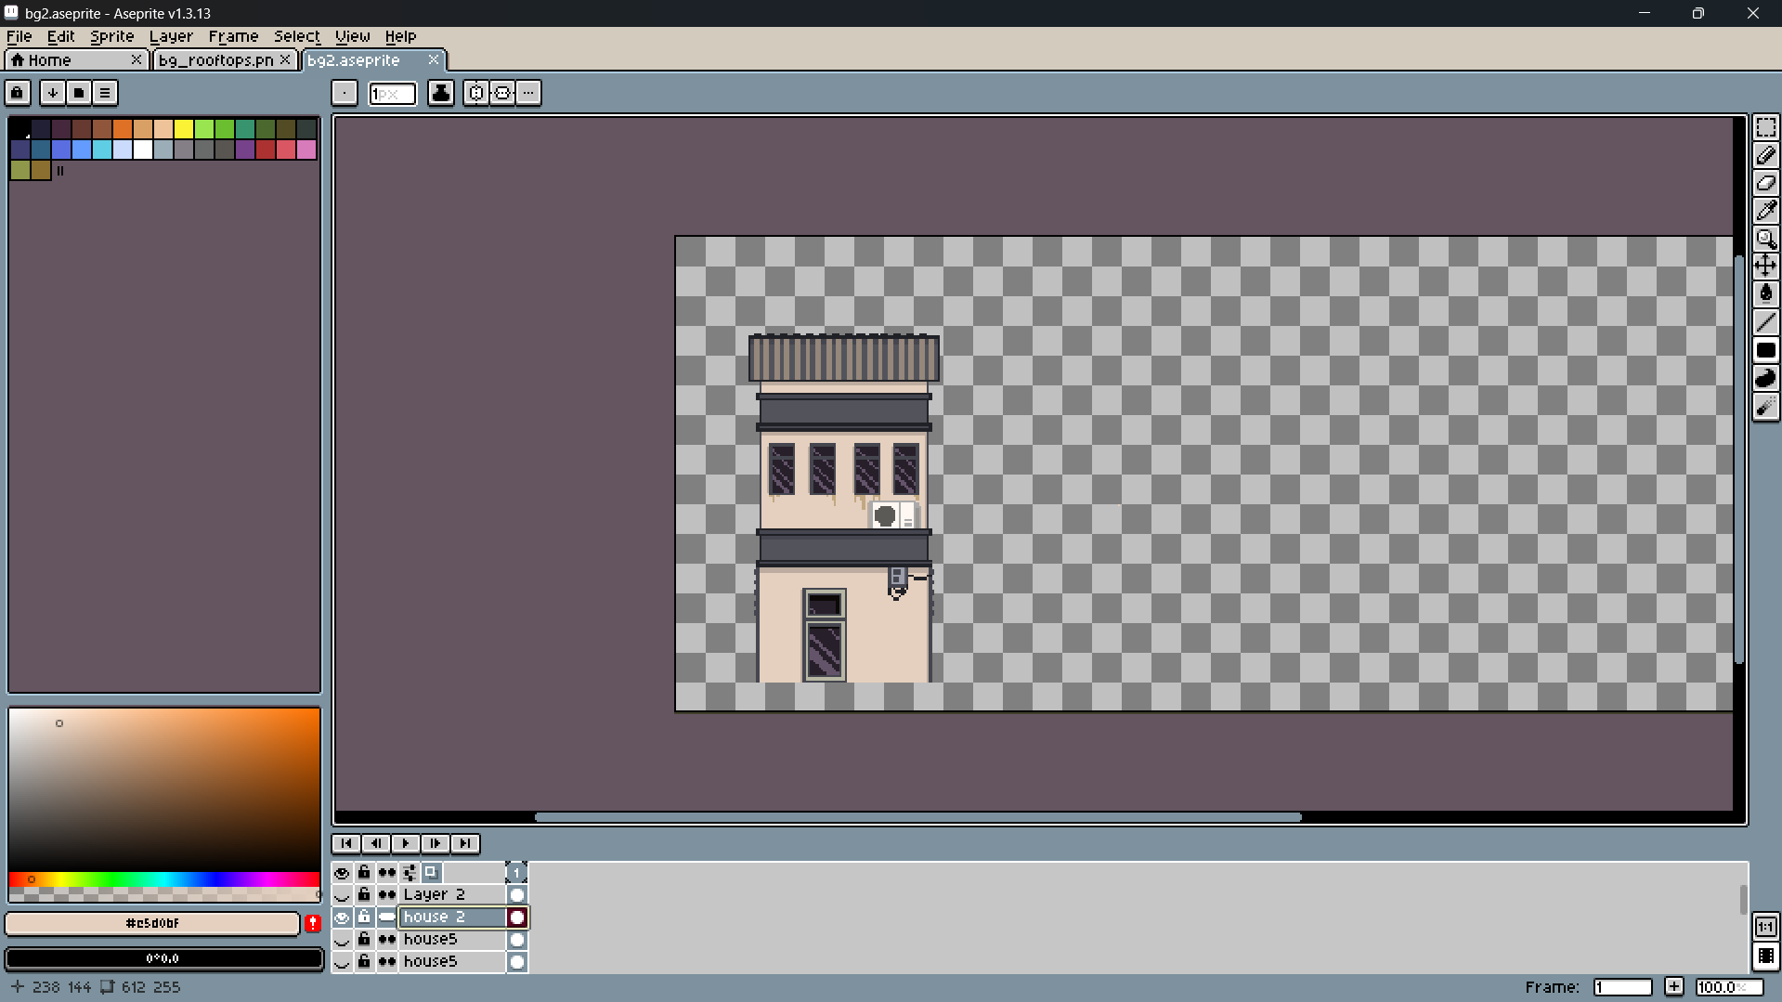

After the completion of one house, We moved on to another. This exact process was repeated for every

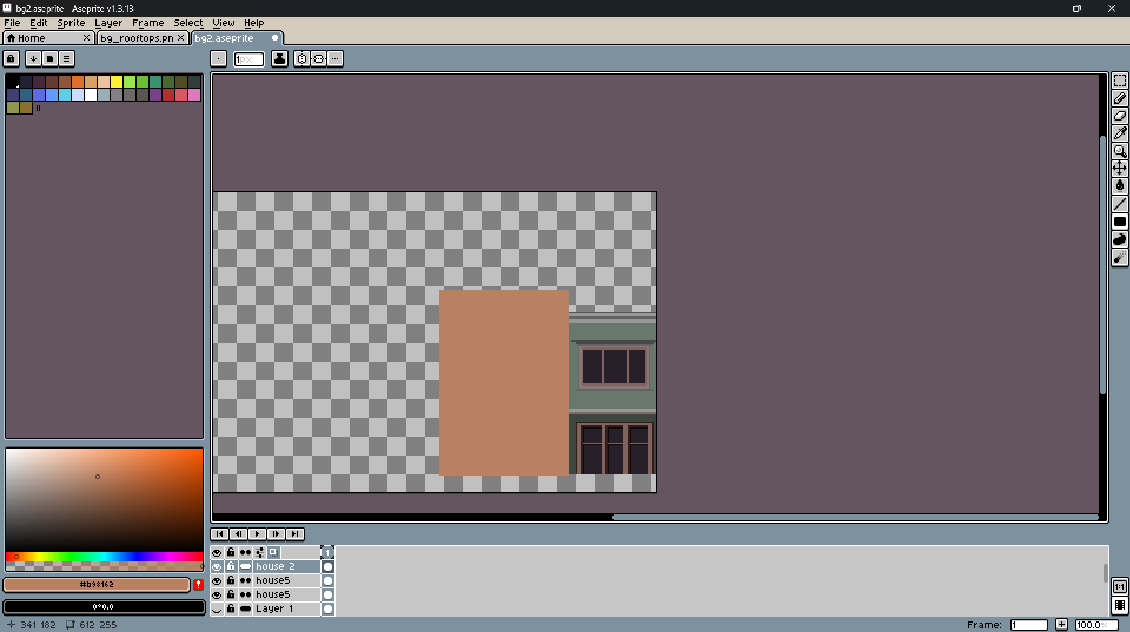

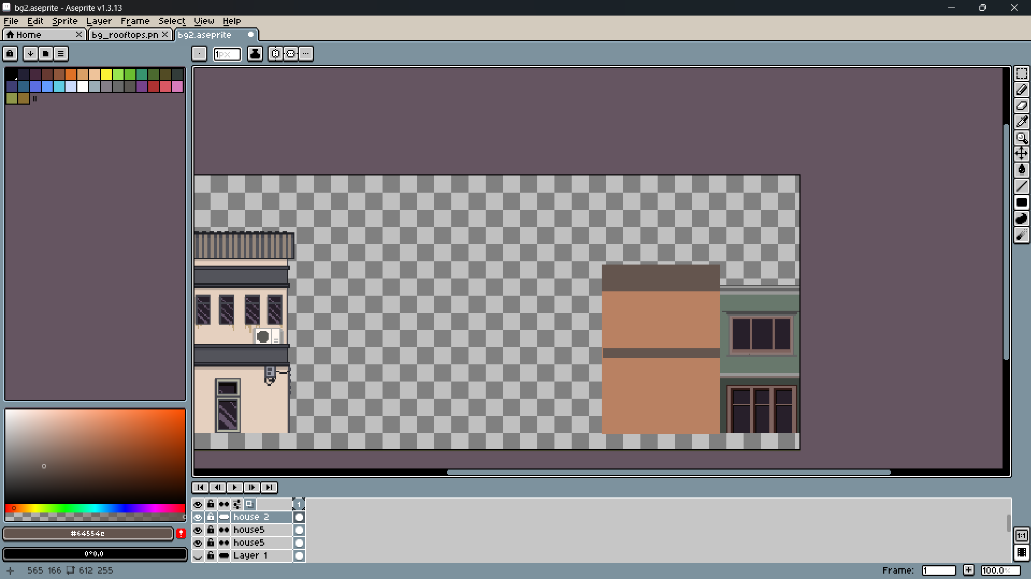

The Details were added to the other houses and also other houses were added to the scene.

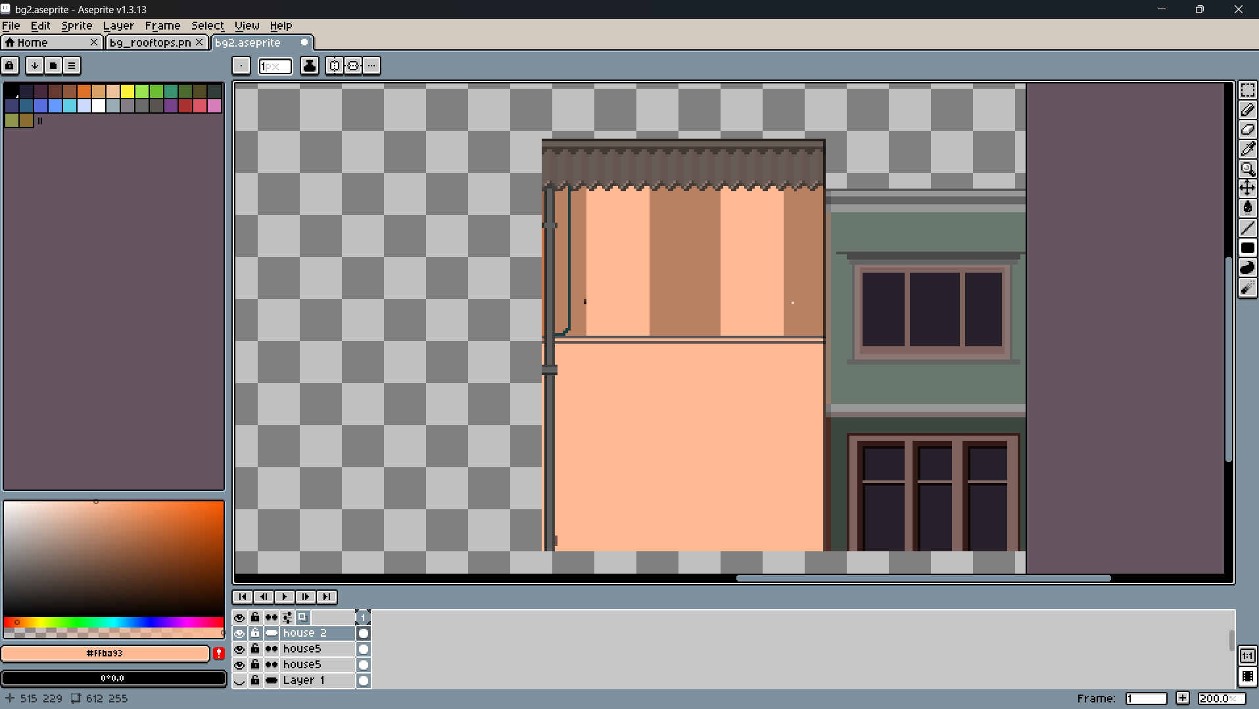

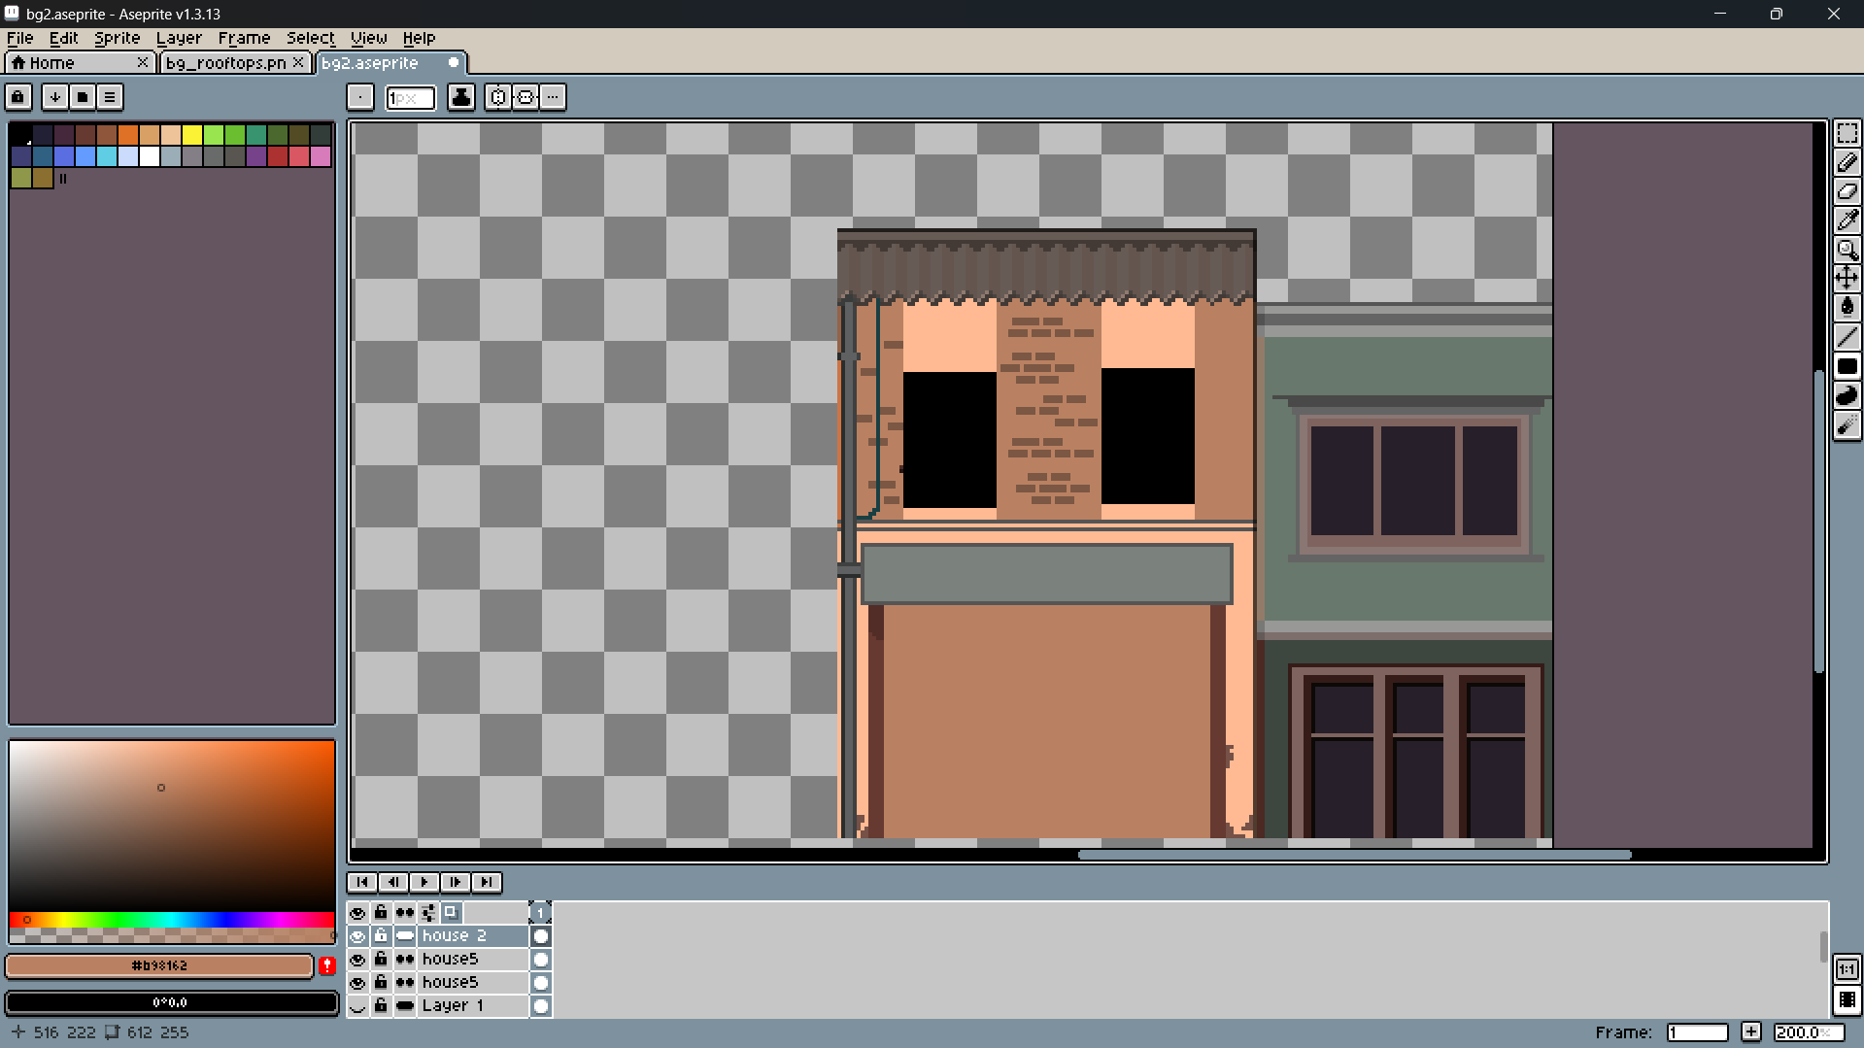

More details were added like bricks and windows.

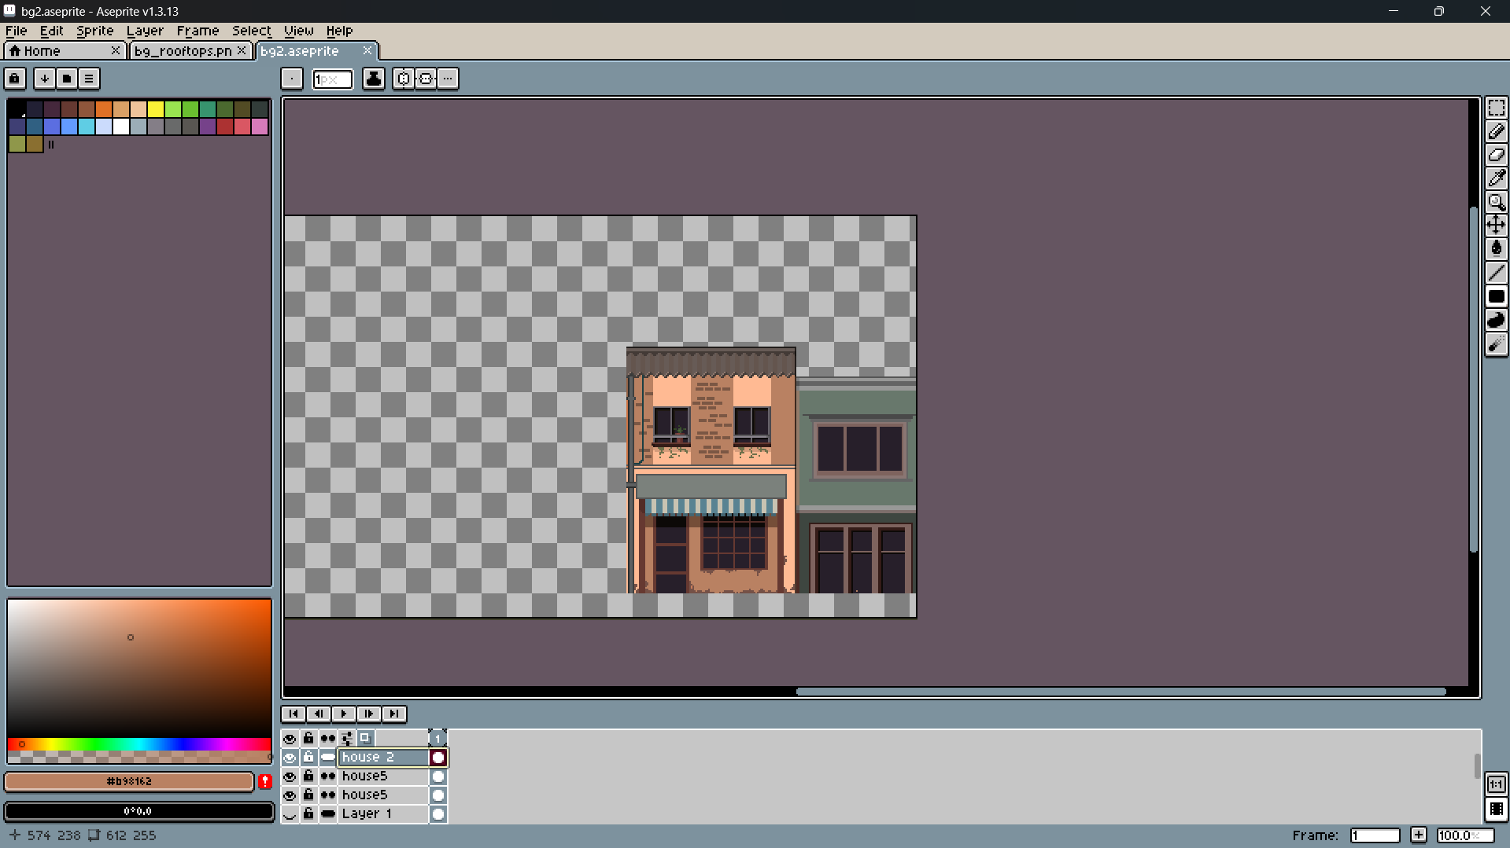

Details like doors, windows and roof was added to the building.

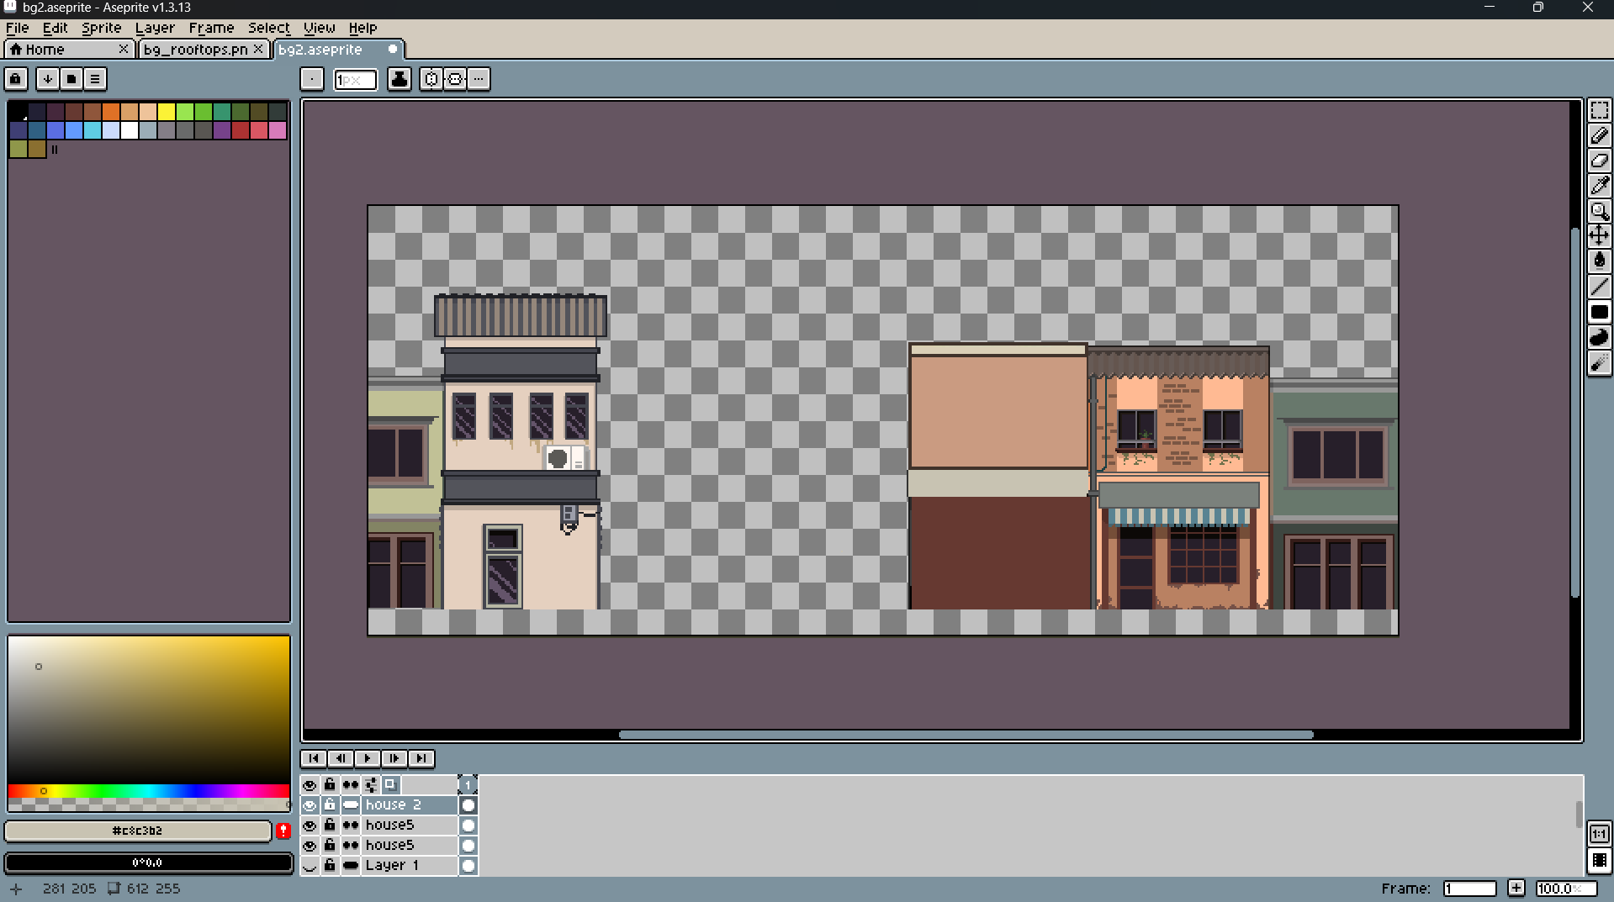

Even more buildings were added.

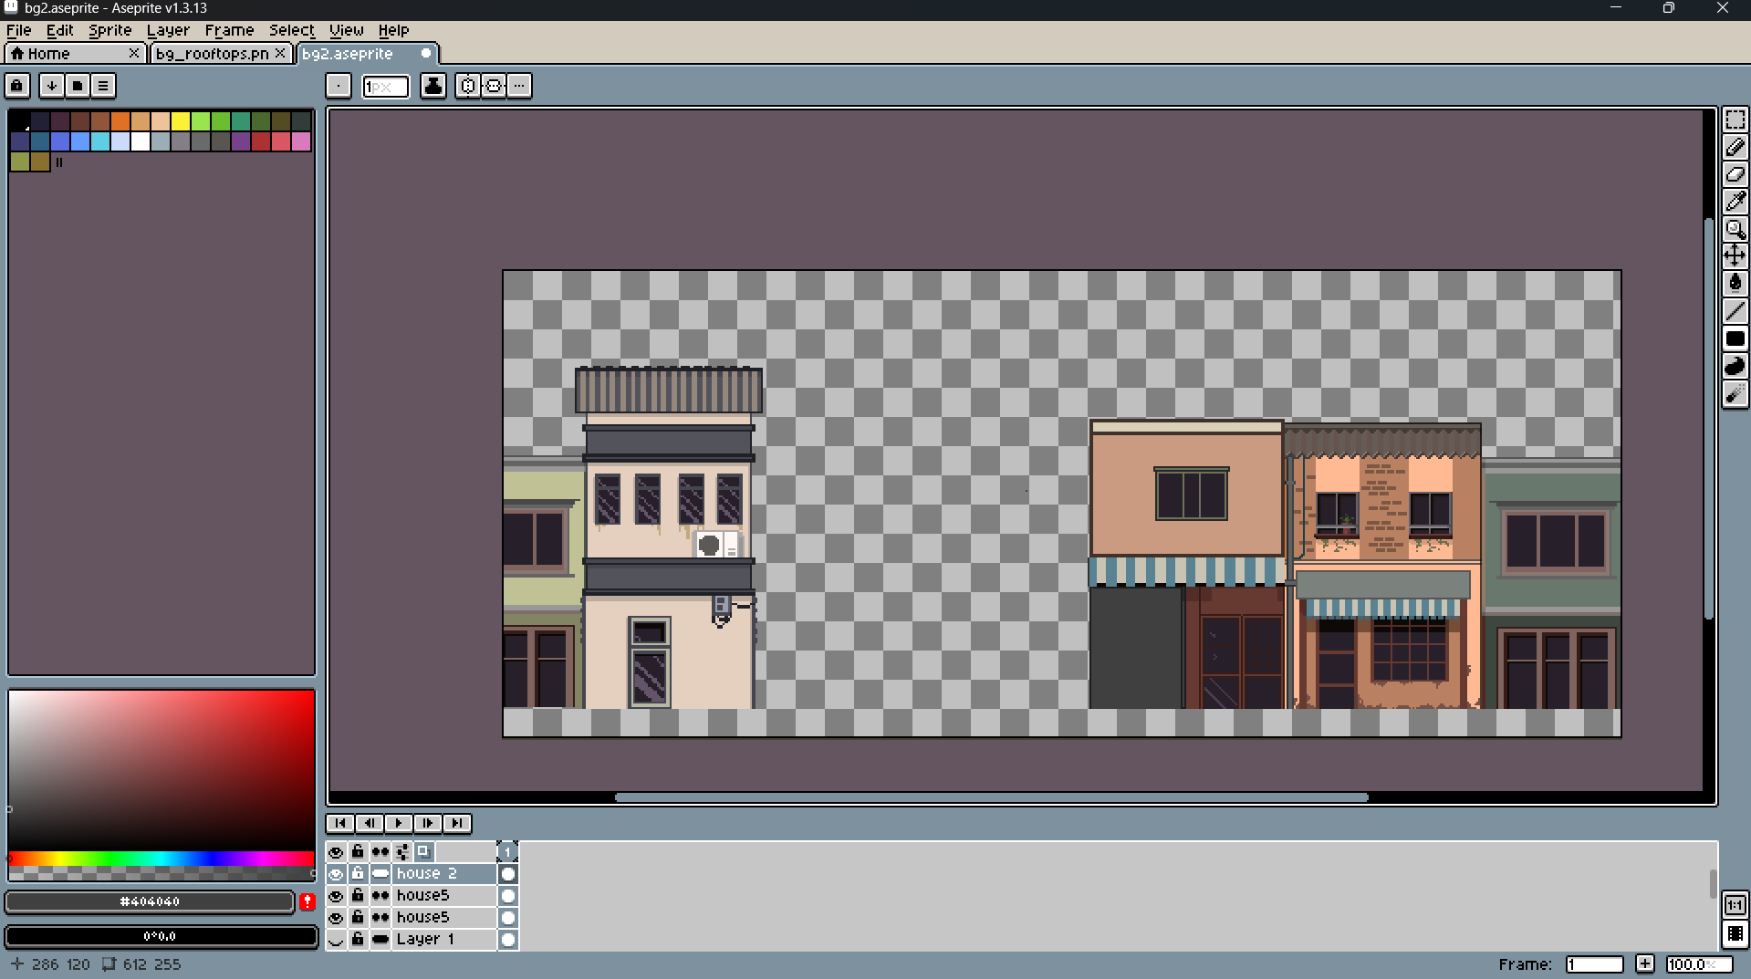

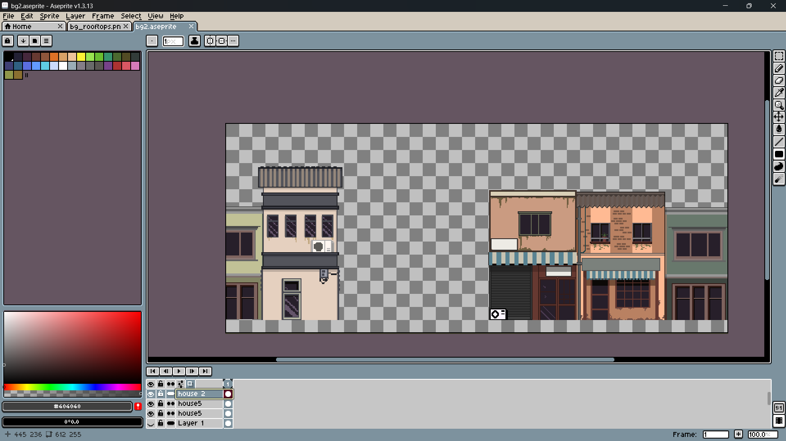

Things like shadow and algae were added to the building.

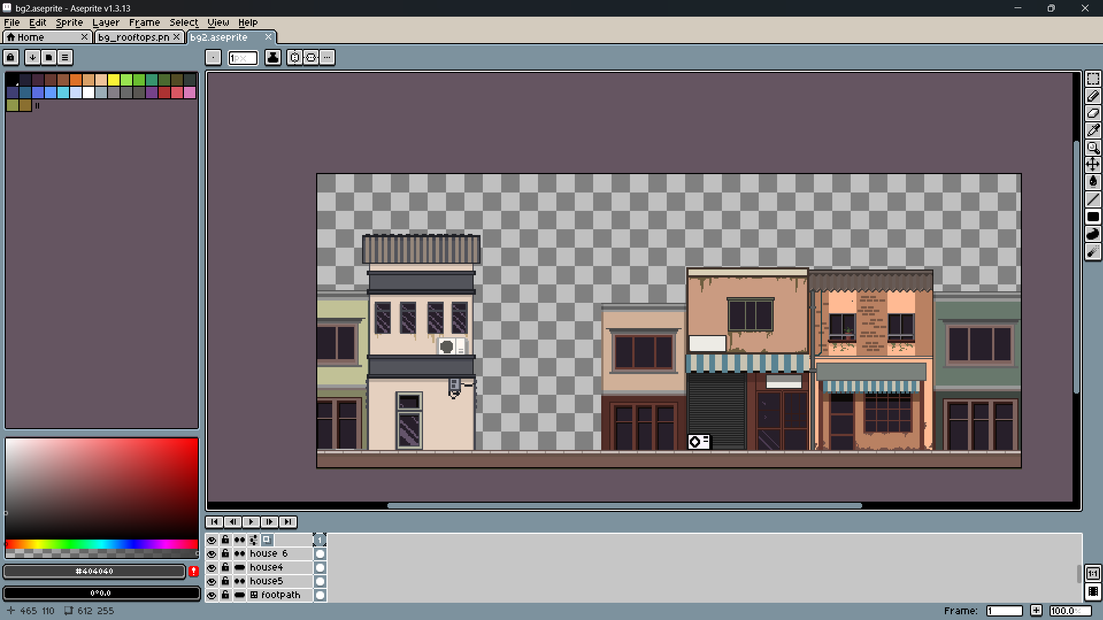

More houses were added to the scene.

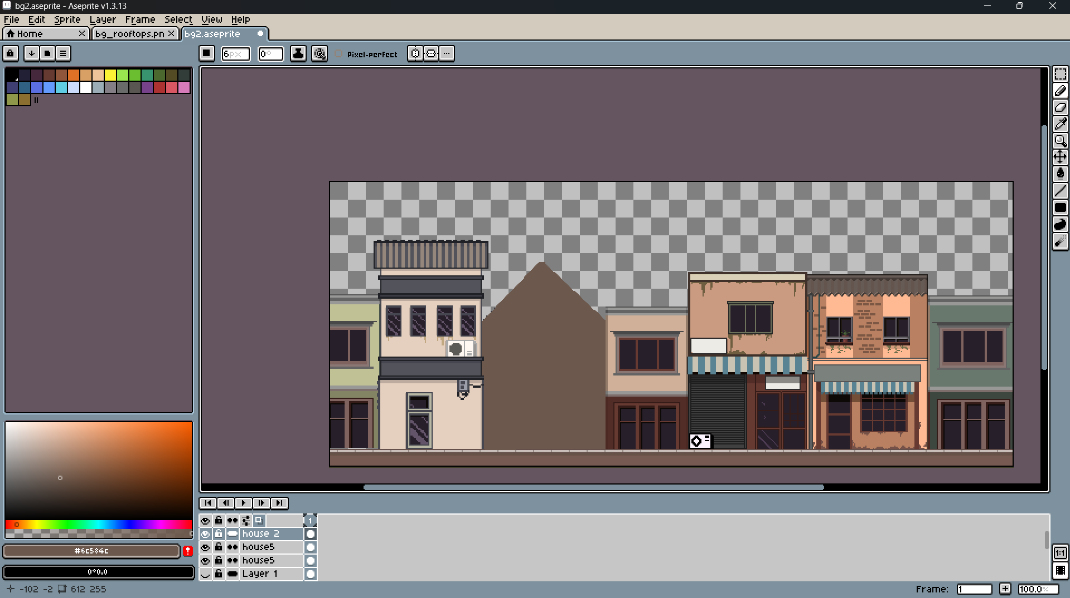

A shillouate of another houses was added to the scene.

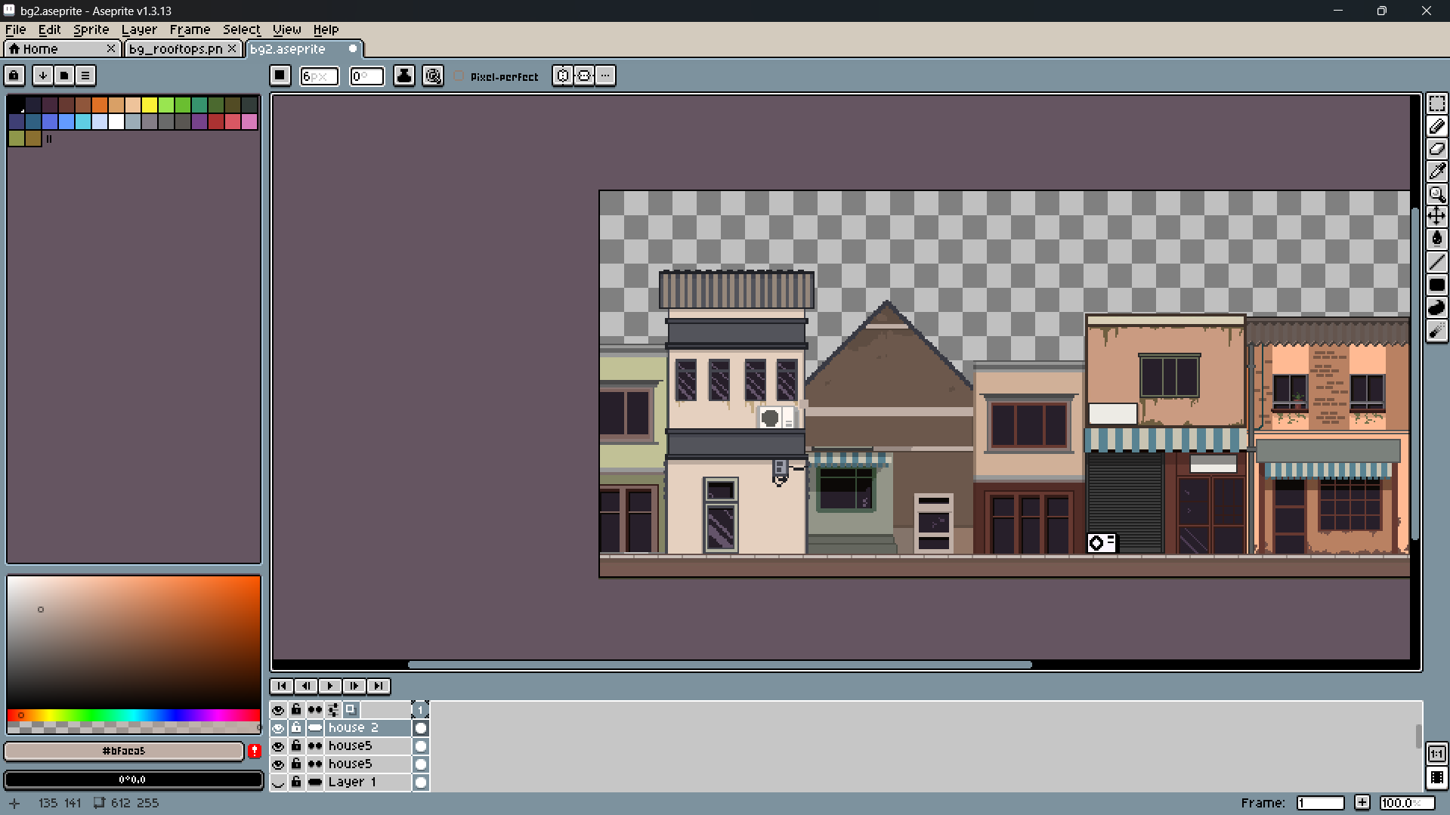

More details were added to the house in the scene.

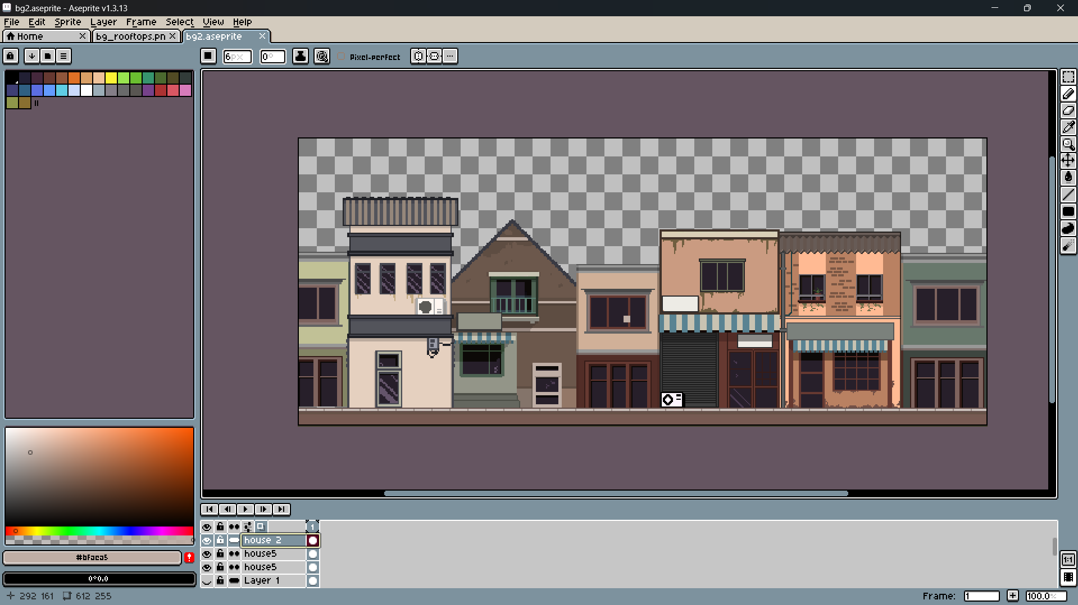

All the houses were completed.

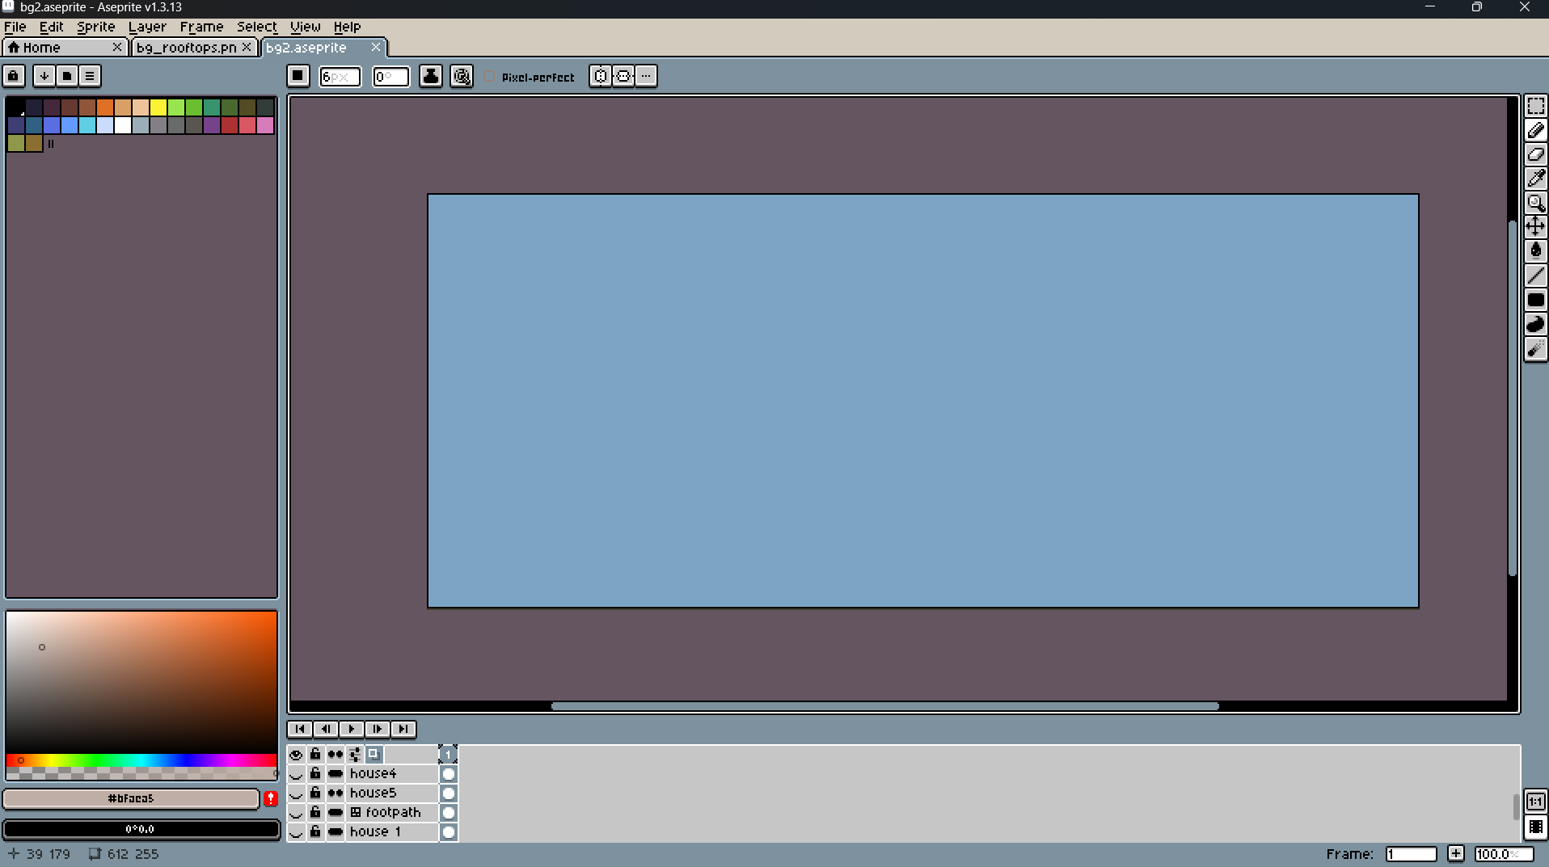

After the houses were made, the bg sky was started. First, the bg was filled with blue color.

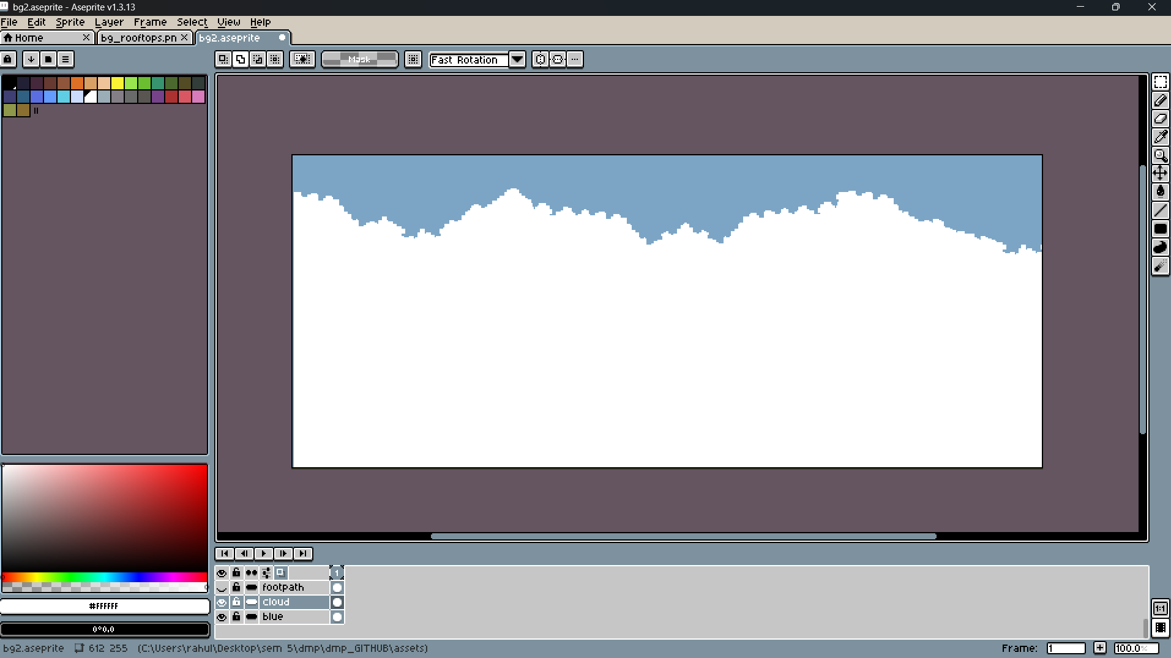

Then, the white parts were started to be drawn.

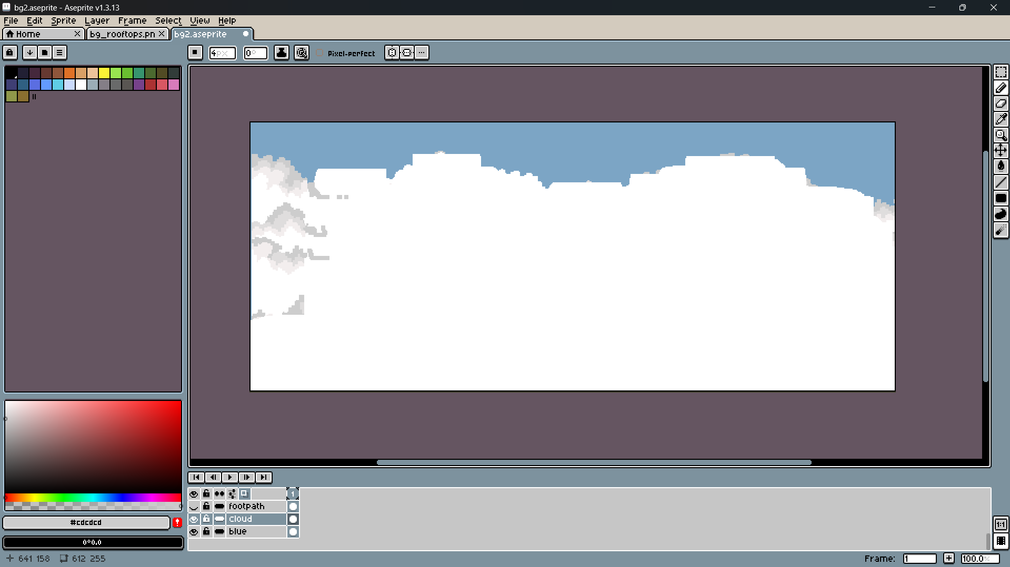

Shadows were slowly added

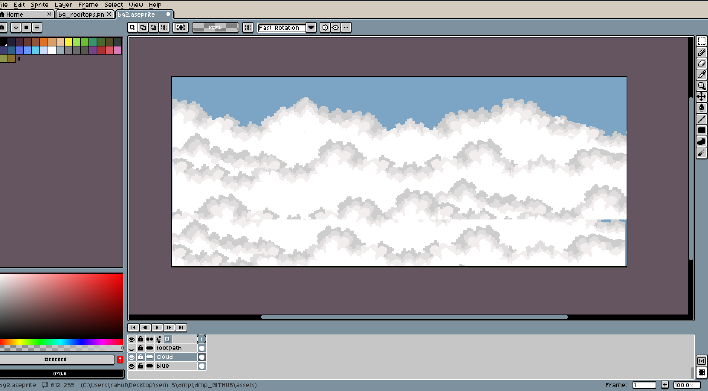

The clouds were added to the scene

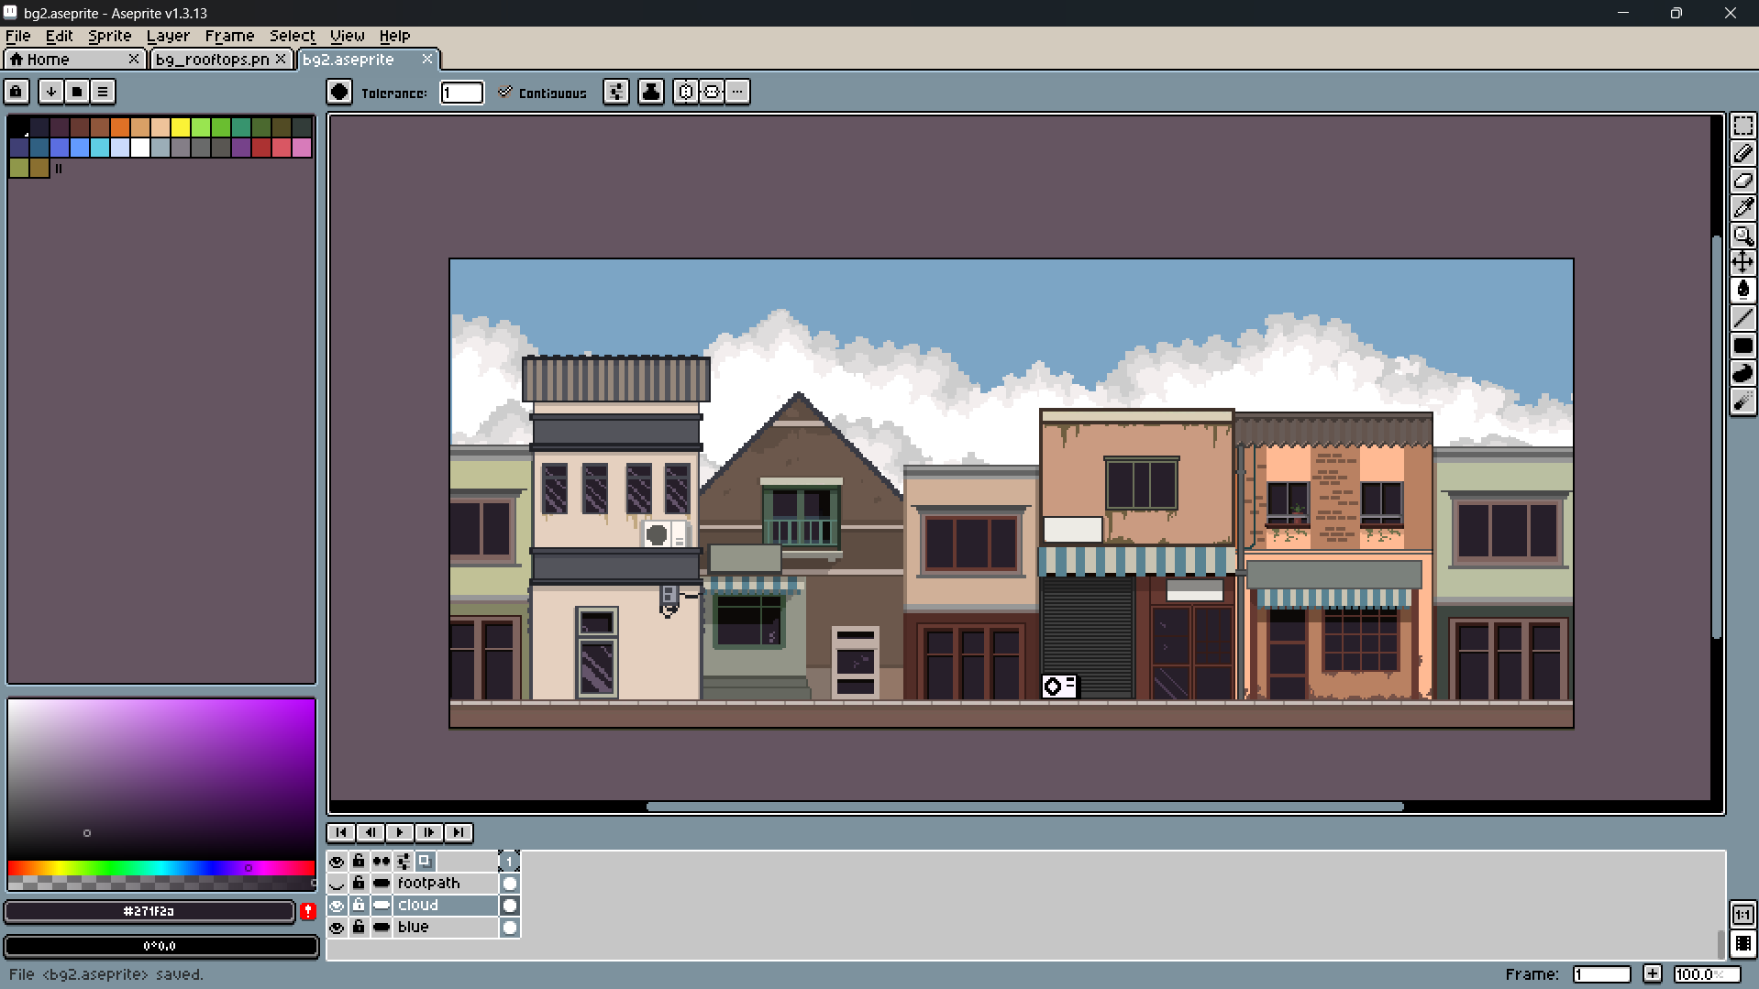

They were all combined and the layers were maintained accordingly.

# Production Phase

## Animation

Sprites were animated through frame-by-frame editting of sprites. The core motion states were idle, walk cycle, run, and interaction movement. A six-frame walk cycle was created for both appearently fluid motion, and remembering storage limits. Onion skinning was used to ensure the movement was consistent across all frames of animation and subtle overlap and ease was used to visualize the body parts to appear realistic. Focus was on clarity and responsiveness during movement. When testing the animations, it was done in the engine environment to check for distruction, representation and speed of play back.

The animations were done in aseprite. They were done by using a digital tablet. Every frame was carefully drawn in order to make the animation.

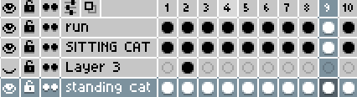

Frame by Frame animation was done for each and every frame

### Main character animation

Animation is an essential part of a video game. It helps make the game more smooth and coherent. It makes the game feel smooth and good.

1. Idle animation

First, the animation of the characters idle was made. This is a necessary animation in every game as it is the animation that is played when the character is doing nothing.

Idle animation was done in aseprite by making the character move up and down as It is breathing and the tail moves and waves as if it were a real cat. This was achieved in the aseprite software by doing everything frame by frame.

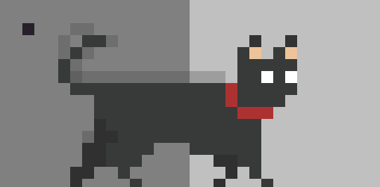

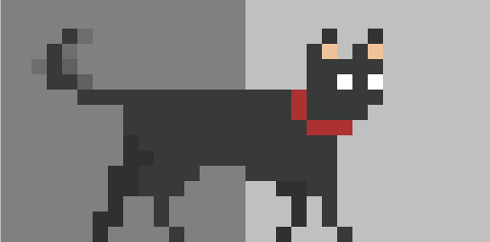

1. Run Animation

The run animation of the cat was also done in aseprite. Similarly to the other animations, this was done by frame by frame animation. Each frame was drown with the intention of giving weight and good feel to the run of the character. For this, The videos of cats were studied in order to see how they move and to incorporate it into the game.

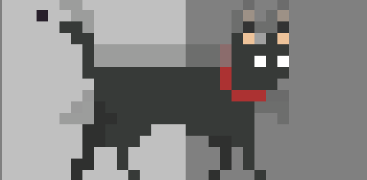

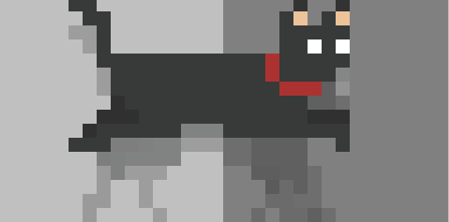

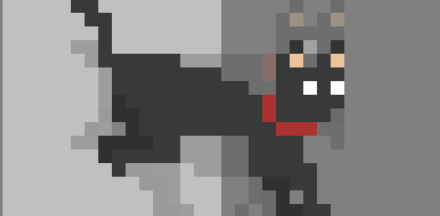

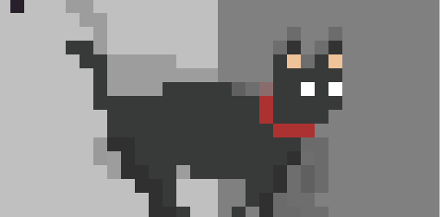

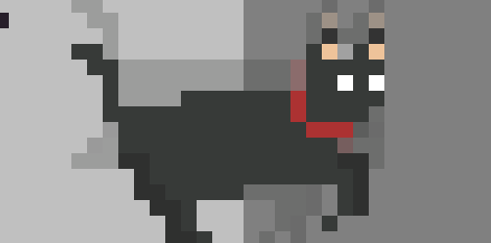

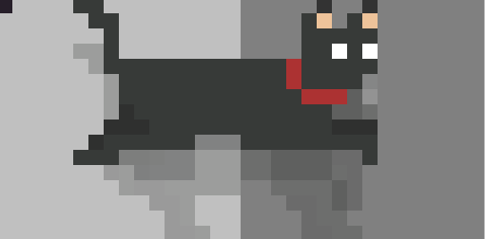

1. Attack Animation

Attack animation was also done by this in the aseprite software. It was done by frame by frame animation and was done properly.

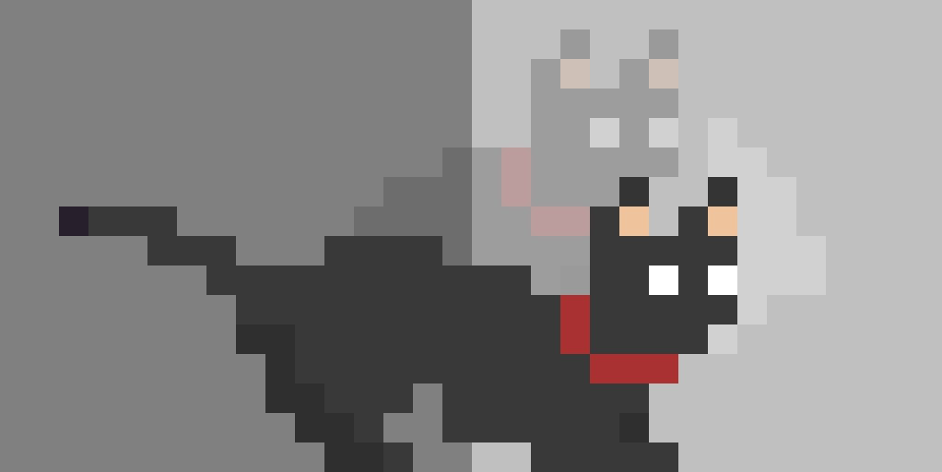

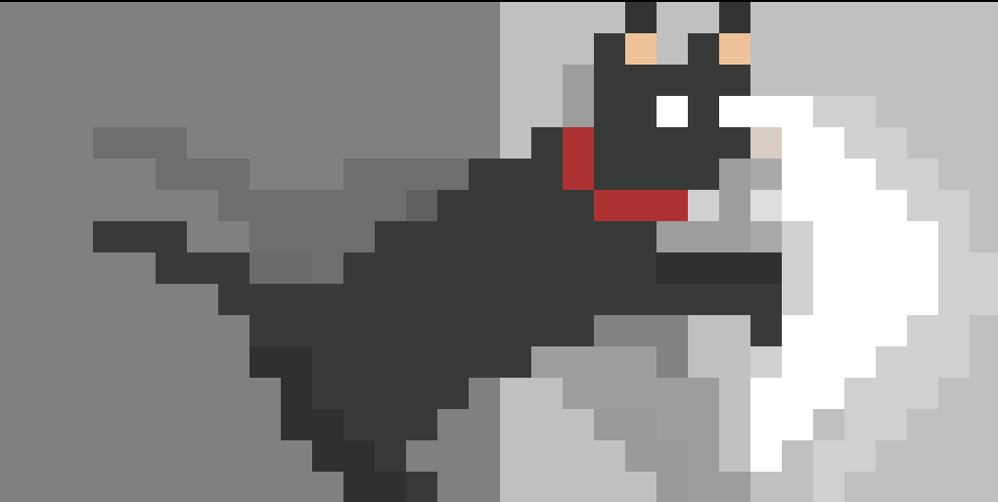

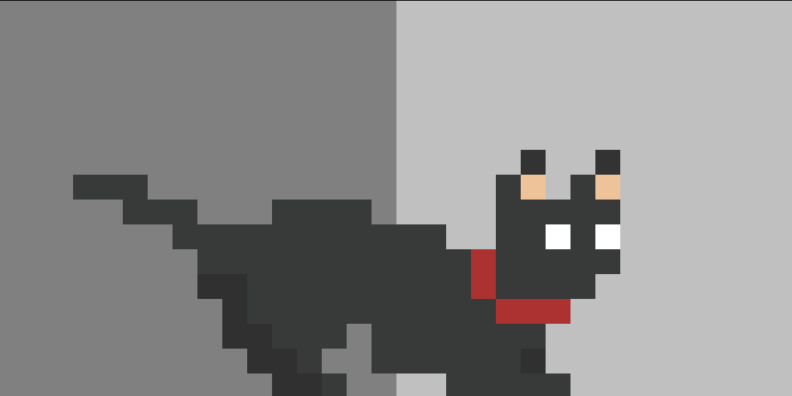

1. Sitting animation

Sitting animation was done in the aseprite software. It was made frame by frame from the movement of the tail, to the movement of the head.

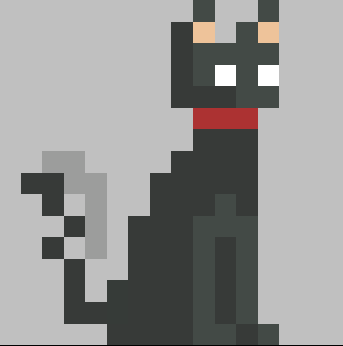

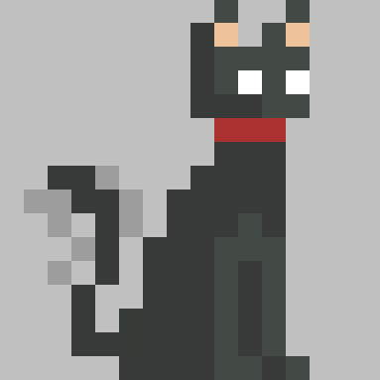

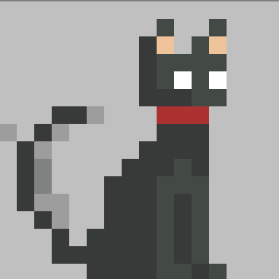

1. Hurt animation

Hurt animation is the animation that is played when the character is hurt. It was done by simply paint bucket white color.

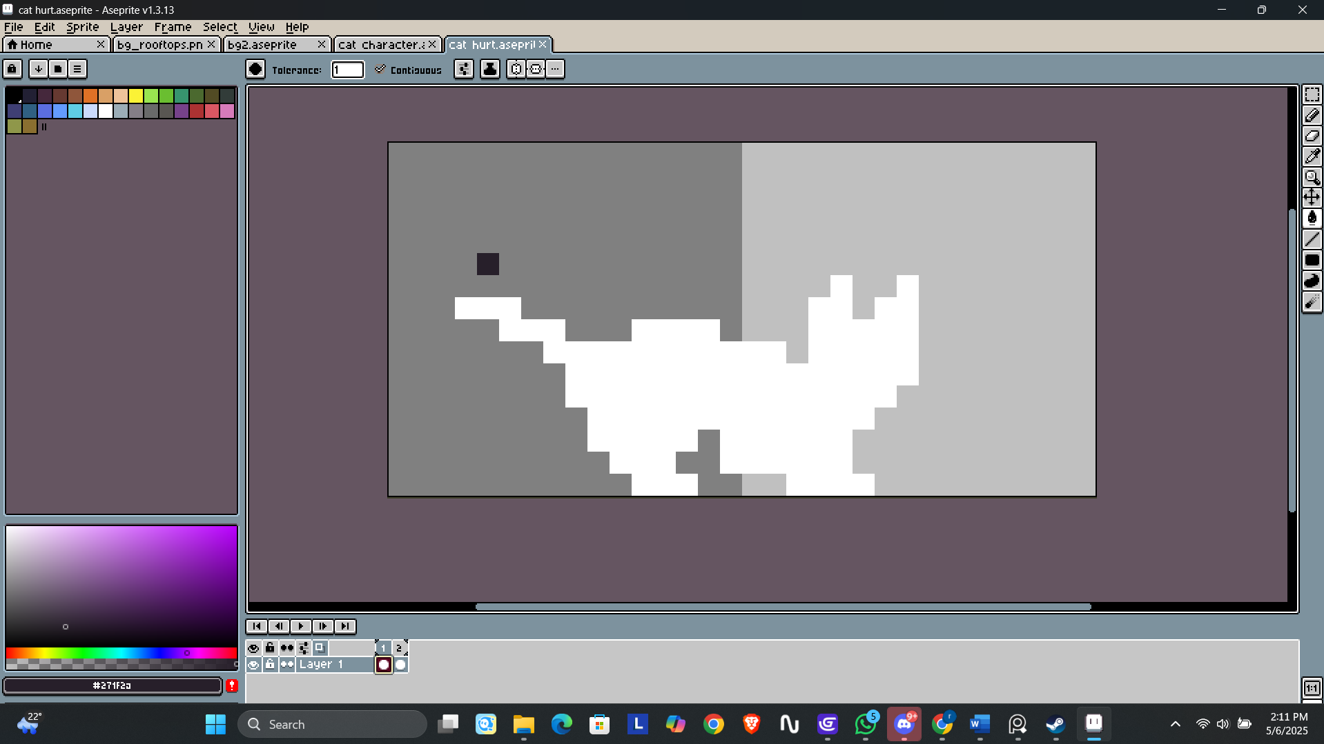

### Dog enemy animation

1. Idle animation

Idle animations are a category of animations that show that a character or object is not doing any major actions and is retained in a "waiting" or "at rest" state. They run on a loop as long as the character or object is idle, presumably keeping the scene visually interesting and life-like.

The idle animation of the dog was done in Piskel. It is a built in pixel art application in g develop. It was made from the Design that was made earlier and was modified frame by frame.

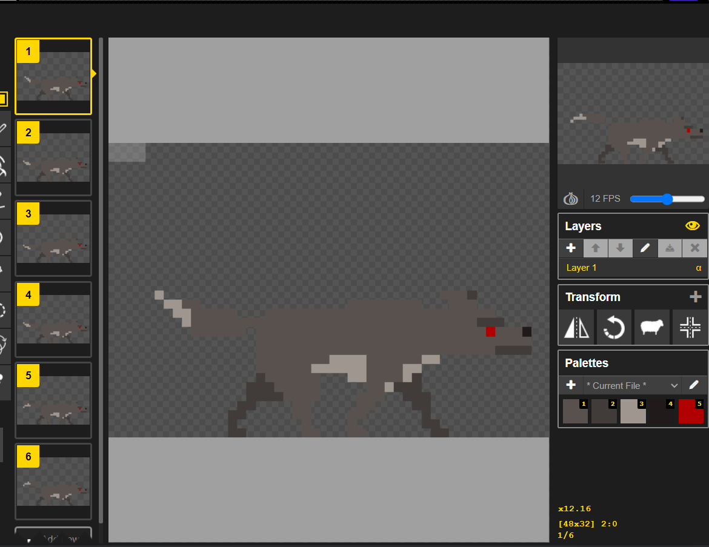

1. Run animation

The run animation was done in the piskel. It was also done by editing frame by frame in the app.

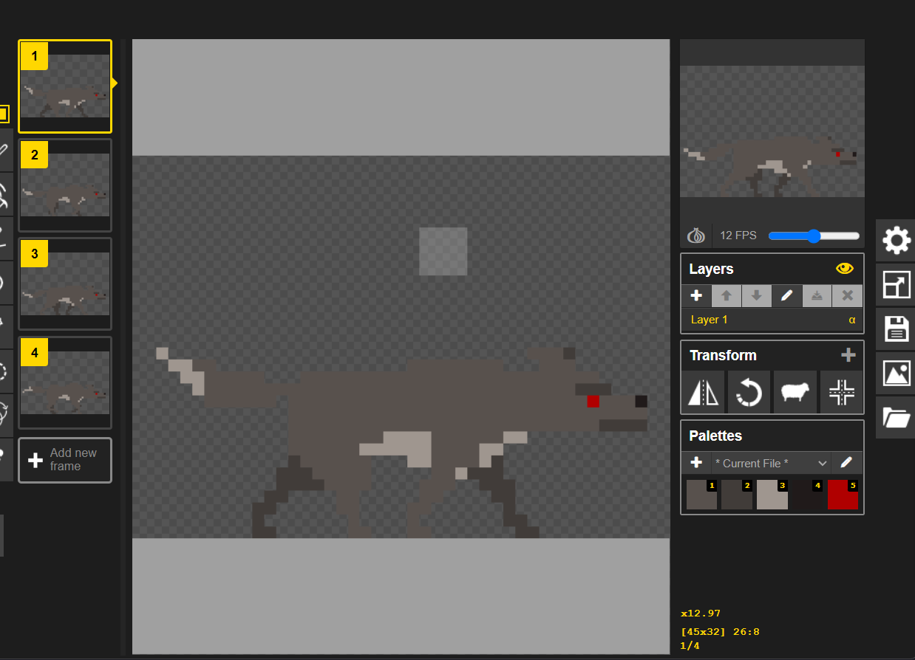

1. Attack animation

Attack animation was the thing that is played when the dog attacks. It was done in the piskel that was edited frame by frame.

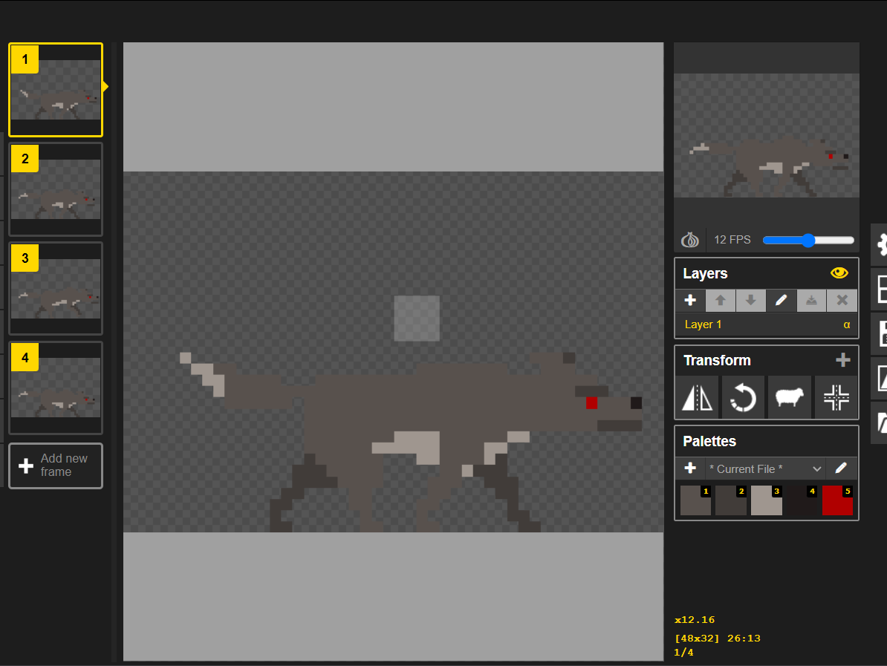

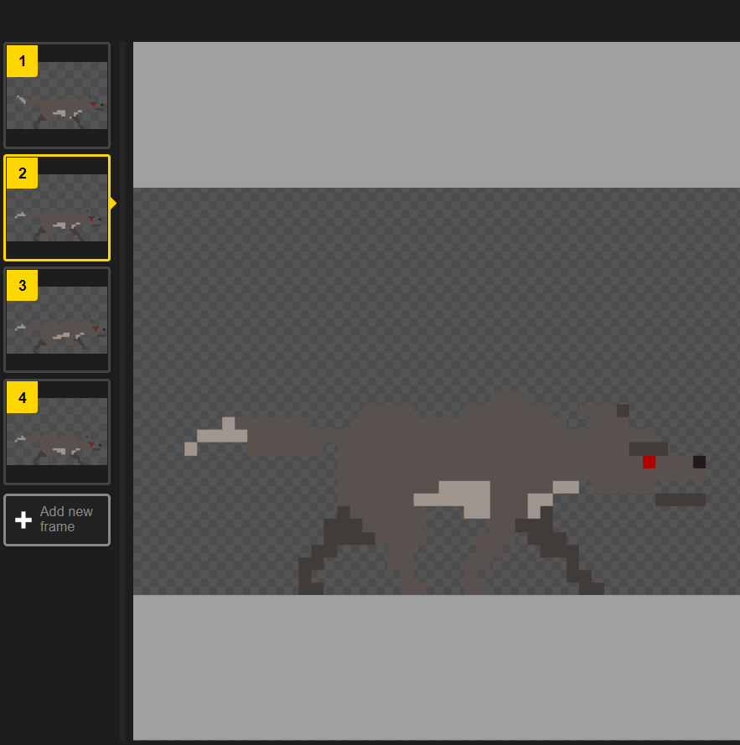

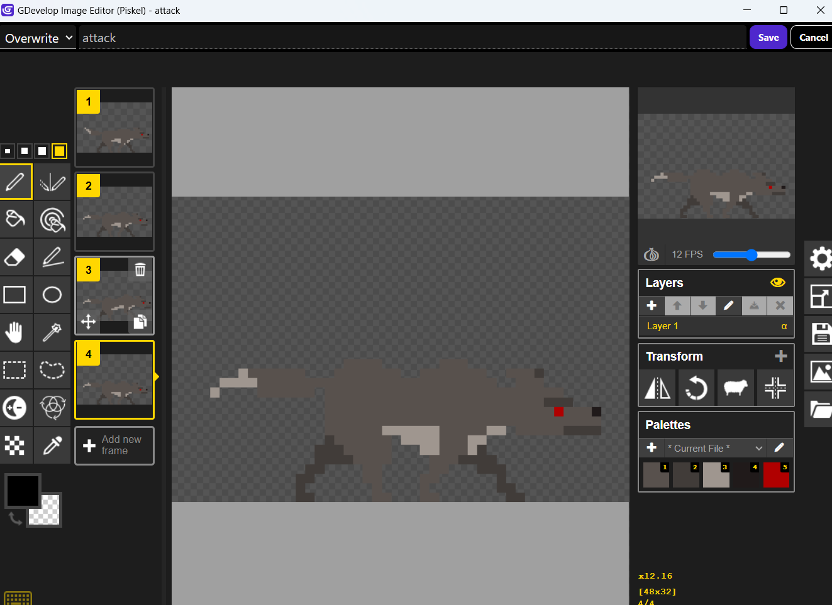

1. Hurt animation

Hurt animation is played when the dog gets damaged. It was siply done by filling the color of the dog in red.

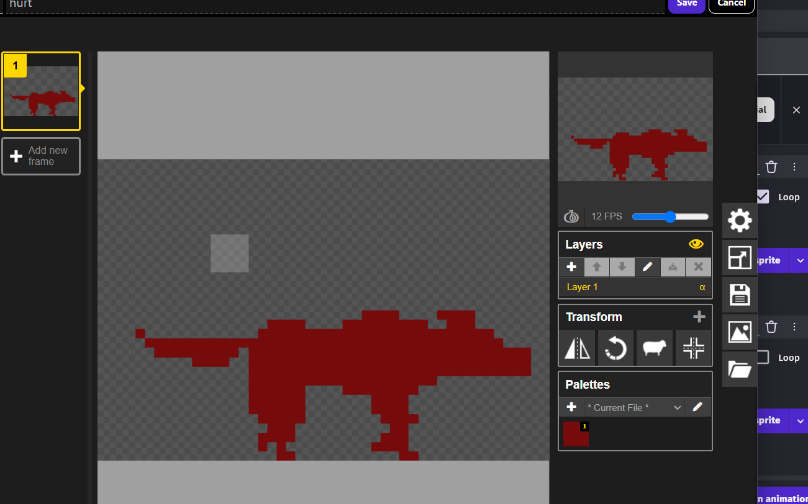

## Character Development ( Behaviour coding)

The character base was constructed using an organized pixel grid inside Aseprite. I started with a neutral, standing pose. I designed my proportions to be semi-realistic, while being visually readable when displayed small. I made sure to pay attention to silhouette clarity overall and double-checked for consistency with the outfit. The layering system in Aseprite made it easy to separate the base skin, clothing and accessories, meaning I could change them in a single variation if desired. I carefully chose the colors in my original palette that I'd made during pre-production so the colors harmonized in the design. In individual internal tests, I altered the poster, limb length and expression a number of times based on however many tests I wanted to assess for readability and emotional expression.

The development process was done in GDevelop. Different events were setup in Gdevelop so that the movement could translate back to the playing screen. Various events were used in the gdevelop events tab so that the changes could appear in the screen

The screenshots of the different events that were used to modify the charter are given below.

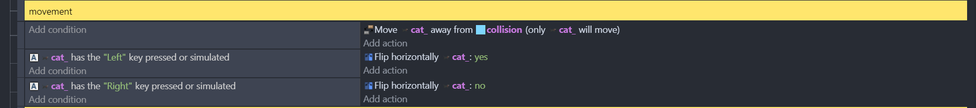

In this sequence of events, It tells the system to flip the cat if the user presses the left key and un flip it when the user presses the right key. Also, The cat cannot come in contact with the object “collision” This was done so that the cat cannot go outside the scene.

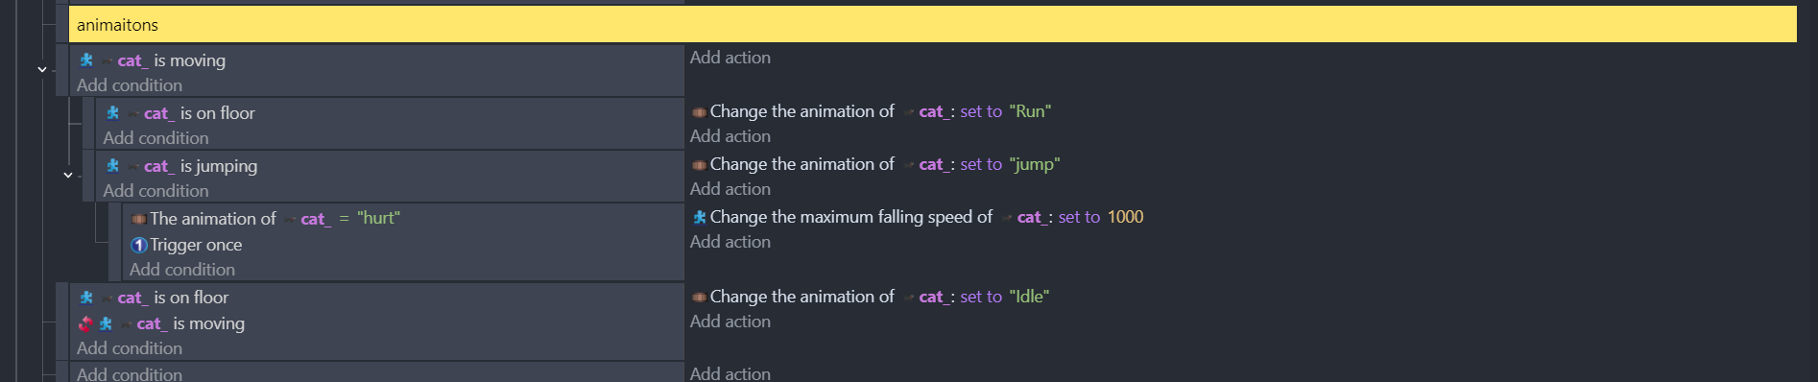

In this group of events, it says if the cat is moving and is on the floor, the animation “Run” gets played.

If the character is jumping, Animation “jump” gets played.

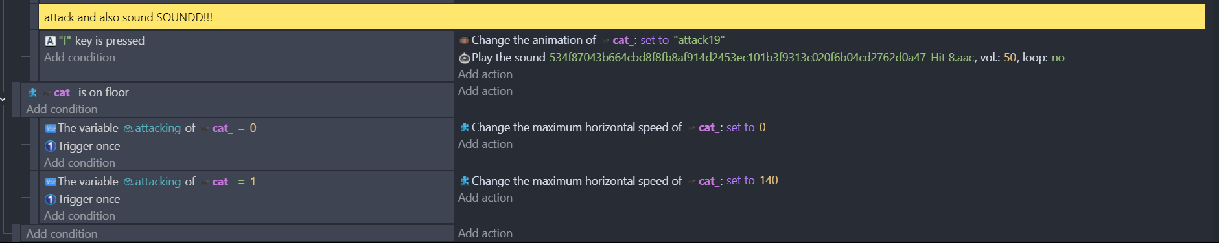

When F key is pressed, The character “cat” animation “attack” gets played.

Also Simply put, the variable is a sort of container that stores information to be used by the game, and this information can be changed during gameplay. The data in a variable can be a number, a string, or even a structure-like an array or an object. Variables are useful in storing scores, health, or states related to the game.

This was used in order to change the horizontal speed of the cat when it attacks, so that it doesn’t move. Then, the variable gets changed back and the cat can move again.

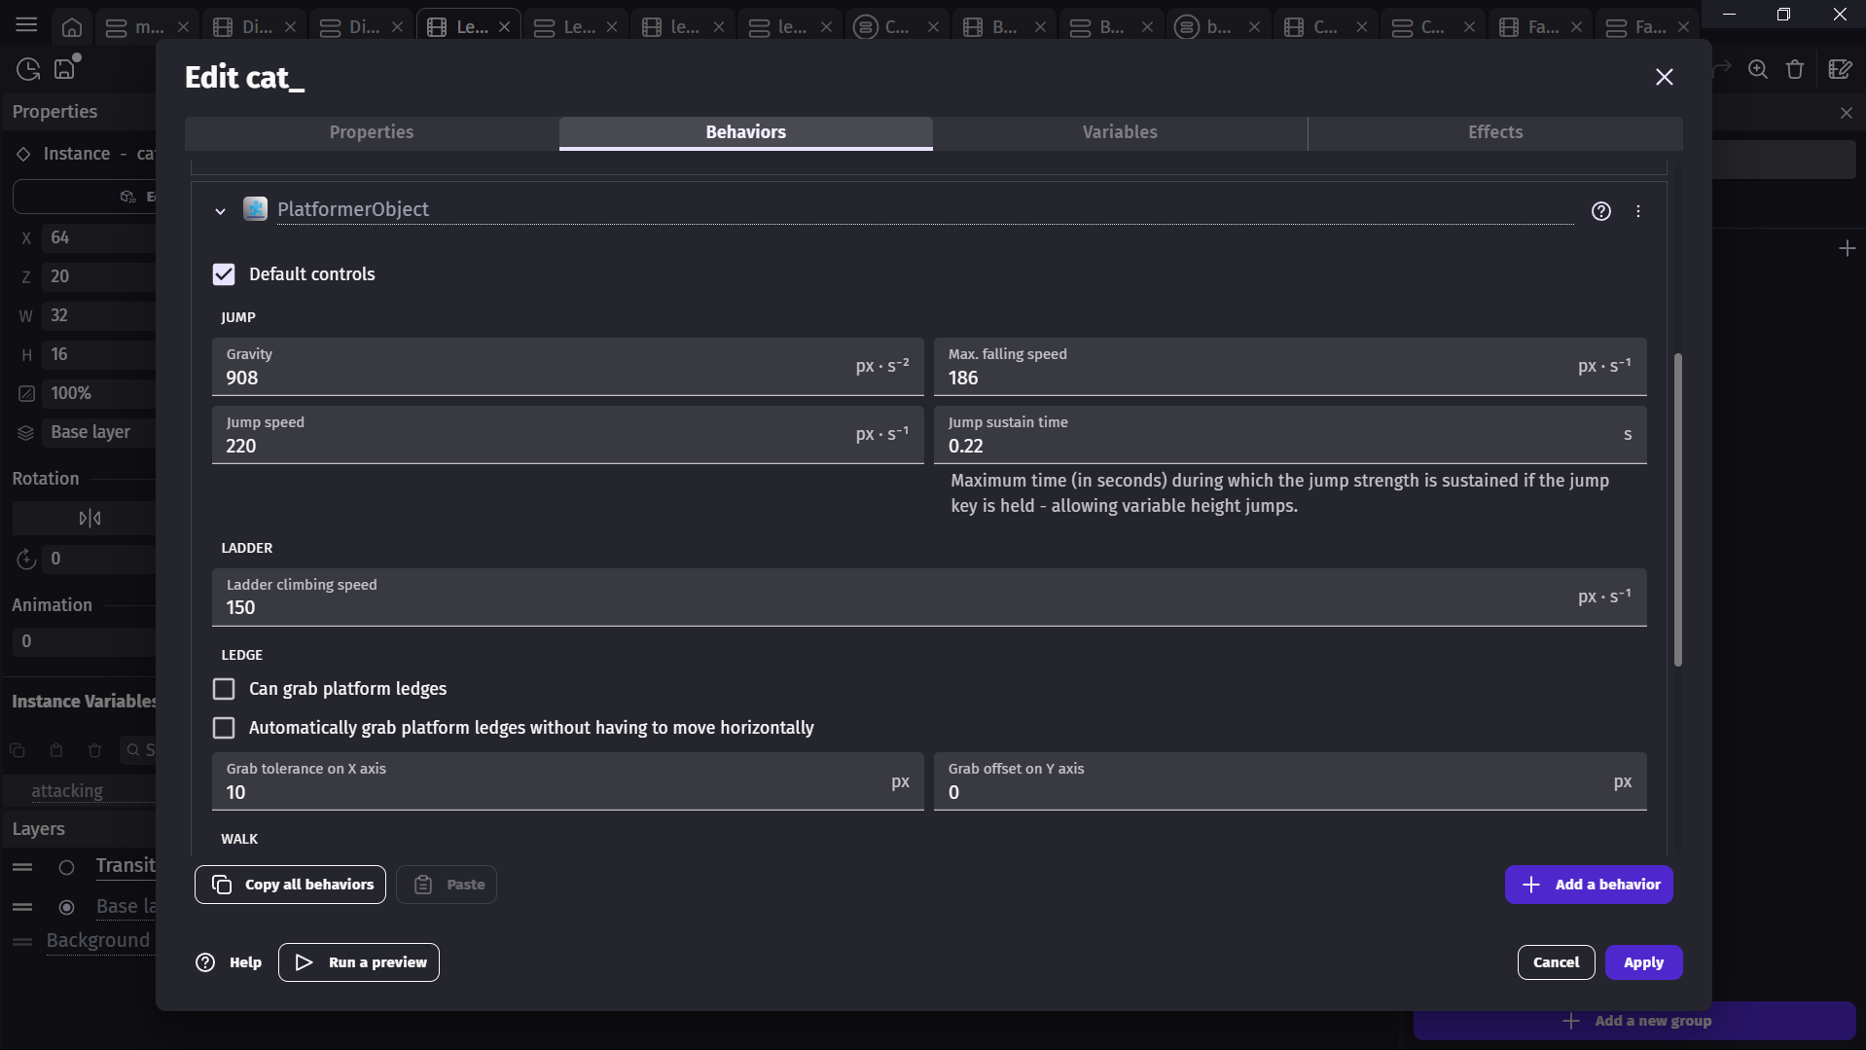

The above screen illustrates the behavior settings for a platformer character from GDevelop, which in this case is for an object called cat_. The "PlatformerObject" behavior will allow the object to move, jump, fall and potentially climb ladders or grab ledges. The default controls are enabled, meaning that the game will automatically provide the basic movement and jumping for this object. The gravity is set to 908 px/s², which allows the character to fall at this rate. The maximum falling speed is limited to 186 px/s to obtain a speed above which the object may experience infinite acceleration. The jump speed is 220 px/s and the jump sustains for a time of 0.22 seconds, which allows jump heights to vary, depending on how long the user holds the jump key. The speed for climbing ladders is set to 150 px/s. Ledge grabbing features are presently disabled, but tolerances and short, mid, or long offsets are defined for ledge grabbing should we want to enable it. The behavior, as part of the object, can be copied to other objects, preview the game, or apply the edited.

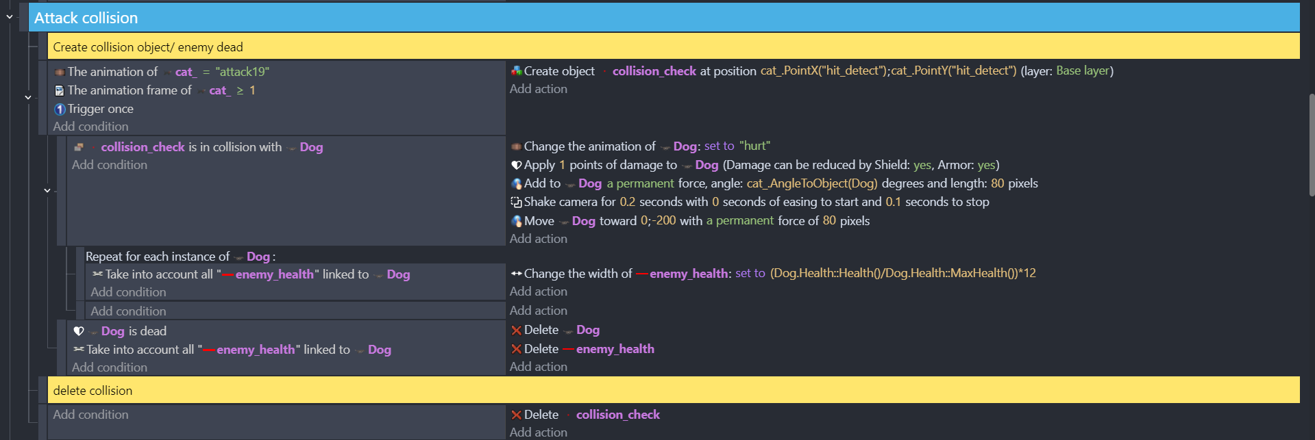

This explains how the collision of the enemy character works

## Enemy AI

To develop enemy AI, pixel sprites were created using aseprite where idle and chase were illustrated through action frames. Enemy logic for patrol and detection were developed using the event system in GDevelop. Each enemy developed a path to patrol, using positional movement to create a path on each enemy combined with timers to simulate awaiting, and created an idle behavior. Detection at this stage is facilitated using hitbox objects positioned in front of the enemy. If the player entered the detection area of the hitbox the enemy would trigger a change to chase animations, and adjust its speed to move faster. Once the player exited the detection area of the enemy, the enemy would return to the patrol path defined by set coordinates.

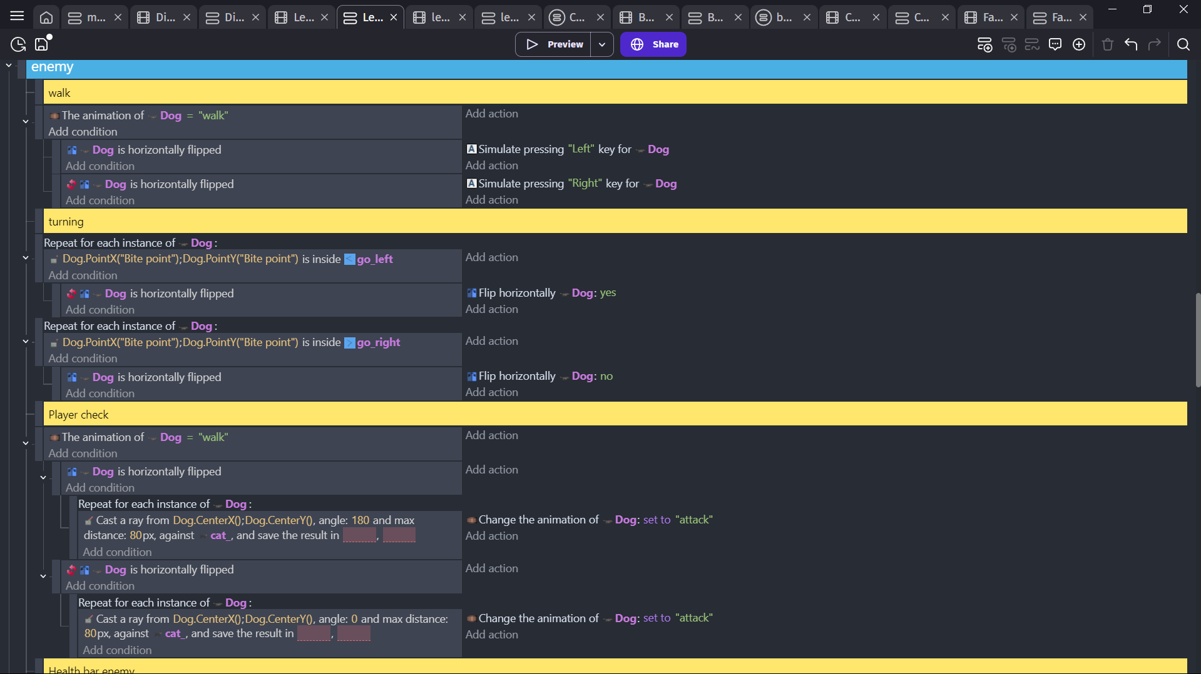

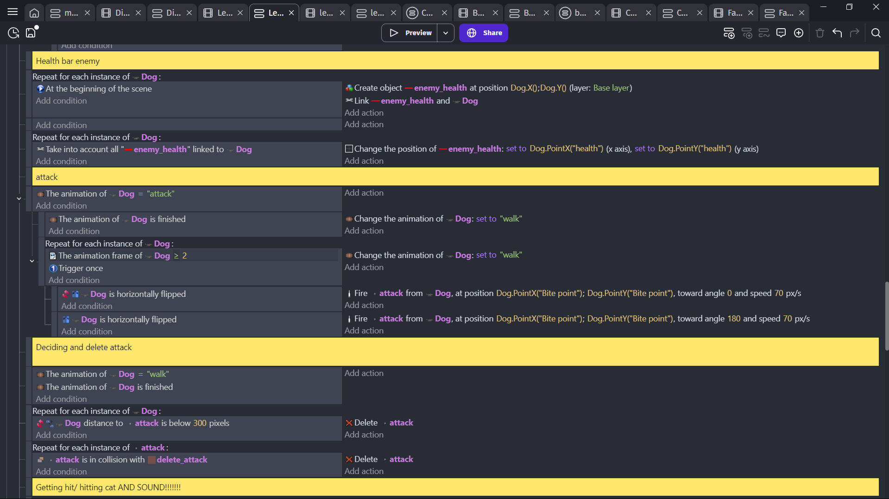

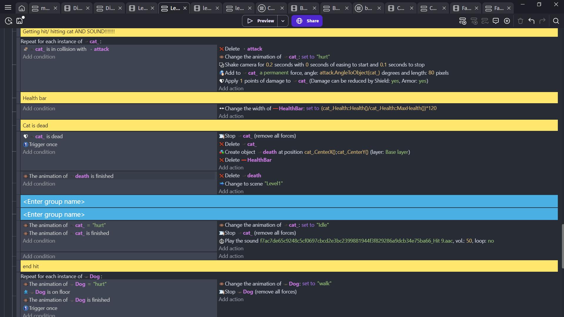

## User Interface

The user interface layers (menus, interaction prompts, health indicators, etc.) were designed in Aseprite with a consistent pixel style. When imported into GDevelop as a sprite asset, they were organized and positioned with layers and positioning tools. The pre-built event system in GDevelop allowed the implementation of button interactivity without a need for external scripting. Visual feedback used animation changes in hover and click states. Fonts were chosen that reflected the tone of the environment while being aware of legibility and aesthetic compatibility. Testing was conducted that validated the UI scaling works for all resolutions.

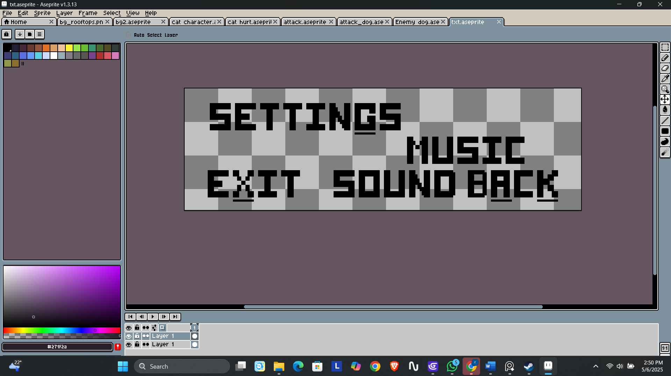

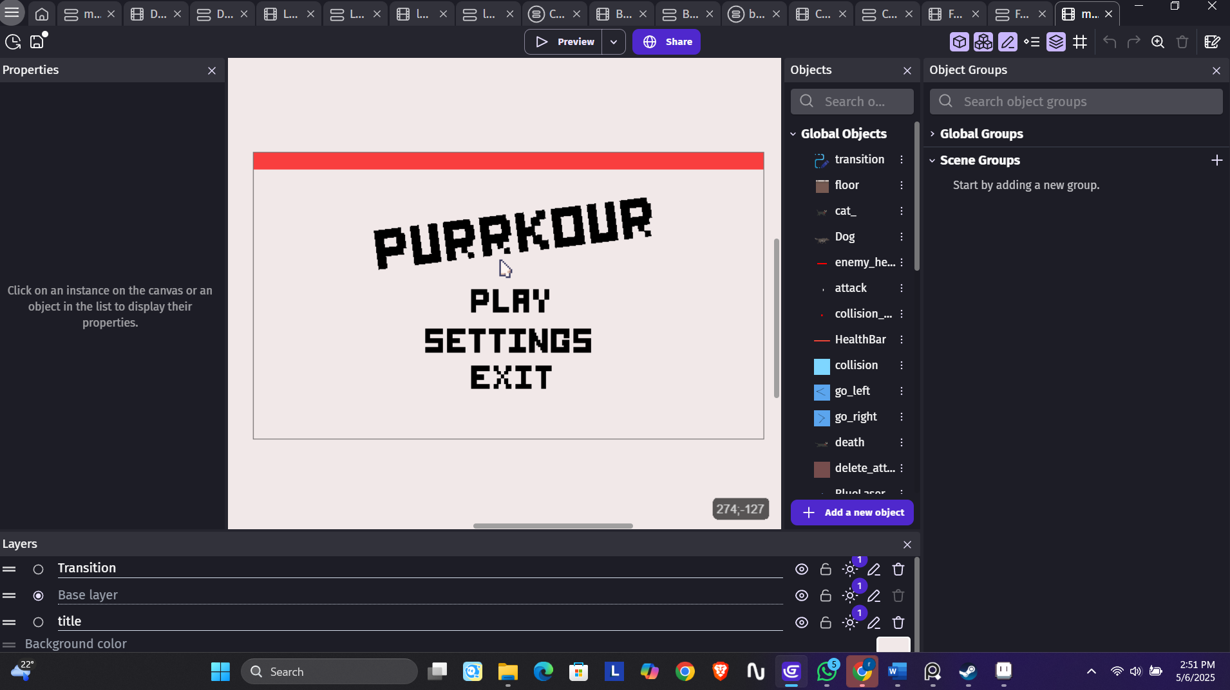

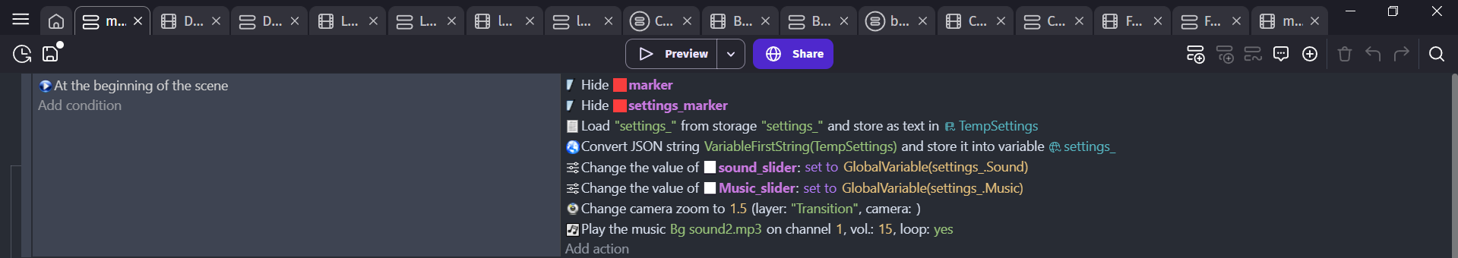

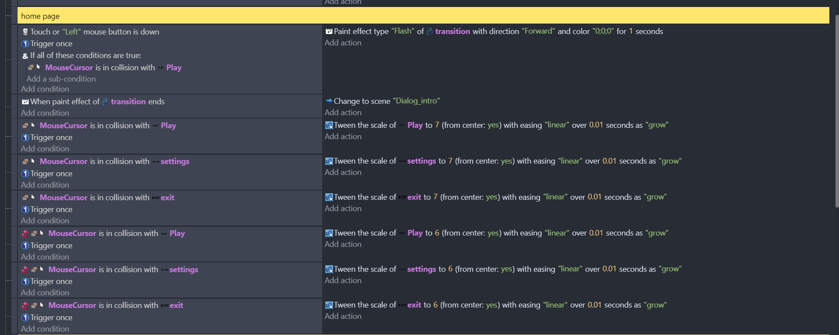

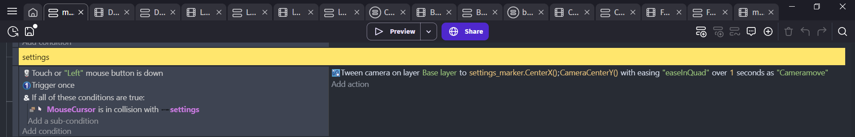

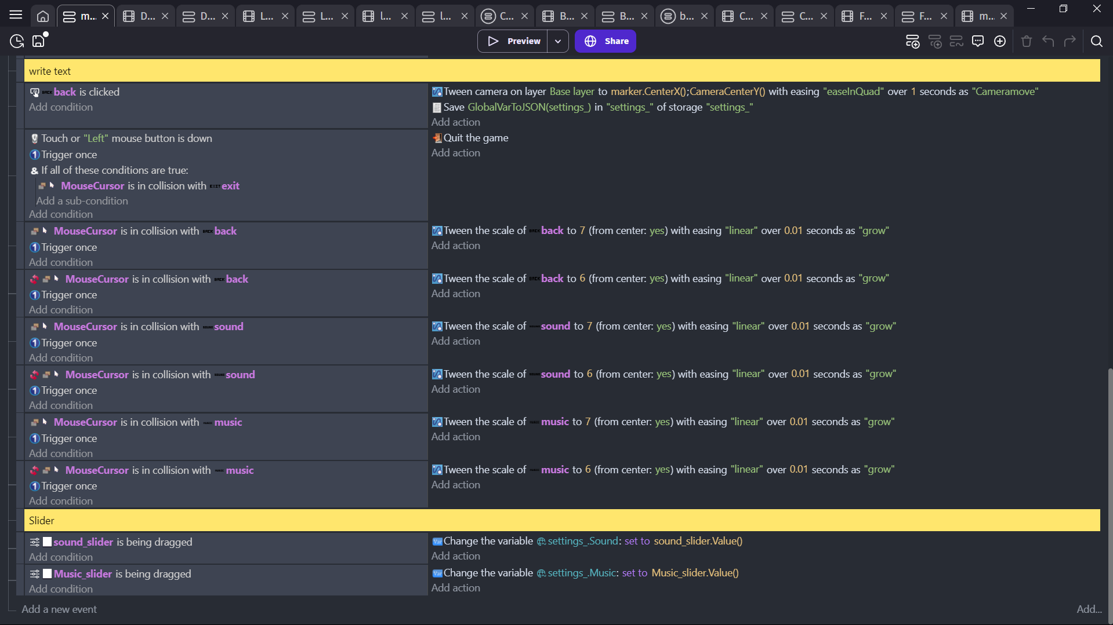

## Sound Effect

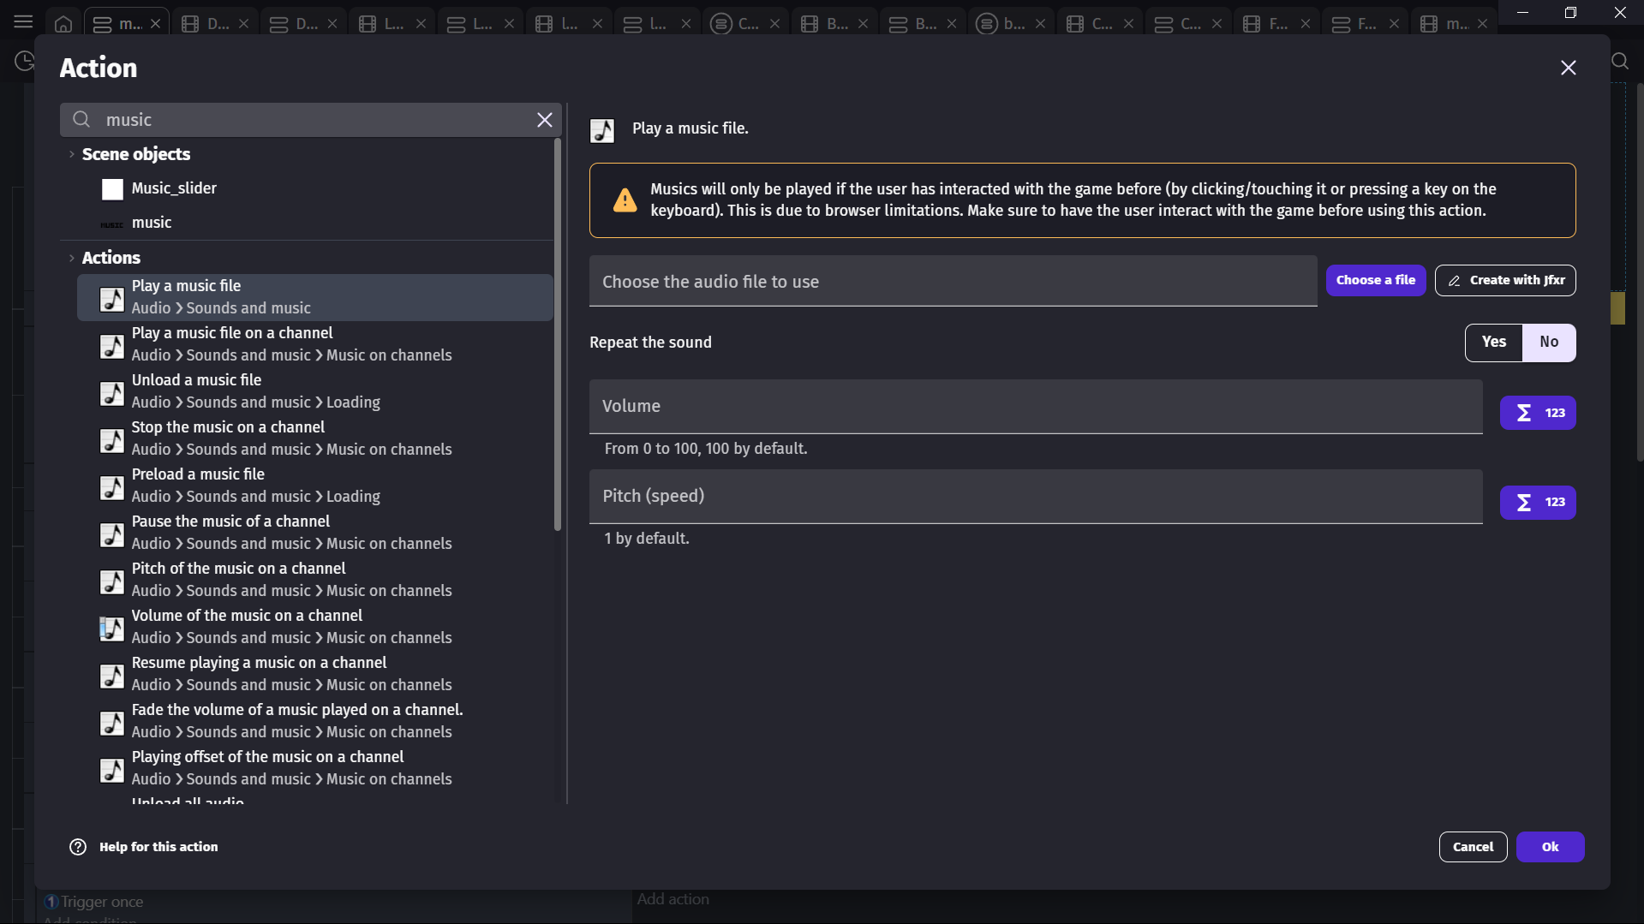



(djartmusic, 2025)

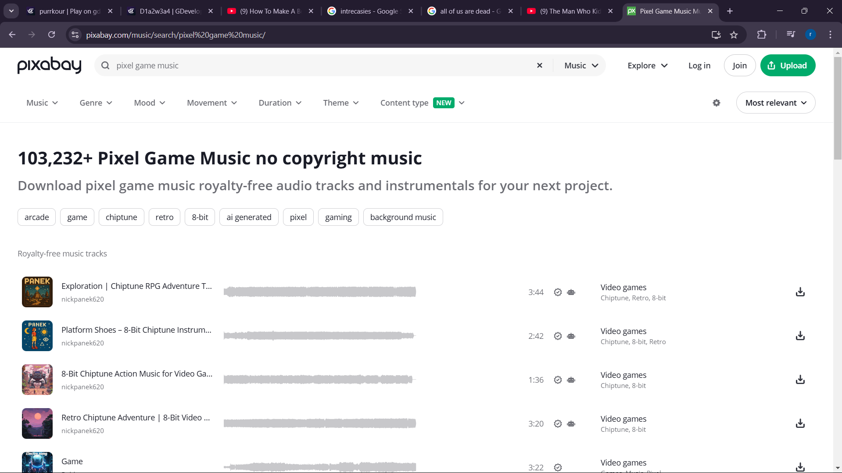

(djartmusic, 2025)

# Post-Production Phase

## Compile

When all assets were finished, character sprites, environment layers, user interface elements and enemy sprites were all combined in done in GDevelop. The scenes were arranged in order based on level flow with transitions put in all scenes to make the gameplay flow better. All objects were stacked and grouped together in GDevelop so I could see them all clearly so they were not stacked along with others unintentionally. Background music and sound effects were also inserted in this part using GDevelop's event system for audio. I ran the project again in this section to check for event errors and regularly confirmed visual consistency.

## Post finalization

After the finalization on gameplay the project was exported into an executable file format. Minor bugs like overlapping hit boxes and misaligned UI sections were fixed based on the testing feedback received. Changes were also made to animation timing and changes to enemy pathing to add the general playability of the game. Screenshots and short gameplay recordings to document the final aspect of the game were taken. Before project submission final checks were performed to ensure the game would run without frame drops or other logic errors.

# Problems faced and it’s solutions

## 10.1. Collision Detection and Integration of movement

### Problem:

One of the first issues i experienced while developing the 2D game was the player movement and collision detection conflicting with each other. The character was walking through objects and barriers and it broke immersion and left a completed but incomplete feeling with the gameplay.

### Solution:

To solve the problem, I rebuilt the entire tilemap, made modifications using 2D Collider components to the collision boxes to be accurate, but I also had to change the movement scripts to check for boundaries, and I also had to rebuild the physics layers to only have the layers that were needed for colliding. The end result exhibited unexpectedly realistic and responsive game play behavior.

## Sound not playing during gameplay

### Problem:

One recurrent issue was that the background music or sound effects would suddenly stop playing during specific scenes or not trigger at all during specific events.

### Solution:

## Long screen load time

### Problem:

One of the game scenes, specifically transition to the boss level, was taking too long to load and thus had a detrimental effect on player experience.

### Solution:

I optimized the assets in the scene by reducing big textures, deleting unused objects, and adding asynchronous loading of scenes. I also added a simple loading animation to keep players engaged during transitions.

# User Testing & Findings

## Survey Form and Results

In order to assess the overall success and reception of the final product a survey form with 20 questions was sent to the audience. Each respondent was asked to provide their name in the event there was a need for follow up. The survey results served as great feedback for identifying what worked in the game as well as potential areas for improvement.

Survey Link:

<https://docs.google.com/forms/d/e/1FAIpQLSd87qErgAmPEKQubWMRgG_NcH0lsIGvpCgaLjXojB1w7GWjSw/viewform?usp=dialog>

The survey results are shown below.

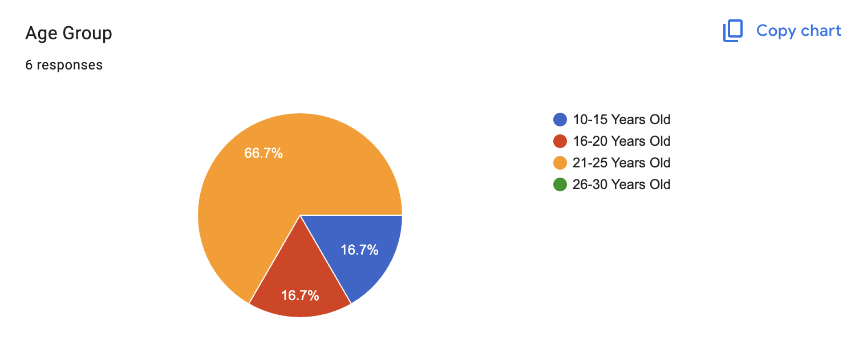

Figure 25: Survey result for age group

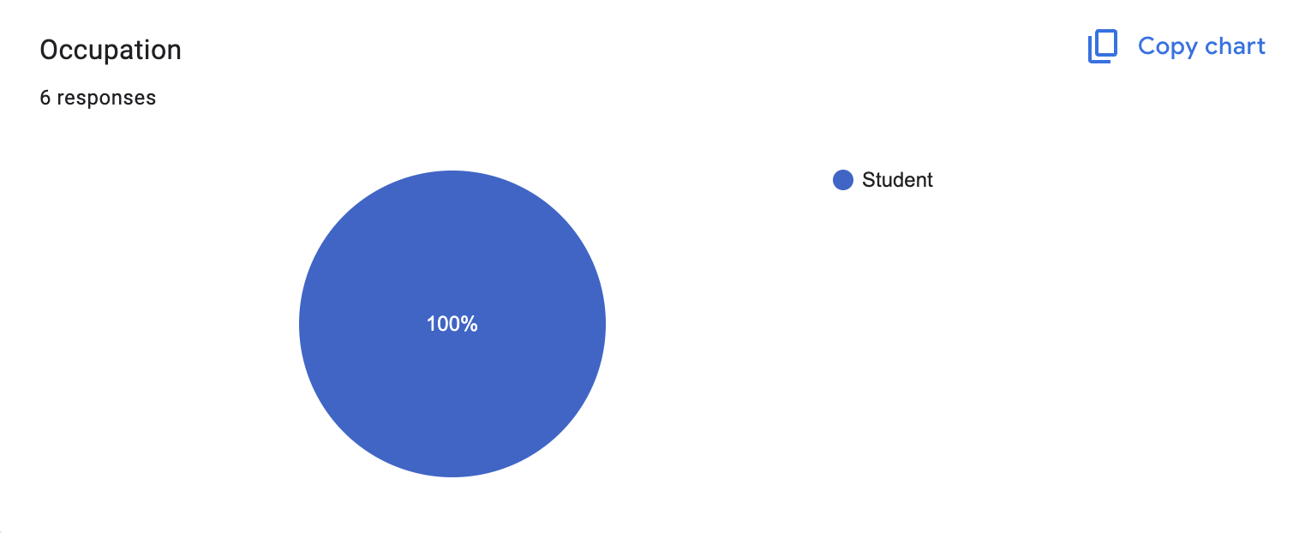

Figure 26: Survey result for occupation

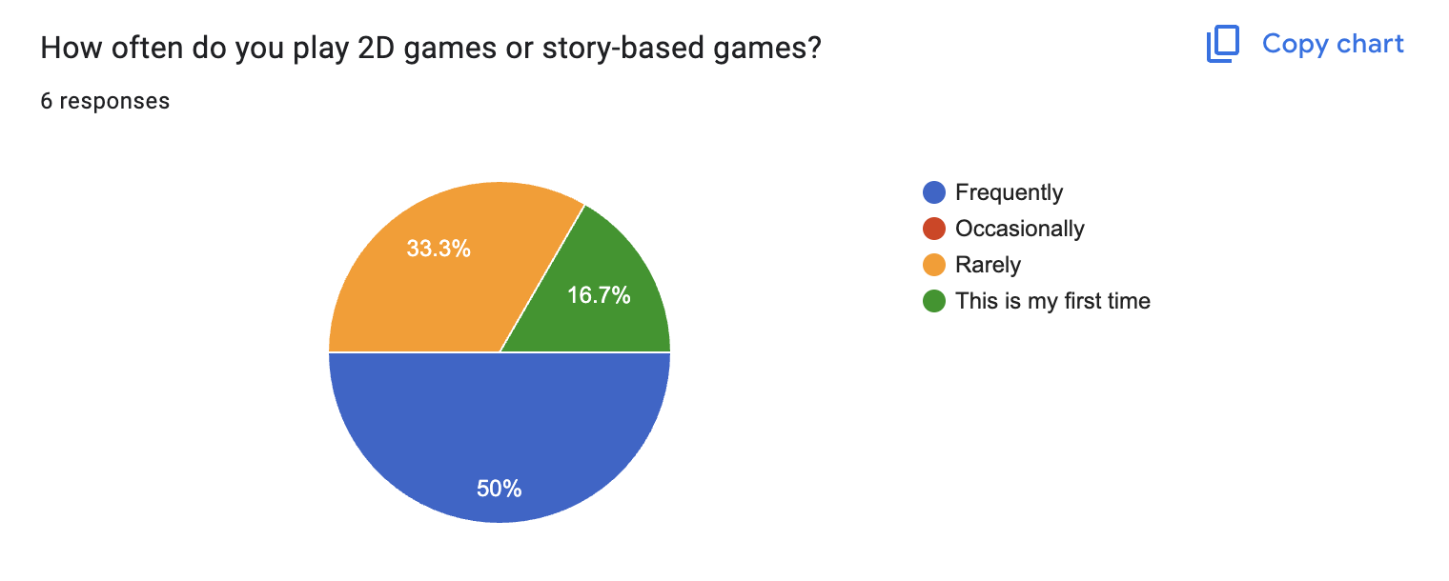

Figure 27:: Survey result for how often user play 2D games

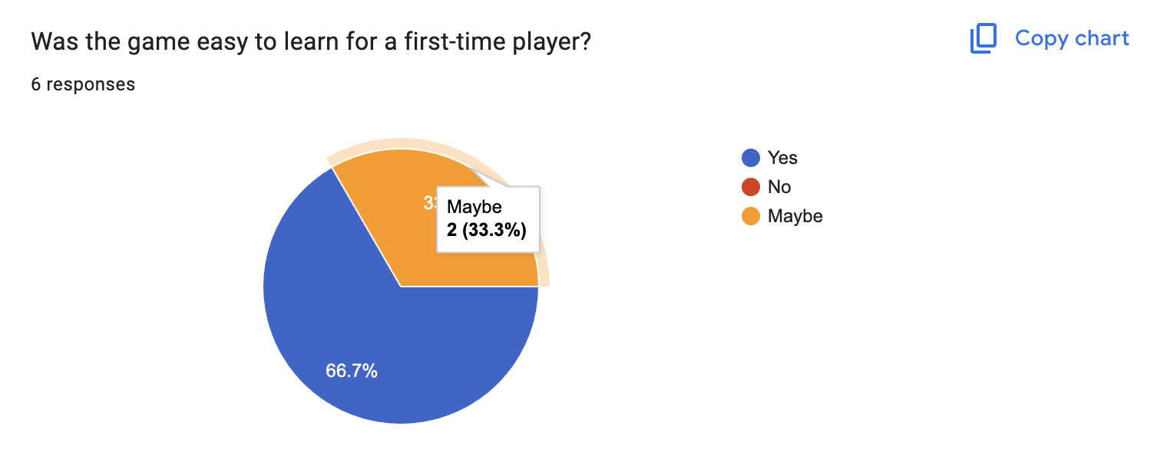

Figure 28: Survey result if the game was easy to play

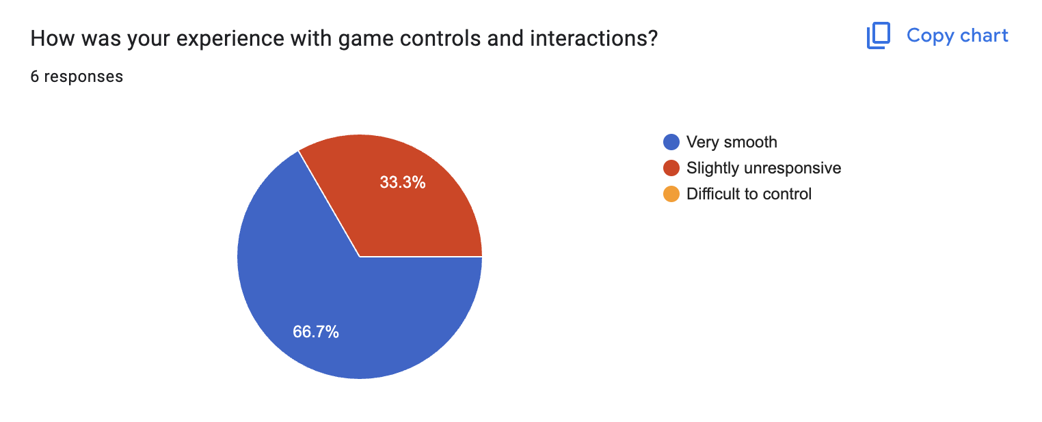

Figure 29: Survey result on experience

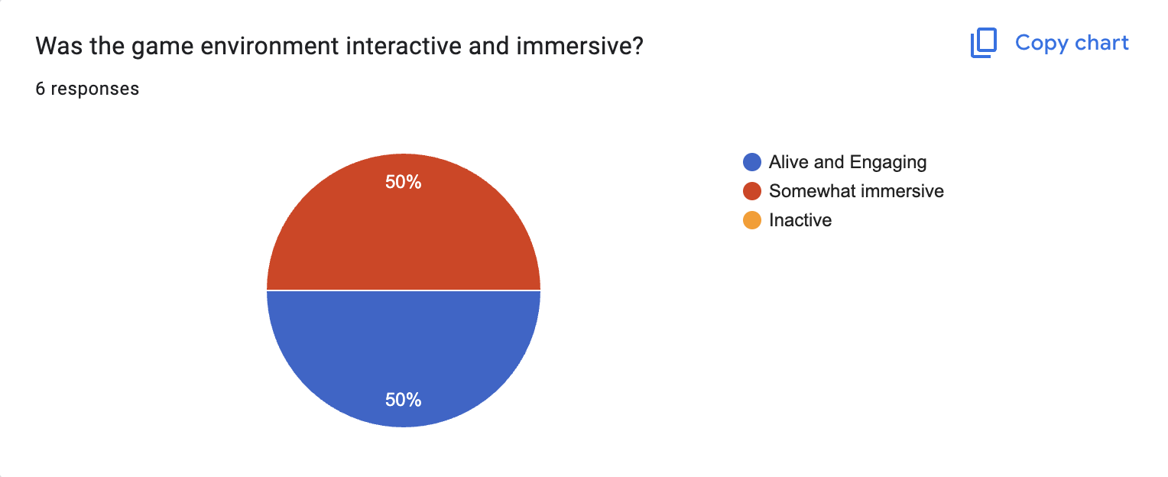

Figure 30: Survey result on game environment

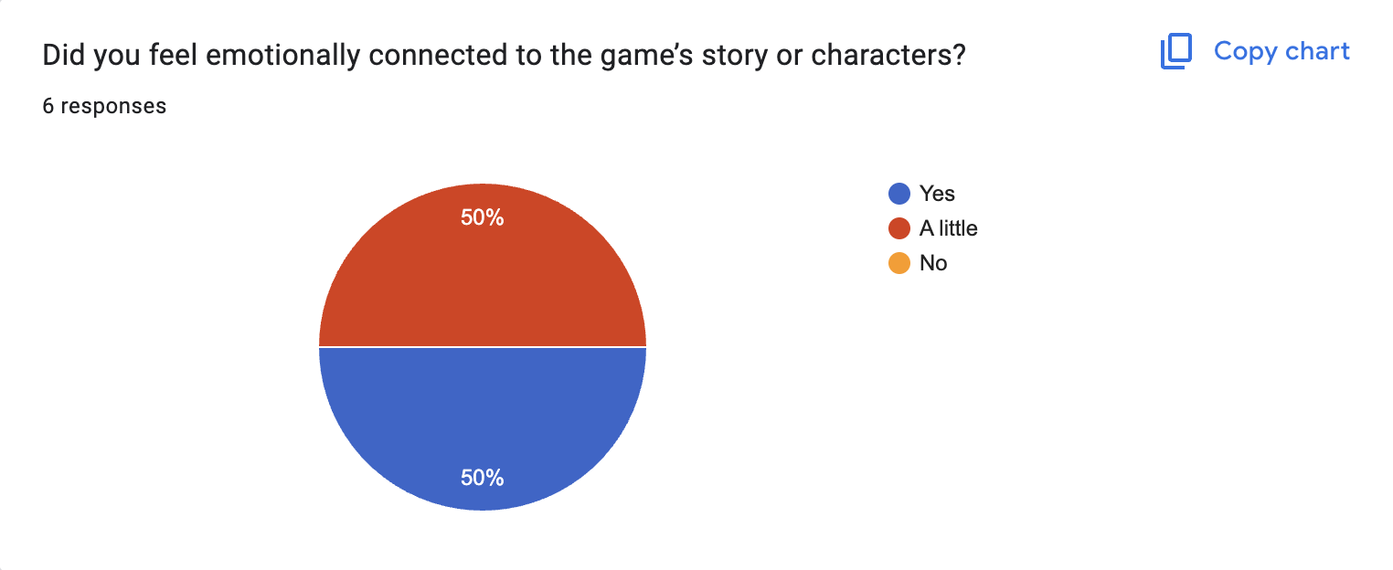

Figure 31:: Survey result on emotion connection

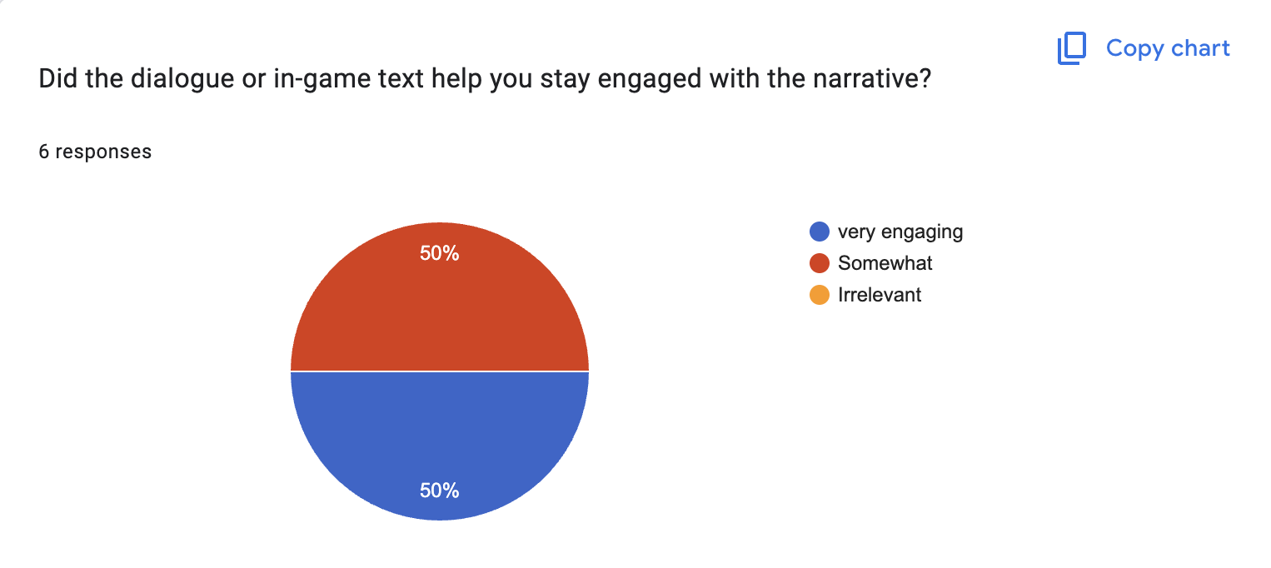

Figure 32: Survey result on if dialog box helped

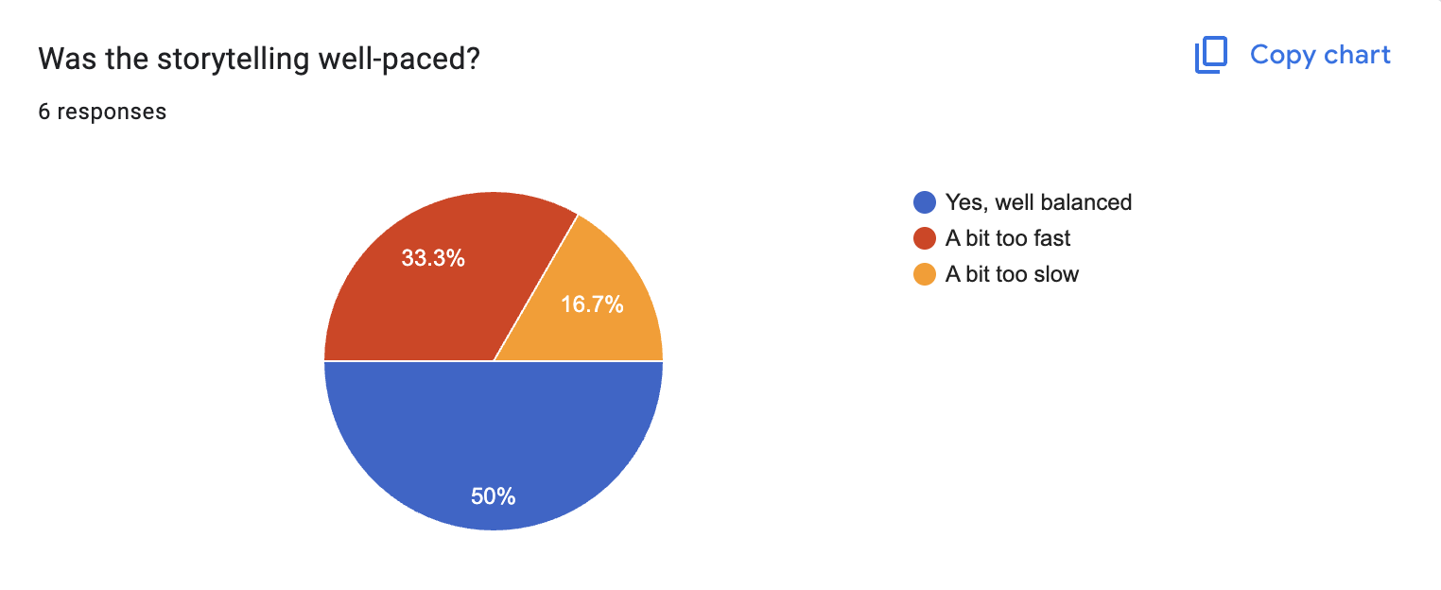

Figure 33: Survey result if the story telling is well-paced

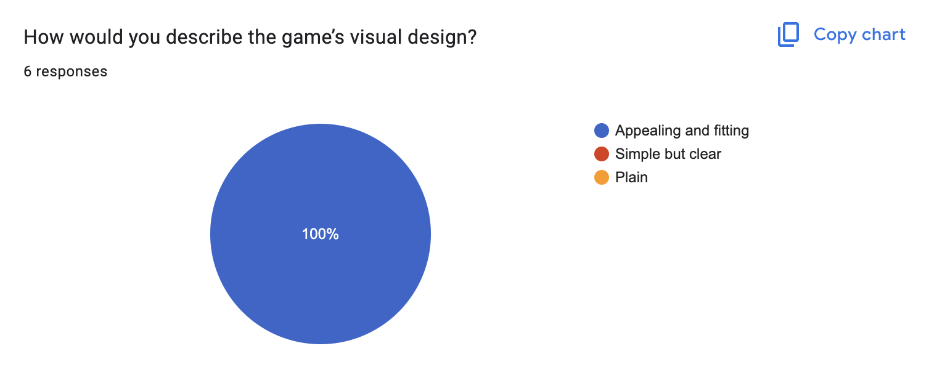

Figure 34: Survey result of gane's visual opinion

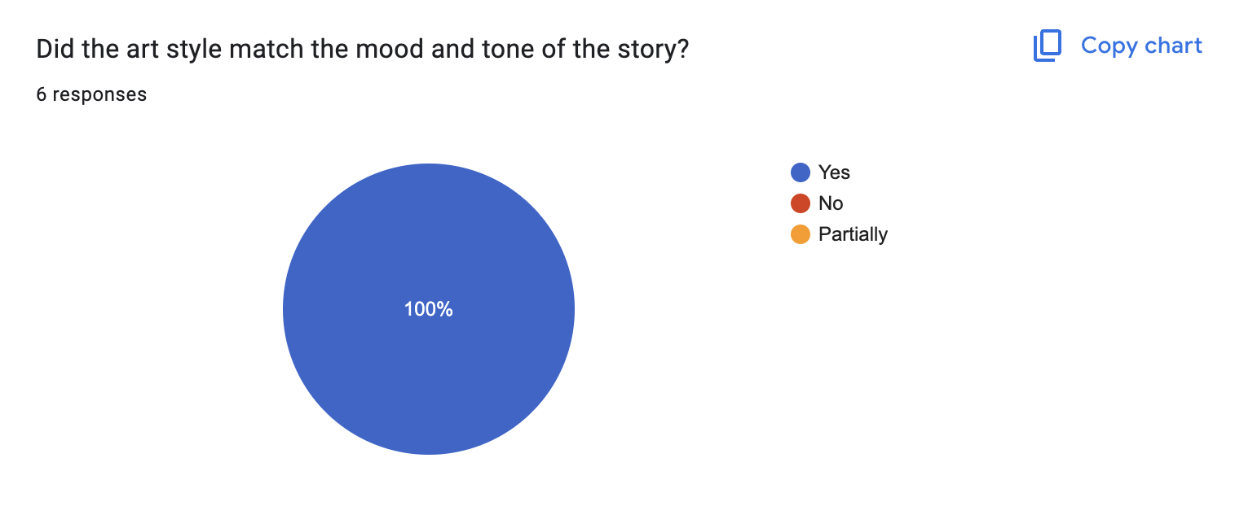

Figure 35: Survey result if style matched the tone of story

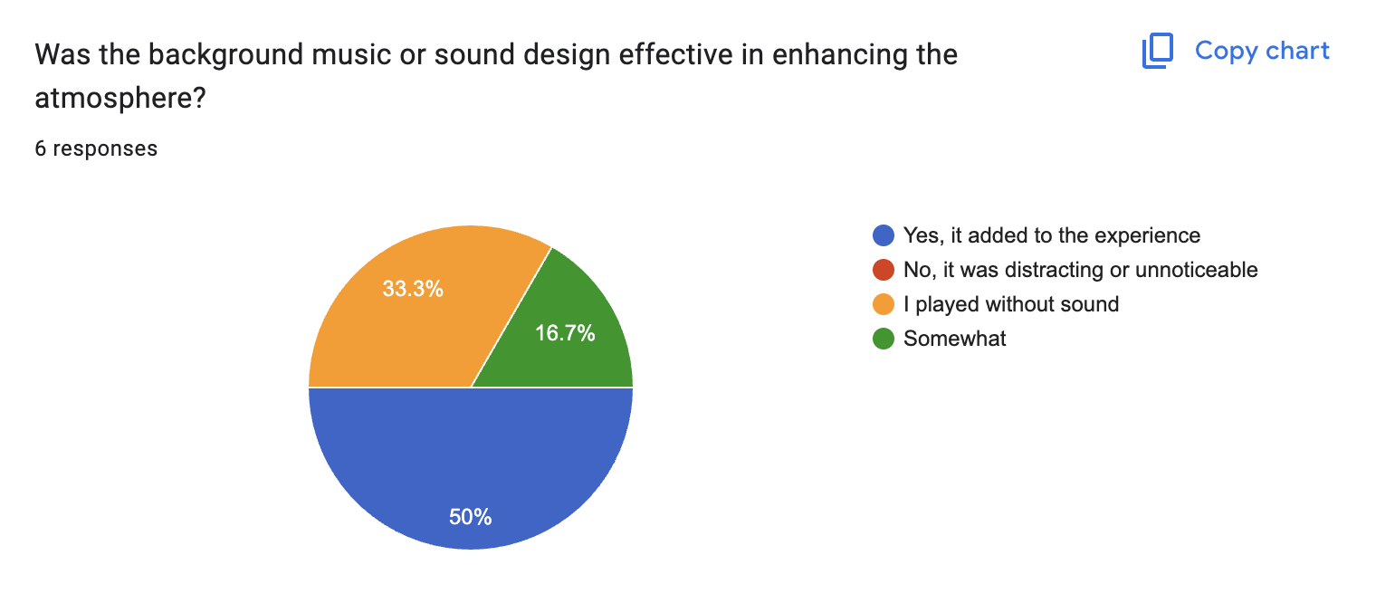

Figure 36: Survey result on background music opinion

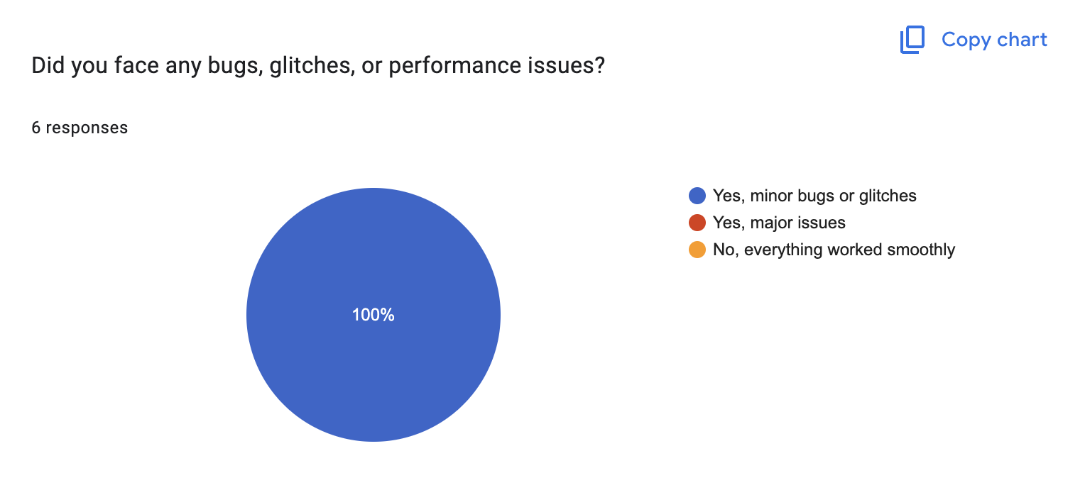

Figure 37: Survey result if any glitches or bugs

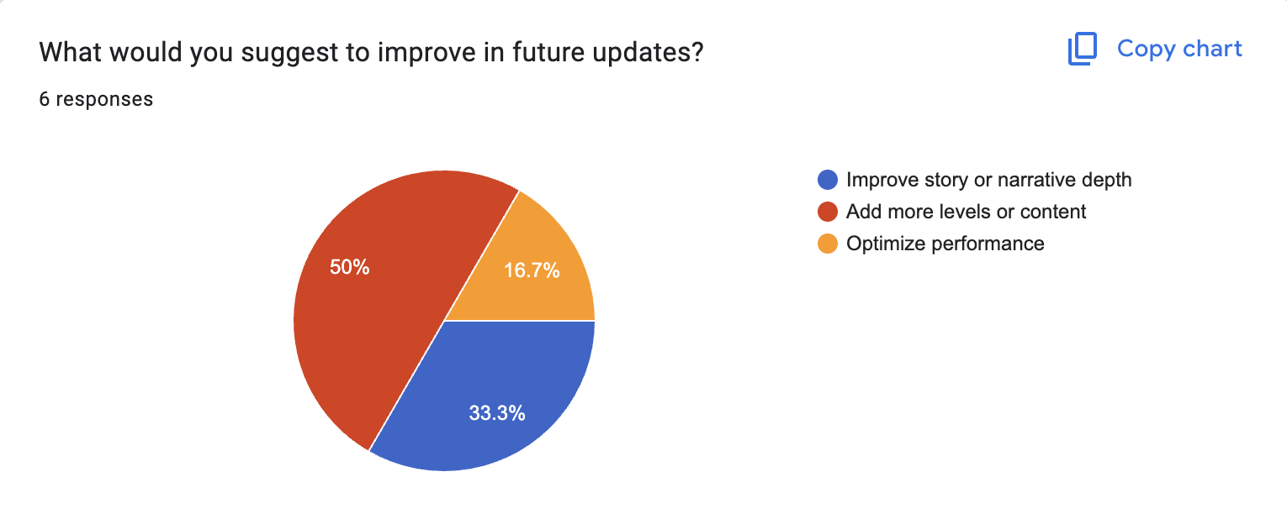

Figure 38: Survey result of suggestion to improve

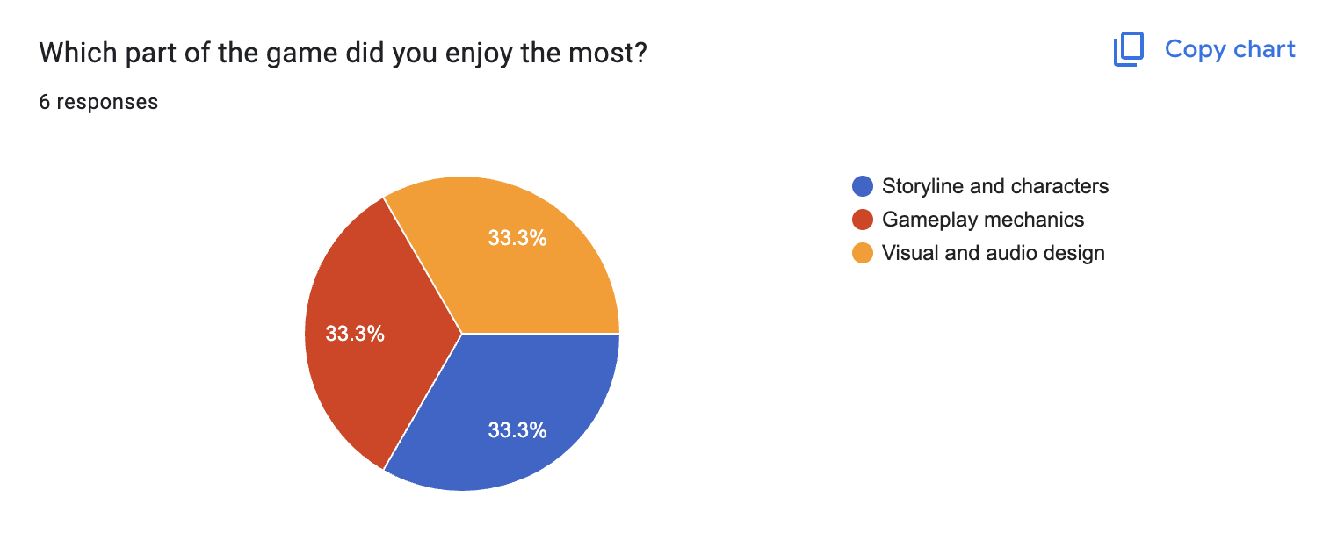

Figure 39: Survey result on which part of game user enjoyed

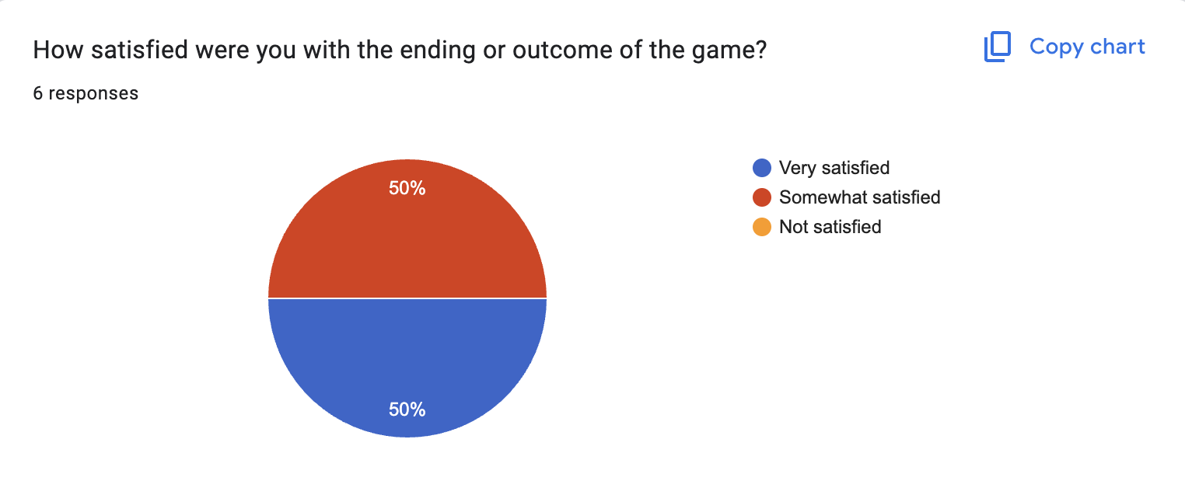

Figure 40: Survey result for satisfaction

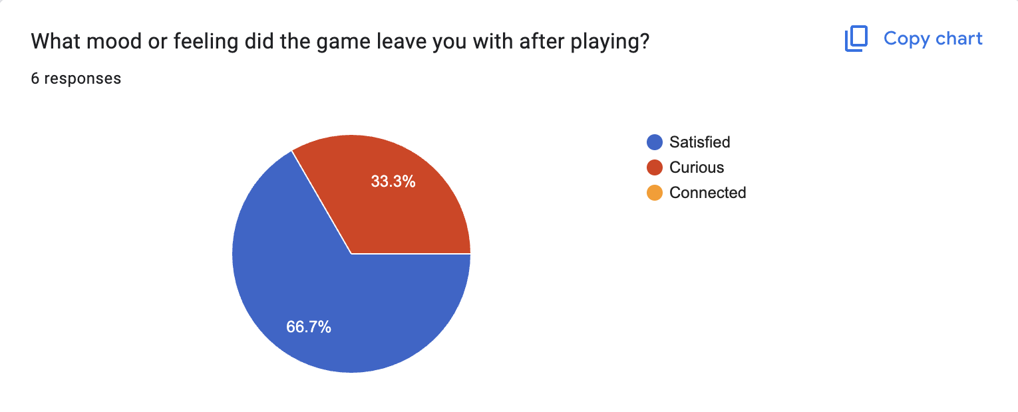

Figure 41: Survey result on mood and feeling after gameplay

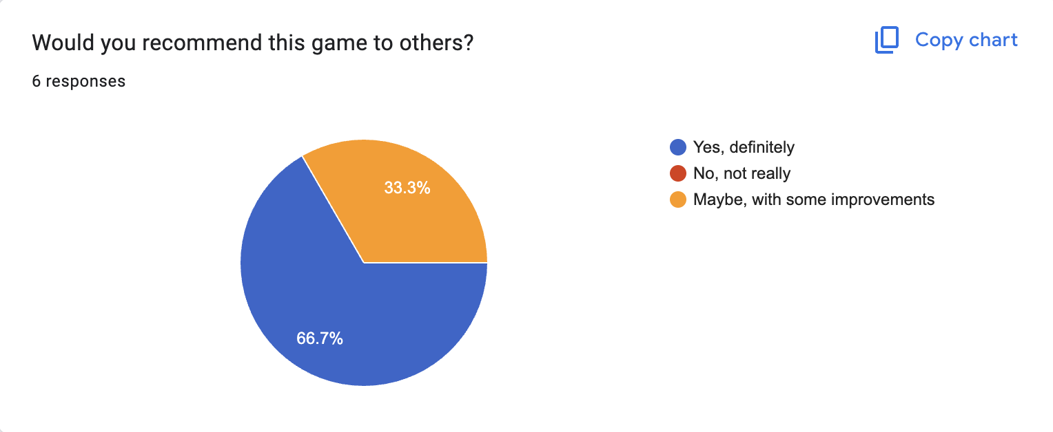

Figure 42: Survey result for if user would recommend this game

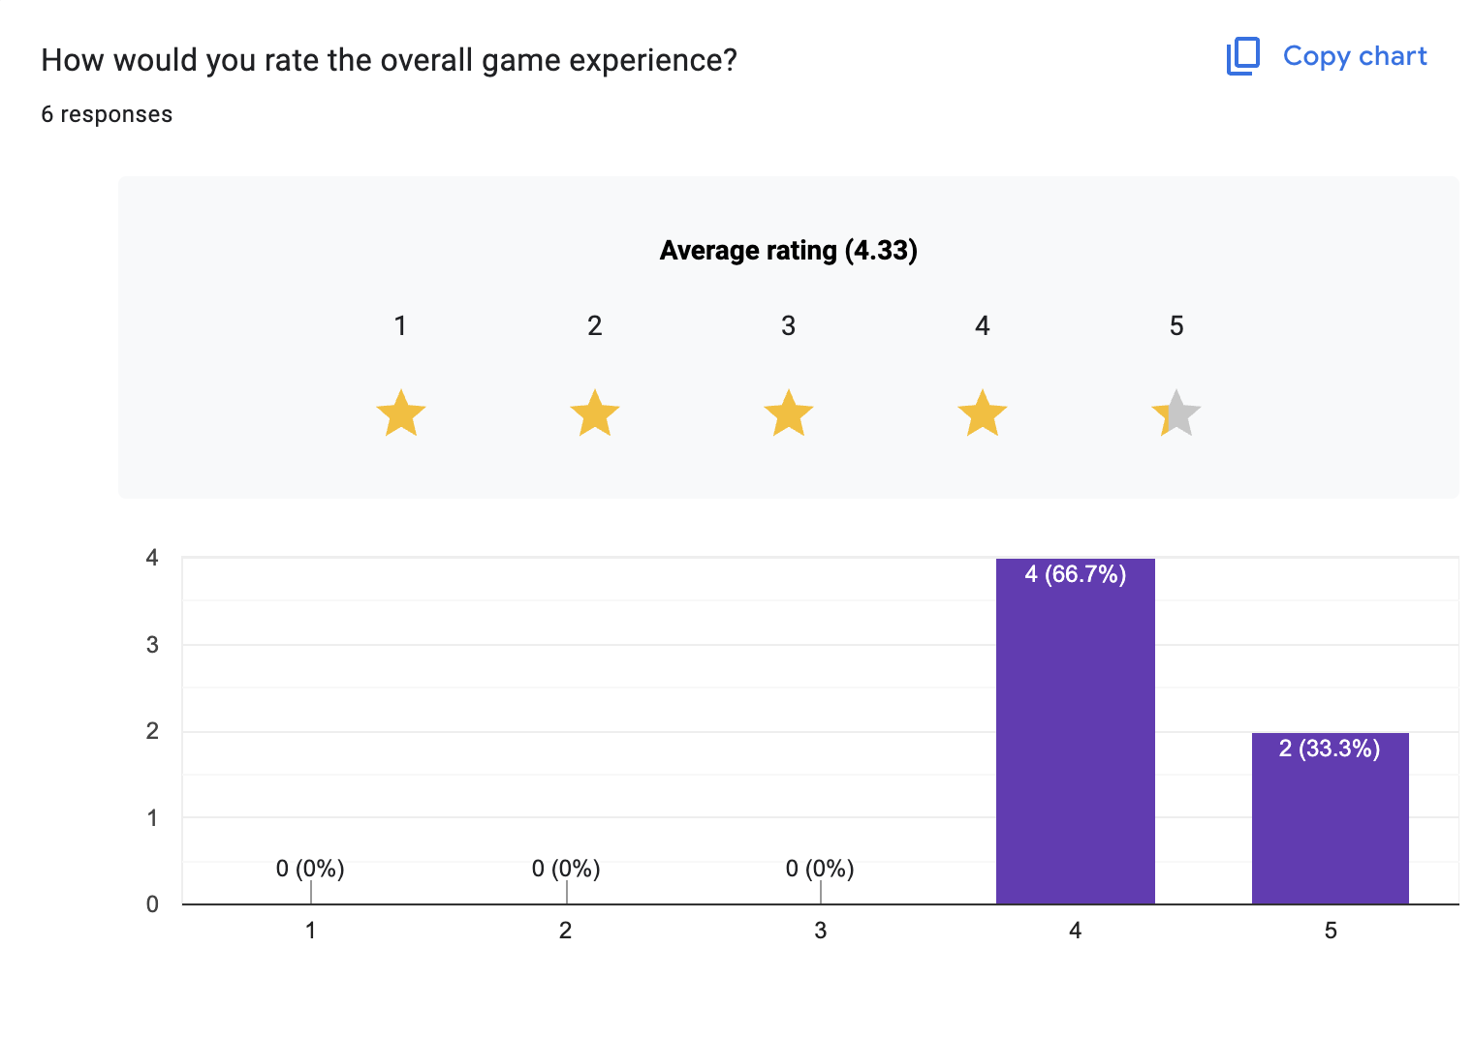

Figure 43: Survey result for rating

### Reflection on the survey result

The survey findings indicate that the game was well received by the target audience. The majority of players indicated that the controls were smooth and easy to learn. The comments indicated the quality of the environment was enjoyable and easy to look at. Respondents resonated with the characters emotionally, and the dialogue coupled with the tone of the story told were appreciated.

Both the visual and sound design decisions were appreciated in the context of the game mood. From a technical standpoint, the game did quite well with only a few minor bugs addressed in the survey. The biggest criticism of the game was related to suggestions for more content and improving the depth of the story.

Overall, the feedback reinforces that the project meet its goals of providing players with an engaging product that was well made.

## Technical Testing

To accomplish testing for technical purposes, the final build for the game was tested first on the Lenovo Legion 5; this was the device used the majority of the time from the start of the development process onward. The game ran well, with no audio or visual interruptions. All pixel visuals were clear and each in-game transition or effects fired at the appropriate pace. Colors in the color palette also appeared bright, and shadows and outlines had an adequate amount of contrast to distinguish them from the primary color.

Further testing was conducted with the XP-Pen Deco Pro, the second device that was used solely in the asset creation phase. This device is primarily a drawing tablet, but I used the screen display device with pen input in order to review pixel precision and quality as it appears when it is played. The artwork was as intended with clean edges and consistent colors suggesting that the visuals were exported as intended from Aseprite into GDevelop.

The sound effects of the game triggered as intended for all interactions and the UI functionality was being prompt. The UI was slightly spaced out in a way when switching between full-screen mode and windowed mode, which was adjusted before finalizing.

All in all, the testing confirmed that the game worked appropriately across all devices used, and there was visual style and interactions the whole way through.

## Third Party Evaluation

# Conclusion

The completion of this coursework did not come without struggles from the planning process to production and exporting processes, and through everything in-between. Working through the phases from pre-production research and building assets in Aseprite to assembling and programming scenes in GDevelop allowed some experimentation and the development of technical skills.

There certainly was some uncertainty on the journey, whether it was in making design decisions or learning to adapt to GDevelop’s event system. Regardless, the entirety of the learning experience was well worth it. I improved my skills in pixel art, my composition of environments and my ability to build logic for interactive design. There is still a long way to be with the professional industry, but there has been a clear improvement in both visual execution and physical functionality of the game, and that is an encouraging sign.

At the same time, soft skills relating to self-managing, planning, and iteration were improved through this whole project. While there were some ups and downs, and restrictions, the project as a whole has been completed, and the knowledge gained makes the experience worth a while.

# Bibliography

aseprite, 2025. *aseprite.* [Online]   
Available at: https://www.aseprite.org/docs/

coolors, 2025. *coolors.* [Online]   
Available at: https://coolors.co/palettes/trending

gadgetbytenepal, 2025. *gadgetbytenepal.* [Online]   
Available at: https://www.gadgetbytenepal.com/product/lenovo-legion-5-2021-ryzen-7-5800h-rtx-3050ti/

gdevelop, 2025. *gdevelop.* [Online]   
Available at: https://gdevelop.io/

GDevelop, 2025. *GDevelop.* [Online]   
Available at: https://youtu.be/mckuSpr8vio?si=b6bkhWB83-edXjju

GDevelop, 2025. *GDevelop.* [Online]   
Available at: https://youtu.be/HagU5uA0vxM?si=jIBK5EQ4pOVSv2ro

GDevelop, 2025. *GDevelop.* [Online]   
Available at: https://youtu.be/0aGBYsrGwm0?si=0Jqdt7qs7vjqTE8G

GDevelop, 2025. *GDevelop.* [Online]   
Available at: https://youtu.be/0aGBYsrGwm0?si=0Jqdt7qs7vjqTE8G

GDevelop, 2025. *GDevelop.* [Online]   
Available at: https://youtu.be/0aGBYsrGwm0?si=0Jqdt7qs7vjqTE8G

GDevelop, 2025. *GDevelop.* [Online]   
Available at: https://youtu.be/Li4vhL1bXLc?si=7BG4AryocIIcnemC

GDevelop, 2025. *GDevelop.* [Online]   
Available at: https://youtu.be/Li4vhL1bXLc?si=7BG4AryocIIcnemC

onlinegantt, 2025. *onlinegantt.* [Online]   
Available at: https://www.onlinegantt.com/#/gantt

onlinegantt, 2025. *onlinegantt.* [Online]   
Available at: https://www.onlinegantt.com/#/gantt

XP-pen, 2025. *XP-pen.* [Online]   
Available at: https://www.xp-pen.com/product/deco-pro-series-bluetooth.html

# Appendix

## Mail exchange with client

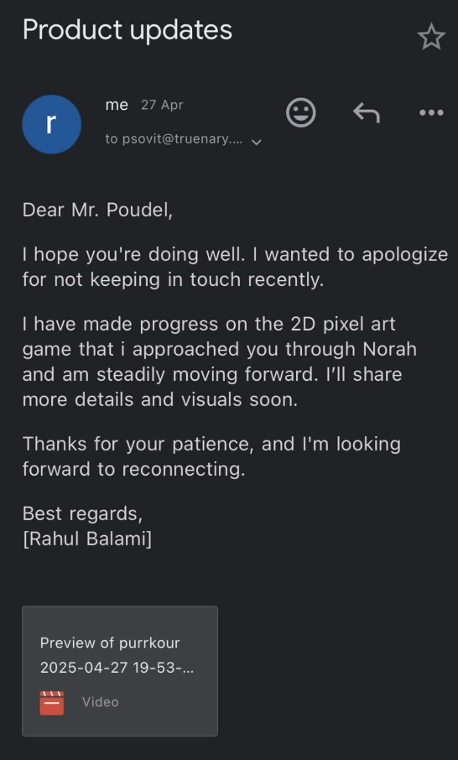

Figure 44: Mail exchange with client

## DMP Letter provided by college

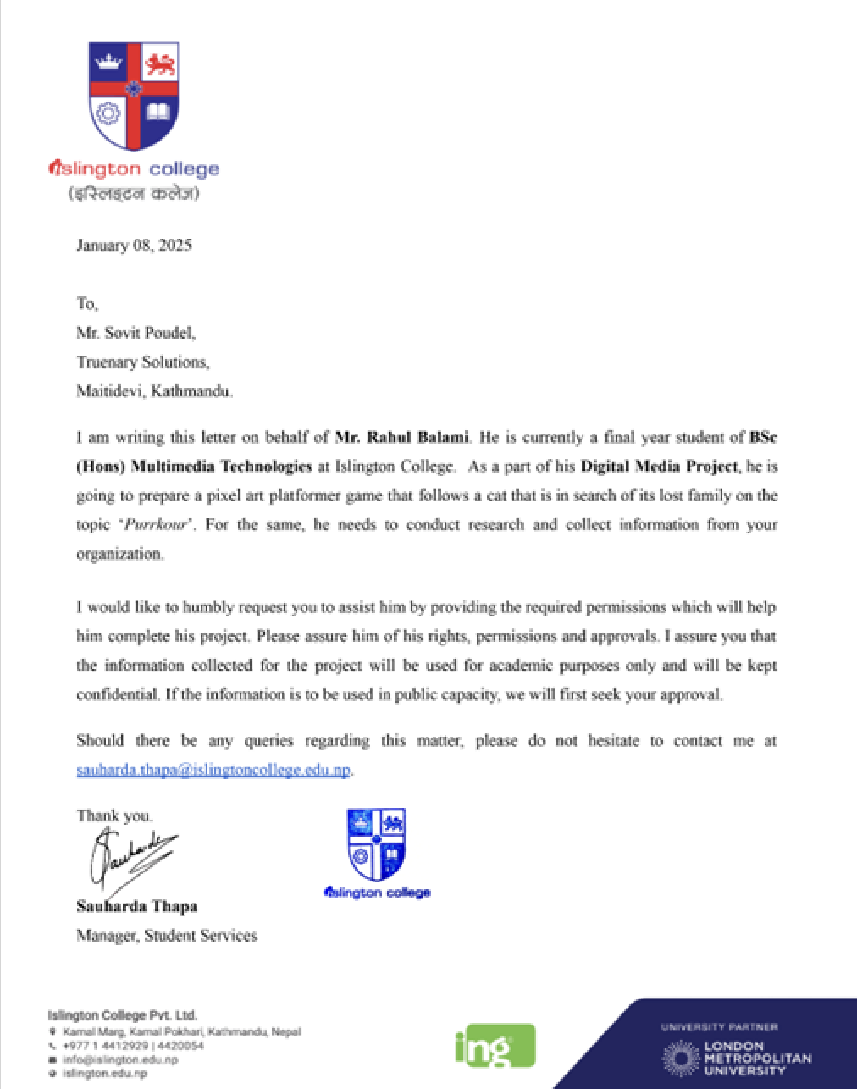

Figure 45: DMP Letter provided by college

## Weekly Logs

